Section 8: Elliott Cheu: Dark energy physics and LSST camera power

Photometric redshift studies (A. Abate, E. Cheu, T. St. Germaine)

Surveys such as LSST use multi-color imaging to obtain approximate redshifts, called photometric redshifts or photo-z. These redshifts are less accurate than spectroscopic methods, but require less exposure time. In order to refine photo-z estimation algorithms and to understand the resulting error distribution, a “calibration sample” of LSST data with spectroscopic redshifts is required.

Ideally this calibration sample should match the characteristics of the full LSST sample, large enough to perform the algorithm training, and produce a robust estimate of the photo-z error distribution. Any incompleteness in this calibration sample data will lead to biases in dark energy constraints. However, complete coverage will not be possible due to the difficulty in obtaining spectra for certain types of galaxies. In order for the collaboration to plan ambitious follow-up spectroscopic surveys and to negotiate the use of data gathered by other facilities, it is vital for us to determine the optimum calibration sample obtainable and the most useful corollary data sets as soon as possible.

For this proposal we will also investigate the following: the impact of adding other multi-wavelength data, the impact of the calibration sample selected, and the impact of sample incompleteness on LSST dark energy constraints. This work aligns with Photometric Redshifts Tasks H-1 and H-2 in the Dark Energy Science Collaboration (DESC) white paper. Abate and Sam Schmidt (UC Davis) share responsibility for coordinating most of the photo-z studies for DESC.

We are also investigating whether low noise spectra can significantly improve LSST redshift determinations, in particular for faint galaxies at high redshift where a calibration sample is most constrained. The outcome of this particular study could impact the wider astronomical community outside of the LSST project. Initial results look encouraging and indicate that such low noise spectra have the potential to break degeneracies between galaxy type and redshift.

Deblending Studies (A. Abate, E. Cheu, A. Weaver)

The LSST will obtain such deep images that nearly all galaxies will overlap with other objects. Deblending algorithms are applied to astronomical images to separate the measured flux of such blended objects. Because weak lensing measurements depend upon accurate determination of galaxy shapes, this deblending must be successfully performed at a much higher level with LSST than previous galaxy surveys. We are working to quantify and understand the requisite precision, a vital task to begin at this time since the LSST deblender algorithm is already in development.

Our work to date has been the following: implement code to detect sources from image files, and evaluate code to measure the shapes (ellipticities) of galaxies. Recently, we have used initial LSST simulations to quantify the impact of nearby objects on galaxy shapes. For this proposal we will undertake a two-pronged attack: i) quantify the problem of residual blending against the resulting shape measurement errors via simulations; ii) quantify the fraction of blended galaxies for LSST as a function of the survey depth.

To proceed we will with image simulators to comprehensively understand the limitations of current deblender algorithms. In tandem we will work with simulated LSST catalogs to find the fraction of LSST galaxies where deblending fails. We will systematically study the effects of these objects on the shape measurements, and determine their impact on the weak lensing constraints. We need to understand when these objects can be removed from the sample, compared to implementing more sophisticated deblending algorithms. We are working with David Kirkby, UC Irvine. Based upon these studies we will be able to set the LSST Data Management requirements for the deblender based on optimizing dark energy science from weak gravitational lensing. This task aligns with Cross-Cutting Task H-4 in the DESC white paper.
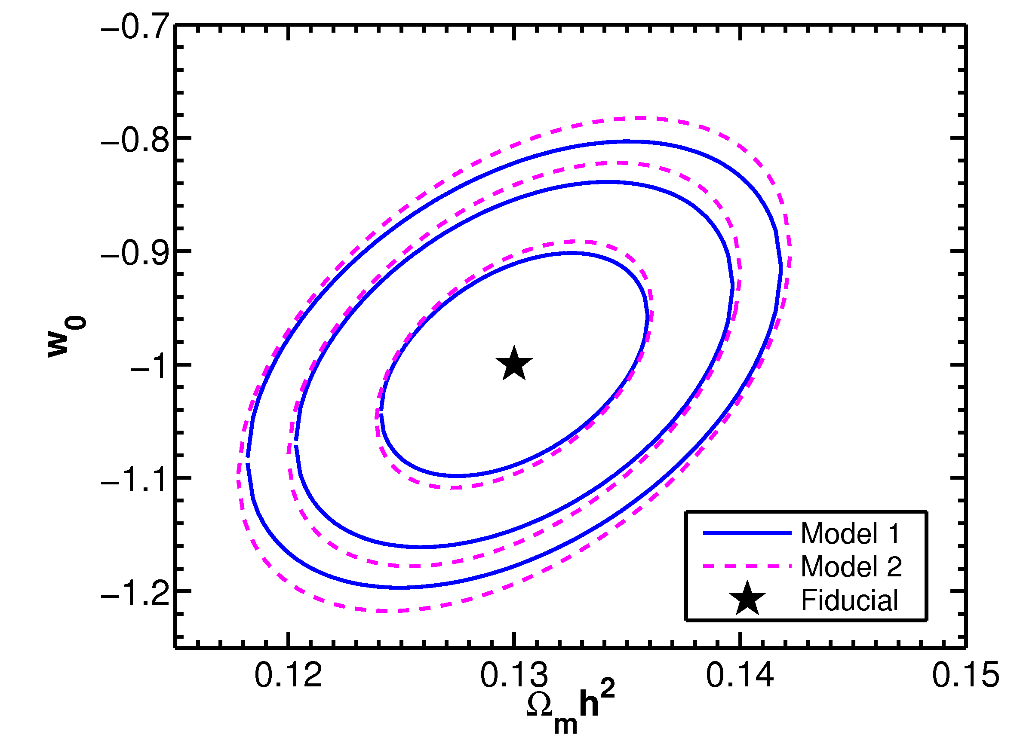
Figure 8-1: A contour plot of the dark energy parameter w₀ versus Ω_{m} for different photometric redshift error distributions.

Weak Lensing Studies (A. Abate and E. Cheu)

Uncertainties in the determination of galaxy distances will be inescapable in weak lensing calculations for LSST and must be effectively taken into account. In particular, cosmological statistics will depend sensitively on the precision to which the redshift of each galaxy is known. Because pipelines to process LSST data and construct cosmological statistics are currently being developed, the impact of current reconstruction algorithms on the final weak lensing results needs to be understood now.

To date, no group has examined the impact of realistic photo-z error distributions on cosmological parameters measured by LSST. We have recently extended code, written by Andrew Zentner of the University of Pittsburgh, to model these effects. This code is being further developed to incorporate realistic LSST error distributions being evaluated by Johns. Figure 8-1 shows one study comparing the constraints on dark energy between two different simple models of photo-z redshift errors.

Based upon LSST simulation data, we will optimize the parameterization of the photo-z error distributions to ensure unbiased determination of the cosmological parameters. This machinery will be incorporated into a pipeline that will provide the dark energy constraints from LSST. The near-term result will be a robust estimation of LSST weak lensing in light of realistic photo-z errors. This aligns with Weak Lensing Task LT-2.

LSST Camera (D. Tompkins and E. Cheu)

Dan Tompkins and Cheu are developing the Power Distribution Cards (PDC) for the LSST camera. These power supplies are mounted directly behind the camera, just outside of the camera cryostat. The power supplies provide all of the clean power used by the camera electronics. The system consists of three crates consisting of approximately 25 power boards. Each power crate will have two commercial off the shelf 110 VAC to 5 VDC and 48 VDC universal input power supply and a redundancy controller to supply power to the backplane. The 48 VDC would provide power to each of two DC to DC converters to provide the requisite voltages. The PDCs have to maintain noise below 1 mV RMS and voltage regulation within 1%. In addition to the tight tolerances, the size constraints of the utility trunk limit both the size and power dissipation of these supplies.

The prototype supplies have been in development for the past year and a half. A design to meet the specifications is complete and layout is in progress. We expect to produce a prototype for testing by the end of 2012. Our plans are to thoroughly test this prototype to ensure that it meets the LSST specifications, and will subject the module to the usual suite of stress tests. We are collaborating closely with Johns’ group to ensure that the PDCs will fold seamlessly into the LSST infrastructure.

Future Plans
- Photometric redshifts
  - Complete study of low noise spectra. (2013)
  - Study the optimization of the photo-z redshift calibration sample. (2014)
- Deblender studies
  - Complete study of nearby objects on weak lensing parameters. (2013)
  - Develop constraints for Data Management deblender requirements. (2014)
- Weak Lensing Studies
  - Complete Fisher Matrix code. (2012)
  - Estimate dark energy constraints based upon realistic photo-z redshift errors. (2015)
- LSST camera PDC work
  - Complete layout and fabrication of prototype cards. (2013)
  - Evaluate PDC card performance and integrate with PCC system. (2013)
  - Develop final PDC card layout. (2105)

