Appendices - Table of Contents
Section A – Program Descriptions and Goals 2
The Department of Mathematics at a Glance - 2008 2
Section B - Overview of Program’s Academic Quality 3
Grants Since 2000 4
Faculty Buy-In 12
VIGRE Site Visit Report 14
Section C – Program History 21
Previous External APR Findings & Recommendations 22
Faculty Turnover 33
Budget Cut History 34
Pima Community College Salary Schedule for Instructional Faculty 35
Projected Annual Department Operations Commitments and Budget 37
Summary Cash Flow 2007-2008 37
TRIF/Optical Science 39
Instructional Salary Petition to Juan Garcia 50
Math Instruction Colloquium 54
Task Force Report 57
Official Communications on Space 66
Section D – Faculty 70
Postdocs and Visitors 71
Peer Review Statistics 72
Section E – Undergraduate Program 76
Winds of Change Article 77
Section F – Graduate Program 85
Recent Graduates and Placement 86
Section I – Academic Outreach 88
Letters for CEMELA 89
Letters for the Physics Bus 93

Section A – Program Descriptions and Goals

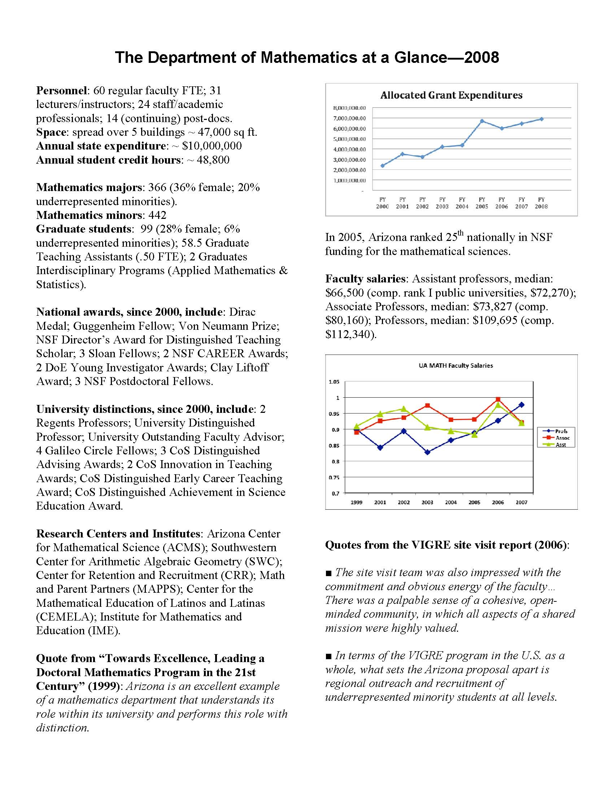
The Department of Mathematics at a Glance - 20

Section B - Overview of Program’s Academic Quality

Grants Since 2000
PI LAST | START DATE | SPONSOR | PROPOSAL_TITLE1 | COPI LAST | DEPT_NAME
THAKUR | 14-Mar-00 | NSA | COMPUTATIONAL CLASSIFICATION WITH ALGEBRAIC PROPERTIES AND DIOPHANTINE APPROXIMATION | THAKUR | MATHEMATICS
MOLONEY | 01-Apr-00 | AFOSR | INTERACTIVE AND LARGE SCALE SUPERCOMPUTING SIMULATIONS IN NONLINEAR OPTICS | MOLONEY | MATHEMATICS
LEGA | 01-Apr-00 | NSF | U.S. FRANCE COOPERATIVE RESEARCH: HYDRO DYNAMICS OF BACTERIAL COLONIES | LEGA | MATHEMATICS
LEVERMORE | 01-Apr-00 | U MN | REACTIVE FLOW AND TRANSPORT PHENOMENA PROGRAM AT THE INSTITUTE FOR MATHEMATICS A | LEVERMORE | MATHEMATICS
KENNEDY | 01-May-00 | NSF | XIII INTERNATIONAL CONGRESS ON MATHEMATICAL PHYSICS, 17-22 JULY 2000, LONDON, UK | FARIS | MATHEMATICS
MOLONEY | 01-Jun-00 | AFOSR | HIGH POWER FEMTOSECOND LASER LIGHT STRINGS | MOLONEY | MATHEMATICS
TOUBASSI | 01-Jun-00 | ABOR | PREPARING THE PREPARERS: HELPING TUCSON'S MATH TEACHERS GEAR UP FOR AIMS | WATKINS | MATHEMATICS
VELEZ | 01-Jul-00 | NSF | CSEMS: COMPUTER SCIENCE, ENGINEERING, & MATHEMATICS SCHOLARSHIPS AT THE U OF AZ | SHOEMAKER | OPTICAL SCIENCES
ULMER | 01-Jul-00 | NSF | ARITHMETICAL ALGEBRAIC GEOMETRY | ULMER | MATHEMATICS
FOTH | 15-Jul-00 | NSF | GEOMETRY AND TOPOLOGY OF MODULI SPACES OF PARABLIC BUNDLES, TORIC VARIETIES, AND | FOTH | MATHEMATICS
LESCH | 15-Jul-00 | NSF | DETERMINANTS, ANALYTIC TORSION AND FUNCTIONAL ANALYTIC MODELS FOR DIRAC OPERATO | LESCH | MATHEMATICS
ZAKHAROV | 01-Aug-00 | NSF | WAVE TURBULENCE: OPEN CHALLENGES AND NEW OPPORTUNITIES | NEWELL | MATHEMATICS
ERCOLANI | 15-Aug-00 | NSF | TOPICS IN PATTERN FORMATION FAR FROM THRESHOLD | ERCOLANI | MATHEMATICS
LEGA | 01-Sep-00 | NSF | ANALYIS AND MODELING OF PATTERN FORMATION IN BIOLOGICAL AND PHYSICS SYSTEMS | LEGA | MATHEMATICS
WANG | 01-Sep-00 | NSF | SOME STUDIES ON NON-UNIFORMLY HYPERBOLIC ATTRACTORS AND THE N-BODY PROBLEM | WANG | MATHEMATICS
ZAKHAROV | 01-Sep-00 | BROWN U | COLLABORATIVE RESEARCH ON HIGH BIT-RATE COMMUNICATION: FROM MATHEMATICAL DEVELOP | ZAKHAROV | MATHEMATICS
MOLONEY | 01-Dec-00 | AFOSR | SEMICONDUCTOR AMPLIFIERS AND LASER WAVELENGTH FROM MICROSCOPIC PHYSICS TO DEVICE | WRIGHT | OPTICAL SCIENCES
TOUBASSI | 01-Jun-01 | ABOR | PREPARING THE PREPARERS: HELPING TUCSON'S MATH TEACHERS GEAR UP FOR AIMS (YR 2) | WATKINS | MATHEMATICS
HU | 15-Jul-01 | NSF | TOPOLOGICAL ASPECTS OF CHOW QUOTIENTS AND MODULI SPACES | HU | MATHEMATICS
LU | 01-Aug-01 | NSF | POISSON STRUCTURES AND LIE THEORY- REVISED BUDGET | LU | MATHEMATICS
MAIER | 15-Aug-01 | NSF | NOISE-INDUCED FLUCTUATIONS IN NONEQUILIBRIUM SYSTEMS | STEIN | PHYSICS
ERCOLANI | 01-Sep-01 | NSF | ITR/AP:OPTIMAL NONLINEAR ESTIMATION IN THE GEOSCIENCES | EYINK | NEUMAN
MOLONEY | 22-Oct-01 | LITE CYCLES | FUNDAMENTAL STUDIES OF SELF-INDUCED WAVEGUIDES IN THE ATMOSPHERE AT VARIOUS WAVE | MOLONEY | MATHEMATICS
WOOD | 01-Nov-01 | CLEMSON U | THE IMPACT OF CALCULUS REFORM ON LONG-TERM STUDENT PERFORMANCE | WOOD | MATHEMATICS
HU | 25-Jan-02 | NSA | PROJECTS IN ALGEBRAIC GEOMETRY | HU | MATHEMATICS
MOLONEY | 15-Mar-02 | NSF | INTERNATIONAL: SPATIAL AND POLARIZATION STATES IN VERTICAL-CAVITY SURFACE-EMITTI | MOLONEY | MATHEMATICS
THAKUR | 28-Mar-02 | NSA | COMPUTATIONAL CLASSIFICATION WITH ALGEBRAIC PROPERTIES AND DIPHANTINE APPROXIMAT | THAKUR | MATHEMATICS
TOUBASSI | 01-Jun-02 | ABOR | TEACHERS HELPING TEACHERS: BRIDGING THE GAP BETWEEN MIDDLE SCHOOL | WATKINS | MATHEMATICS
NEWELL | 01-Jul-02 | NSF | GLOBAL DESCRIPTION OF PATTERNS FAR FROM ONSET | NEWELL | MATHEMATICS
KENNEDY | 01-Jul-02 | NSF | PROBLEMS IN QUANTUM AND CLASSICAL STATISTICAL MECHANICS | KENNEDY | MATHEMATICS
WANG | 01-Jul-02 | NSF | SOME STUDIES ON NON-UNIFORMLY HYPERBOLIC ATTRACTORS AND THE N-BODY PROBLEM | WANG | MATHEMATICS
MOLONEY | 01-Jul-02 | AFOSR | NOVEL DESIGNS AND COUPLING SCHEMES FOR AFFORDABLE HIGH ENERGY LASER MODULES | MOLONEY | MATHEMATICS
FOTH | 01-Aug-02 | NSF | WORKSHOP: GEOMETRY AND TOPOLOGY OF QUOTIENTS, DECEMBER 5-8, 2002, TUCSON, ARIZONA | LU | MATHEMATICS
BHATTACHARYA | 01-Aug-02 | NSF | COLLABORATIVE RESEARCH: STOCHASTIC AND MULTISCALE STRUCTURE ASSOCIATED WITH THE | BHATTACHARYA | MATHEMATICS
RESTREPO | 15-Aug-02 | DOE | PARTICLE AND BLOOD CELL DYNAMICS IN OSCILLATORY FLOWS | RESTREPO | MATHEMATICS
ULMER | 01-Sep-02 | NSF | SOUTHWESTERN CENTER FOR ARITHMETICAL ALGEBRAIC GEOMETRY | ULMER | MATHEMATICS
CUSHING | 01-Sep-02 | NSF | QEIB: STOCHASTIC NONLINEAR POPULATION DYNAMICS: MATHEMATICAL MODELS, BIOLOGICAL | COSTANTINO | ECOL & EVOL BIOLOGY
GAY | 04-Dec-02 | ABOR | MATH EDUCATION MEETING [AT CONFERENCE: MATHEMATICS EDUCATION AND MATHEMATICS | GAY | MATHEMATICS
BRIO | 01-Jan-03 | NSF | OPTICAL BEAMS AND SHORT PULSES IN NONLINEAR MEDIA AND IN NONLINEAR PERIODIC | BRIO | MATHEMATICS
MOLONEY | 01-Jan-03 | AFOSR | COMPUTATIONAL NONLINEAR OPTICS: FEMTO ATMOSPHERIC LIGHT STRING APPLICATIONS | WRIGHT | OPTICAL SCIENCES
MOLONEY | 15-Apr-03 | IONATRON | FEMTOSECOND PULSE PROPAGATION CHARACTERISTICS | MOLONEY | MATHEMATICS
LEGA | 01-Jul-03 | NSF | YOUNG US-BASED MATHEMATICIANS AT THE FIELDS INSTITUTE SPECIAL YEAR | LEGA | MATHEMATICS
PINSON | 01-Jul-03 | NSF | STATISTICAL MECHANICS AND RANDOM MATRIX THEORY | PINSON | MATHEMATICS
GORIELY | 15-Jul-03 | NSF | INSTABILITIES, WAVES, AND GROWTH IN THE DYNAMICS OF FILAMENTS | TABOR | COMM APPLIED MATH
KUNYANSKY | 15-Jul-03 | NSF | DEVELOPMENT OF EFFICIENT ALGORITHMS FOR COMUTATIONAL ELECTROMAGNETISM AND COMPU | KUNYANSKY | MATHEMATICS
LUX | 15-Jul-03 | NSF | COMPUTATIONAL METHODS IN MODULAR REPRESENTATION THEORY | LUX | MATHEMATICS
KUNYANSKY | 01-Sep-03 | DOE | ASYMPTOTICALLY OPTIMAL HIGH-ORDER ACCURATE ALGORITHMS FOR THE SOLUTION OF CE | KUNYANSKY | MATHEMATICS
RESTREPO | 01-Sep-03 | NSF | COLLABORATIVE RESEARCH: MATHEMATICAL THEORY AND MODELING OF WAVE CURRENT INTERACTION | RESTREPO | MATHEMATICS
MOLONEY | 01-Oct-03 | NSF | NOVEL PASSIVE AND ACTIVE PHOTONIC CRYSTAL AND HIGH INDEX-CONTRAST STRUCTURES | PEYGHAMBARIAN | OPTICAL SCIENCES
MOLONEY | 13-Oct-03 | NP PHOT | DEVELOPMENT OF PREFORM DRILLING TECHNIQUES | PEYGHAMBARIAN | OPTICAL SCIENCES
WILES | 01-Jan-04 | ABOR | LEARNER-CENTERED MATHEMATICS EDUCATION FOR PRE-SERVICE TEACHERS | MCGRAW | MATHEMATICS
BRIO | 15-Jan-04 | NSF | COLLABORATIVE RESEARCH ITR: AN INTEGRATED SIMULATION ENVIRONMENT | BRIO | MATHEMATICS
VELEZ | 15-Jan-04 | ASU | MINORITY MATH UG MAJORS TRAVEL | VELEZ | MATHEMATICS
NEWELL | 01-Feb-04 | AFOSR | COMMUNICATION WITH HYPERSONIC VEHICLES VIA NONLINEAR PLASMA PROCESSES | ZAKHAROV | MATHEMATICS
MOLONEY | 04-Feb-04 | NP PHOT | DEVELOPMENT OF PREFORM DRILLING TECHNIQUES | PEYGHAMBARIAN | OPTICAL SCIENCES
THAKUR | 05-Feb-04 | NSA | MULTIZETA VALUES, COMPUTATIONAL HEIRARCHY, AND DIOPHANTINE APPROXIMATION | THAKUR | MATHEMATICS
MOLONEY | 01-Apr-04 | AFOSR | FUNDAMENTAL MODELING AND DESIGN STRATEGIES IN COMPUTATIONALPHOTO | BRIO | MATHEMATICS
ERCOLANI | 01-May-04 | NSF | PROGRAM IN NONLINEAR WAVES, KINETIC THEORY AND HAMILTONIAN PARTIAL DIFFERENTIAL | ERCOLANI | MATHEMATICS
MOLONEY | 01-May-04 | AFOSR | SCALABLE SHARED MEMORY SUPERCOMPUTER REPLACEMENT FOR DOD RESEARCH (DURIP) | MOLONEY | MATHEMATICS
ULMER | 01-Jul-04 | NSF | ARITHMETIC ALGEBRAIC GEOMETRY | ULMER | MATHEMATICS
ERCOLANI | 01-Jul-04 | NSF | ASYMPTOTIC ANALYSIS VARIATIONAL AND HAMILTONIAN PDES | ERCOLANI | MATHEMATICS
VELEZ | 01-Jul-04 | ASU | MINORITY MATH UG MAJORS AT AMUC CONF NOV 2004 | VELEZ | MATHEMATICS
VELEZ | 01-Jul-04 | NSA | ARIZONA MATHEMATICS UNDERGRADUATE CONFERENCE - FALL 2004 | VELEZ | MATHEMATICS
MCLAUGHLIN | 01-Jul-04 | NSF | FRG: COLLABORATIVE RESEARCH IN SEMICLASSICAL ASYMPTOTIC QUESTION | MCLAUGHLIN | MATHEMATICS
VELEZ | 01-Jul-04 | CASH MISC | PROGRAM INCOME FOR ARIZONA MATHEMATICS UNDERGRADUATE CONFERENCE | VELEZ | MATHEMATICS
LEGA | 15-Jul-04 | NSF | CURRENT PROBLEMS IN NONLINEAR DYNAMICS: MACROSCOPIC MODELING OFM | LEGA | MATHEMATICS
FOTH | 01-Aug-04 | NSF | WORKSHOP ON GEOMETRY AND REPRESENTATION THEORY | JOSHI | MATHEMATICS
GLASNER | 01-Aug-04 | NSF | STUDIES IN SMALL SCALE FLUID FLOWS | GLASNER | MATHEMATICS
CIVIL | 01-Aug-04 | NSF | CENTER FOR THE MATHEMATIS EDUCATION OF LATINOS/AS (CEMELA) | MOLL | EDUC, DEAN'S OFFICE
BHATTACHARYA | 01-Sep-04 | NSF | COLLABORATIVE RESEARCH: STATISTICAL ANALYSIS ON MANIFOLDS: A NON | BHATTACHARYA | MATHEMATICS
CUSHING | 01-Sep-04 | NSF | COMPETITIVE COEXISTENCE AND LIFE CYCLE STAGES | COSTANTINO | ECOL & EVOL BIOLOGY
NEWELL | 01-Sep-04 | NSF | WAVE TURBULENCE: A WEALTH OF APPLICATIONS AND A RICH PARADIGMFOR | ZAKHAROV | MATHEMATICS
VENKATARAMANI | 01-Sep-04 | NSF | CAREER: SINGULARITIES AND MICROSTRUCTURE - MULTIPLE SCALEANALYSI | VENKATARAMANI | MATHEMATICS
MOLONEY | 20-Sep-04 | NP PHOT | NP PHOTONICS: PREFORM DRILLING TECHNIQUES | PEYGHAMBARIAN | OPTICAL SCIENCES
WOJTKOWSKI | 01-Nov-04 | NSF | GEOMETRIC & PHSYICAL ASPECTS OF HYPERBOLIC DYNAMICS | WOJTKOWSKI | MATHEMATICS
HU | 18-Nov-04 | NSA | PROJECTS ON QUOTIENTS AND MODULI SPACES | HU | MATHEMATICS
MCGRAW | 01-Jun-05 | U PITT | SCALING UP MATHEMATICS: THE INTERFACE OF CURRICULA WITH HUMAN AN | MCGRAW | MATHEMATICS
KIM | 01-Jul-05 | NSF | MOTIVIC FUNDAMENTAL GROUPS, MULTIPLE POLYLOGARITHMS, AND DIOPHANTINE GEOMETRY | KIM | MATHEMATICS
WANG | 01-Jul-05 | NSF | SOME STUDIES ON THE RANK ONE ATTRACTORS AND THE N-BODY PROBLEM | WANG | MATHEMATICS
KENNEDY | 01-Jul-05 | NSF | MATHEMATICAL PROBLEMS FROM STATISTICAL MECHANICS | KENNEDY | MATHEMATICS
MCCALLUM | 01-Jul-05 | NSF | JOINT ANALYSIS OF SCHOOL MATHEMATICS PROBLEMS. A NATIONAL NOVEL FOR COLLABORATION | MCCALLUM | MATHEMATICS
LOMEN | 01-Jul-05 | U/P. RICO | FULL DEVELOPMENT OF VISUALIZATION TOOLS FOR 3-D | LOMEN | MATHEMATICS
NEWELL | 01-Jul-05 | NSF | PATTERNS IN NATURE AND IN THE LABORATORY | NEWELL | MATHEMATICS
GABITOV | 15-Jul-05 | NSF | NEGATIVE REFRACTION INDEX | INDIK | MATHEMATICS
VENKATARAMANI | 01-Oct-05 | US/ISREL BSF | INDUCIBLE SHAPE TRANSFORMATIONS IN THIN ELASTIC SHEETS | VENKATARAMANI | MATHEMATICS
ALAYONT | 01-Jan-06 | AWM | SONIA KOVALEVSKY HIGH SCHOOL MATHEMATICS DAY | BERGER | MATHEMATICS
MCGRAW | 01-Apr-06 | TUSD | TEACHER IMPROVEMENT THROUGH MATH EDUCATION (TIME I) | MCGRAW | MATHEMATICS
SAVITT | 01-Jul-06 | NSF | SOUTHWEST CENTER FOR ARITHMETIC GEOMETRY | THAKUR | MATHEMATICS
KENNEDY | 01-Jul-06 | NSF | MACROSCOPIC PROPERTIES OF QUANTUM MECHANICAL SYSTEMS | UELTSCHI | MATHEMATICS
BERGER | 01-Aug-06 | AWM | SONIA KOVALEVSKY HIGH SCHOOL MATHEMATICS DAYS | ARPIN | MATHEMATICS
SAVITT | 01-Sep-06 | NSF | P-ADIC AND MOD P GALOIS REPRESENTATIONS AND GENERALIZED BREUIL-MEZARD CONJECTURES | SAVITT | MATHEMATICS
MADDEN | 01-Sep-06 | NSF | ARIZONA TEACHER INSTITUTE | MCCALLUM | MATHEMATICS
GABITOV | 01-Sep-06 | PURDUE | OPTICAL MATERIALS WITH NEGATIVE INDEX | GABITOV | MATHEMATICS
CIVIL | 01-Sep-06 | MSU | THE CENTER FOR LEARNING AND TEACHING IN THE WEST CLTW PROJECT | CIVIL | MATHEMATICS
ULMER | 15-Sep-06 | NSF | ENHANCING THE MATHEMATICAL SCIENCES WORKFORCE (EMSW21-VIGRE) | ERCOLANI | MATHEMATICS
CHOI | 01-Oct-06 | NSF | PARTIAL DIFFERENTIAL EQUATIONS AND HARMONIC ANALYSIS | CHOI | MATHEMATICS
GAY | 02-Oct-06 | YPP | BUILDING DEMAND FOR MATH LITERACY | GAY | MATHEMATICS
MOLONEY | 01-Nov-06 | AFOSR | ULTRASHORT INTENSE PULSE PROPAGATOR APPLICATIONS; FEMTO | MOLONEY | MATHEMATICS
WEHR | 01-Jan-07 | NSF | DISORDERED ATOMIC LATTICE GASES AND QUANTUM INFORMATION | RUIZ | SCIENCE ADMIN
GORIELY | 01-Jan-07 | NSF | ONE YEAR AT BIO5: MATHEMATICAL MODELING OF VASCULAR SYSTEMS, ANGIOGENESIS, AND T | TOLBERT | COMM APPLIED MATH
MCGRAW | 01-Feb-07 | TUSD | TEACHER IMPROVEMENT THROUGH MATH EDUCATION (TIME II) | MCGRAW | MATHEMATICS
FOTH | 15-Mar-07 | NSF | WORKSHOP ON ANALYSIS ON HOMOGENEOUS SPACES | JOSHI | MATHEMATICS
SAVITT | 01-Apr-07 | MAA | TENSOR-SUMMA PROGRAM: STRENGTHENING UNDERREPRESENTED MINORITY MATHEMATICS ACHIEVEMENT | VELEZ | MATHEMATICS
MCCALLUM | 01-Jun-07 | NSF | COLLABORATIVE PROPOSAL: SUMMER SCHOOL ON IWASAWA THEORY | MCCALLUM | MATHEMATICS
ULMER | 01-Jul-07 | NSF | ARITHMETICAL ALGEBRAIC GEOMETRY | ULMER | MATHEMATICS
SUIDAN | 01-Jul-07 | NSF | LARGE SCALE RANDOM SYSTEMS: STOCHASTIC PARTIAL DIFFERENTIAL EQUATIONS | SUIDAN | MATHEMATICS
MOLONEY | 15-Aug-07 | AFOSR | HIGH POWER LASER USING OPTICALLY PUMPED SEMICONDUCTOR LASER(OPSL) | MOLONEY | MATHEMATICS
ULMER | 01-Sep-07 | NSF | INCREASING THE NUMBER OF HIGHLY QUALIFIED MATHEMATICAL SCIENTISTS | TABOR | COMM APPLIED MATH
RESTREPO | 01-Sep-07 | NSF | CMG COLLABORATIVE RESEARCH: WAVE BREAKING DISSAPATION MODELING AND PARAMETRIZATION | RESTREPO | MATHEMATICS
ERCOLANI | 01-Sep-07 | NSF | CONFERENCE ON MATHEMATICAL MODELING AND ANALYSIS OF POPULATIONSI | ERCOLANI | MATHEMATICS
SIMONSEN | 01-Jan-08 | ABOR | USING DISTANCE LEARNING TO EXTEND MATHEMATICS OUTREACH TO RURAL TEACHERS | SIMONSEN | MATHEMATICS
ROBERTSON | 12-Mar-08 | AWM | SONIA KOVALEVSKY HIGH SCHOOL GIRLS WORKSHOP | ROBERTSON | MATHEMATICS
HU | 19-Mar-08 | NSA | PROJECTS IN ALGEBRAIC GEOMETRY | HU | MATHEMATICS
SAVITT | 01-Apr-08 | MAA | TENSOR-SUMMA PROGRAM: STRENGTHENING UNDERREPRESENTED MINORITY MATHEMATICS ACHIEVEMENT | VELEZ | MATHEMATICS
MCLAUGHLIN | 15-Apr-08 | NSF | UNIVERSALITY IN RANDOM MATRICES AND INTEGRABLE SYSTEMS: ASYMPTOTIC ANALYSIS VIA RIEMANN-HILBERT AND D-BAR METHODS | MCLAUGHLIN | MATHEMATICS
GLICKENSTEIN | 01-May-08 | NSF | CAREER: DISCRETE AND GENERALIZED RIEMANNIAN GEOMETRY ANDCURVATUR | GLICKENSTEIN | MATHEMATICS
THAKUR | 19-May-08 | NSA | IHARA POWER SERIES, MULTIZETA VALUES, AND RELATED STRUCTURES INFUNCTION FIELD | THAKUR | MATHEMATICS
RESTREPO | 19-May-08 | UCLA/NSF | COLLABORATIVE RESEARCH: CMG: MATHEMATICAL THEORY AND MODELING OF WAVE-CURRENT | RESTREPO | MATHEMATICS
VENKATARAMANI | 15-Jun-08 | NSF | DEVELOPING ROBUST TECHNIQUES FOR THE ANALYSIS OF MULTIPLE-SCALE BEHAVIORS | VENKATARAMANI | MATHEMATICS
WANG | 01-Jul-08 | NSF | RETURN MAPS IN EXTENDED PHASE SPACE FOR NON-AUTONOMOUSLY PERTURBED EQUATIONS | WANG | MATHEMATICS
BHATTACHARYA | 01-Jul-08 | NSF | COLLABORATIVE RESEARCH: NONPARAMETRIC THEORY ON MANIFOLDS OF SHAPES AND IMAGES | BHATTACHARYA | MATHEMATICS
GLASNER | 01-Jul-08 | NSF | LARGE SCALE INTERFACE DYNAMICS OF ENERGY-DRIVEN CONDENSED MATTER SYSTEMS | GLASNER | MATHEMATICS
FATKULLIN | 15-Aug-08 | NSF | ANALYTICAL STUDY OF LIQUID-CRYSTALLINE PATTERNS AND PHASE TRANSITIONS | FATKULLIN | MATHEMATICS
STEPANOV | 01-Sep-08 | NSF | ASYMPOTOTIC PERFORMANCE OF ERROR CORRECTING CODES | STEPANOV | MATHEMATICS
NEWELL | 01-Sep-08 | NSF | WAVE TURBULENCE: COMPUTATIONAL AND THEORETICAL INVESTIGATIONS | ZAKHAROV | MATHEMATICS
MCGRAW | 01-Sep-08 | NSF | R&D: UNTANGLING MATHEMATICAL KNOTSS | MCGRAW | MATHEMATICS
ERCOLANI | 15-Sep-08 | NSF | VARIATIONAL THEORIES FOR DEFECTS AND PATTERNS | ERCOLANI | MATHEMATICS
SUIDAN | 16-Sep-08 | SLOAN FND | ALFRED P. SLOAN RESEARCH FOR DR. TOUFIC MUBADDA SUIDAN IN MATHEMATICS | SUIDAN | MATHEMATICS
MCGRAW | 01-Oct-08 | TUSD | TEACHER IMPROVEMENT THROUGH MATH EDUCATION (TIME III) | MCGRAW | MATHEMATICS

Faculty Buy-In
Name | Manage  VIGRE | Thesis | RTG | Core Crse | Grad Comm | Prop Comm | Quals | UTA* | URA/Und Res* | Postd mentor | TA Trng | ASP | Participated?
Bayly |  |  |  |  |  |  |  |  |  |  |  |  | 0
Bhattacharya |  | 1 |  | 1 |  |  |  |  |  |  |  |  | 1
Brio |  |  |  |  | 1 |  | 1 | 1 |  | 1 |  | 1 | 1
Castravet |  |  |  | 1 |  |  |  |  |  |  |  |  | 1
Choi |  |  |  |  |  |  |  |  |  |  |  |  | 0
Civil | 1 | 1 |  |  | 1 |  |  |  |  |  |  |  | 1
Conway |  |  |  |  |  |  |  |  |  |  |  |  | 0
Cushing |  | 1 |  |  |  |  |  |  |  |  |  |  | 1
Ercolani | 1 | 1 |  |  |  |  |  |  |  | 1 |  |  | 1
Faris |  | 1 |  | 1 |  |  |  |  |  |  |  |  | 1
Fatkullin |  |  |  |  |  |  |  |  |  |  |  |  | 0
Flaschka |  | 1 |  |  | 1 |  | 1 |  |  |  |  |  | 1
Foth |  | 1 |  |  |  |  |  |  |  |  |  |  | 1
Friedlander |  |  |  |  |  |  |  |  |  |  |  |  | 0
Gabitov | 1 | 1 |  |  |  |  |  |  |  |  |  |  | 1
Glasner |  | 1 |  |  | 1 |  |  |  |  |  |  |  | 1
Glickenstein |  | 1 |  |  |  |  |  | 1 |  | 1 |  | 1 | 1
Goriely |  | 1 |  |  | 1 |  | 1 |  |  | 1 | 1 |  | 1
Hamara |  |  |  |  |  |  |  |  |  |  |  |  | 0
Horak |  | 1 |  |  |  |  |  |  |  |  |  |  | 1
Hu |  | 1 |  |  |  |  |  |  |  |  |  |  | 1
Hughes Hallett |  |  |  |  |  |  |  |  |  |  |  |  | 0
Indik | 1 |  |  | 1 |  |  | 1 |  | 1 |  |  |  | 1
Joshi |  | 1 |  | 1 | 1 |  |  |  |  |  |  |  | 1
Kennedy |  | 1 | 1 |  | 1 |  | 1 |  | 1 |  |  |  | 1
Kunyansky |  |  |  |  | 1 |  | 1 |  |  |  |  |  | 1
Laetsch | 1 |  |  |  |  |  |  |  |  |  | 1 |  | 1
Lega | 1 | 1 |  |  |  |  |  |  |  | 1 |  |  | 1
Lin |  |  | 1 |  |  |  |  |  |  |  |  |  | 1
Lomen | 1 |  |  |  |  |  |  |  |  |  |  |  | 1
Lux |  | 1 | 1 |  | 1 |  |  |  | 1 |  |  | 1 | 1
Madden |  |  |  |  |  |  |  | 1 |  |  |  |  | 1
Maier |  |  |  |  |  |  |  |  |  |  |  |  | 0
McCallum | 1 | 1 |  |  |  |  |  |  |  | 1 |  |  | 1
McGraw |  | 1 |  |  |  |  |  |  | 1 |  |  |  | 1
McLaughlin |  | 1 |  |  | 1 |  | 1 |  | 1 | 1 | 1 |  | 1
Moloney |  |  | 1 |  |  |  |  |  |  |  |  |  | 1
Newell |  | 1 |  |  |  |  |  |  |  |  |  |  | 1
Palmer |  | 1 | 1 |  |  | 1 |  |  |  |  |  |  | 1
Peng |  |  |  |  |  |  |  |  |  |  |  |  | 0
Pickrell |  | 1 | 1 | 1 |  |  | 1 |  |  |  |  |  | 1
Piegorsch |  | 1 |  | 1 |  |  |  |  |  |  |  |  | 1
Pinson |  |  |  |  |  |  |  |  |  |  |  |  | 0
Pomeau |  |  |  |  |  |  |  |  |  |  |  |  | 0
Restrepo | 1 | 1 |  |  |  |  | 1 |  |  | 1 |  |  | 1
Rychlik |  |  |  |  |  |  |  |  |  |  |  |  | 0
Savitt |  | 1 | 1 |  |  |  | 1 | 1 |  |  |  |  | 1
Shaked |  |  |  |  |  |  |  |  |  |  |  |  | 0
Simonsen |  |  |  |  |  |  |  |  |  |  |  |  | 0
Sims |  |  |  |  |  |  |  |  |  | 1 |  |  | 1
Stepanov |  |  | 1 |  |  |  |  |  |  |  |  |  | 1
Stevenson | 1 |  |  |  |  |  |  |  |  |  |  |  | 1
Suidan |  |  |  |  |  |  |  |  |  |  |  |  | 0
Tabor | 1 | 1 |  |  | 1 | 1 | 1 |  |  | 1 |  |  | 1
Thakur |  |  |  |  |  |  |  | 1 |  | 1 |  |  | 1
Tiep |  |  |  |  |  | 1 |  |  |  |  |  |  | 1
Ulmer | 1 | 1 | 1 |  | 1 | 1 |  |  |  |  |  |  | 1
Velez | 1 |  |  |  |  |  |  | 1 |  |  |  |  | 1
Venkataramani |  |  |  | 1 | 1 | 1 | 1 | 1 |  |  |  |  | 1
Wang |  |  |  |  | 1 |  |  |  |  |  |  |  | 1
Watkins | 1 | 1 | 1 |  |  |  |  |  |  |  |  |  | 1
Wehr |  | 1 | 1 | 1 | 1 |  |  |  |  |  |  |  | 1
Zakharov |  |  |  |  |  |  |  |  |  |  |  |  | 0
 |  |  |  |  |  |  |  |  |  | Total Participated |  |  | 46
 |  |  |  |  |  |  |  |  |  | Percentage Participated |  |  | 73%
 |  |  |  |  |  |  |  |  |  | Average Particip per Faculty Member |  |  | 1.94

*Many other UTA and URA projects were supervised by non-tenure track faculty

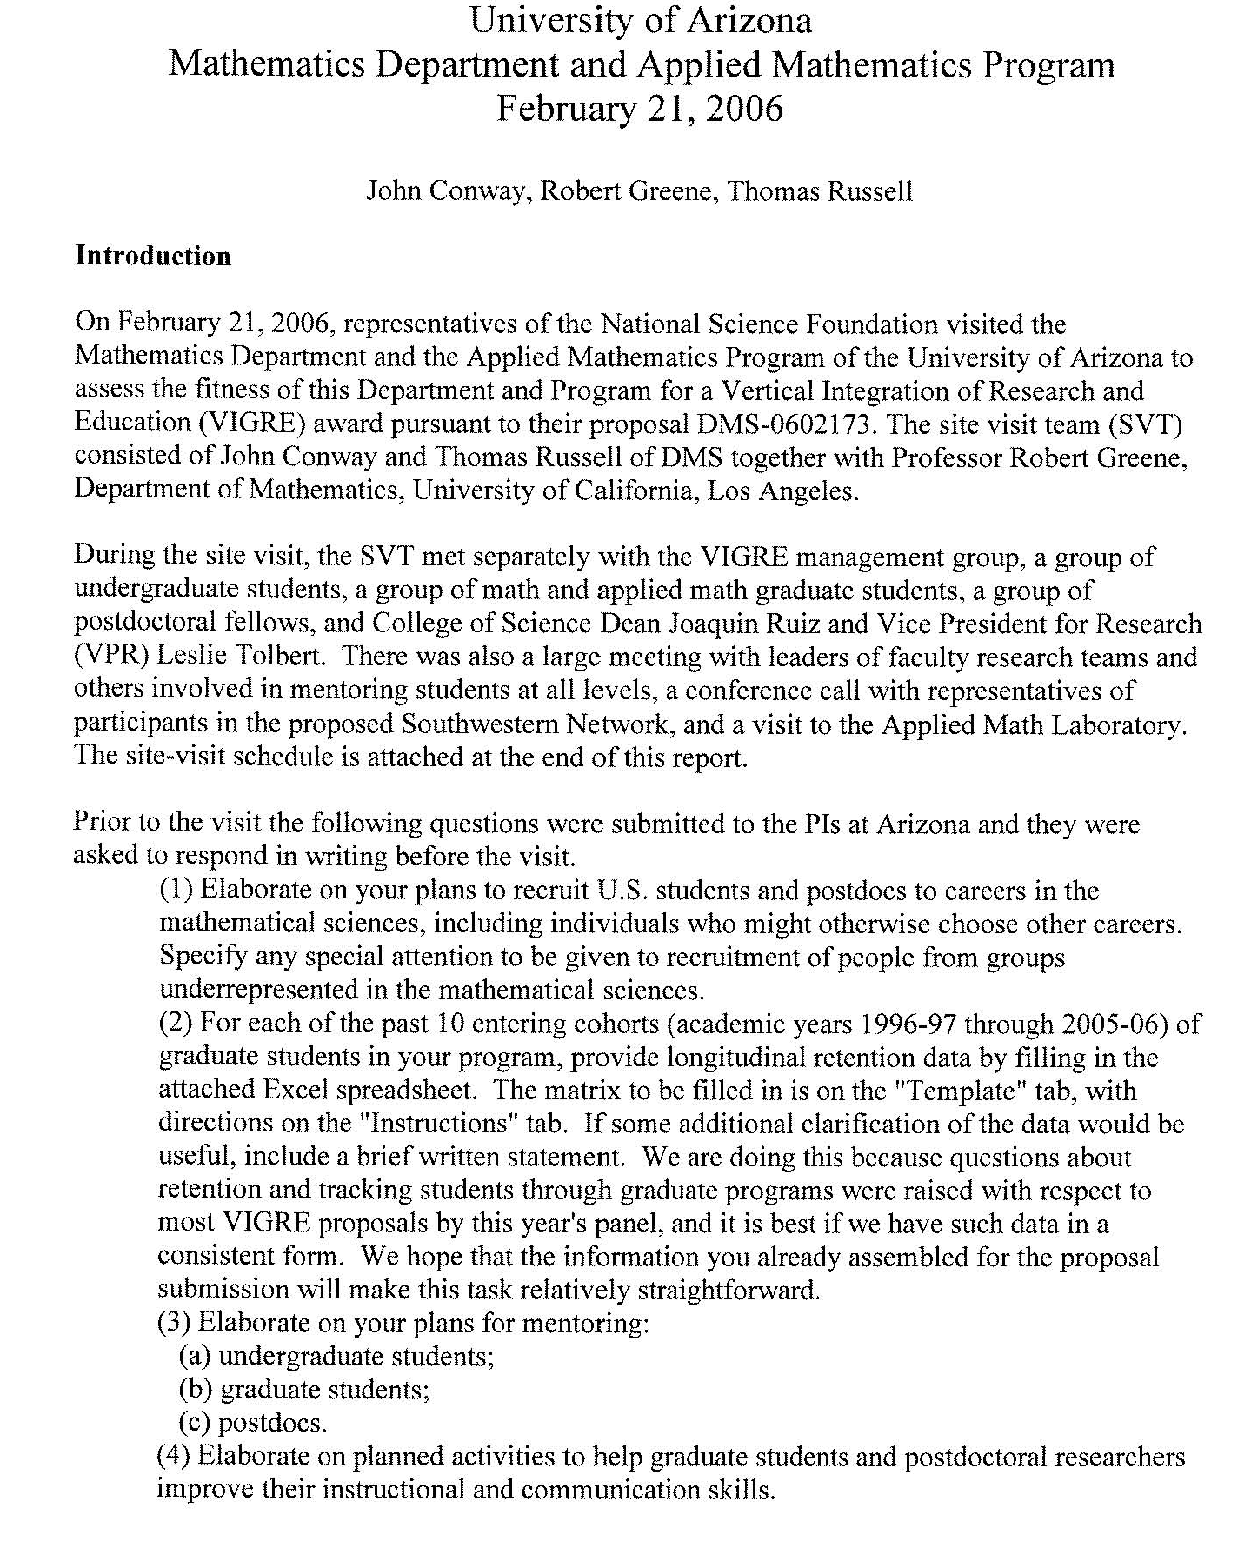
VIGRE Site Visit Report
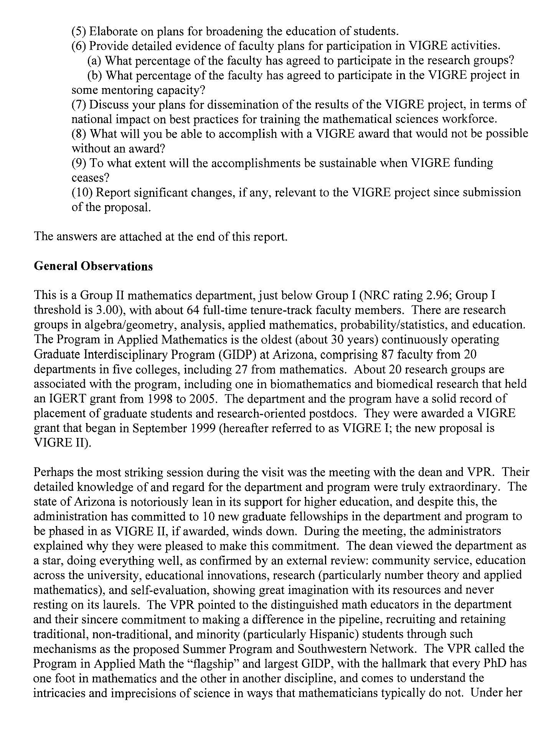
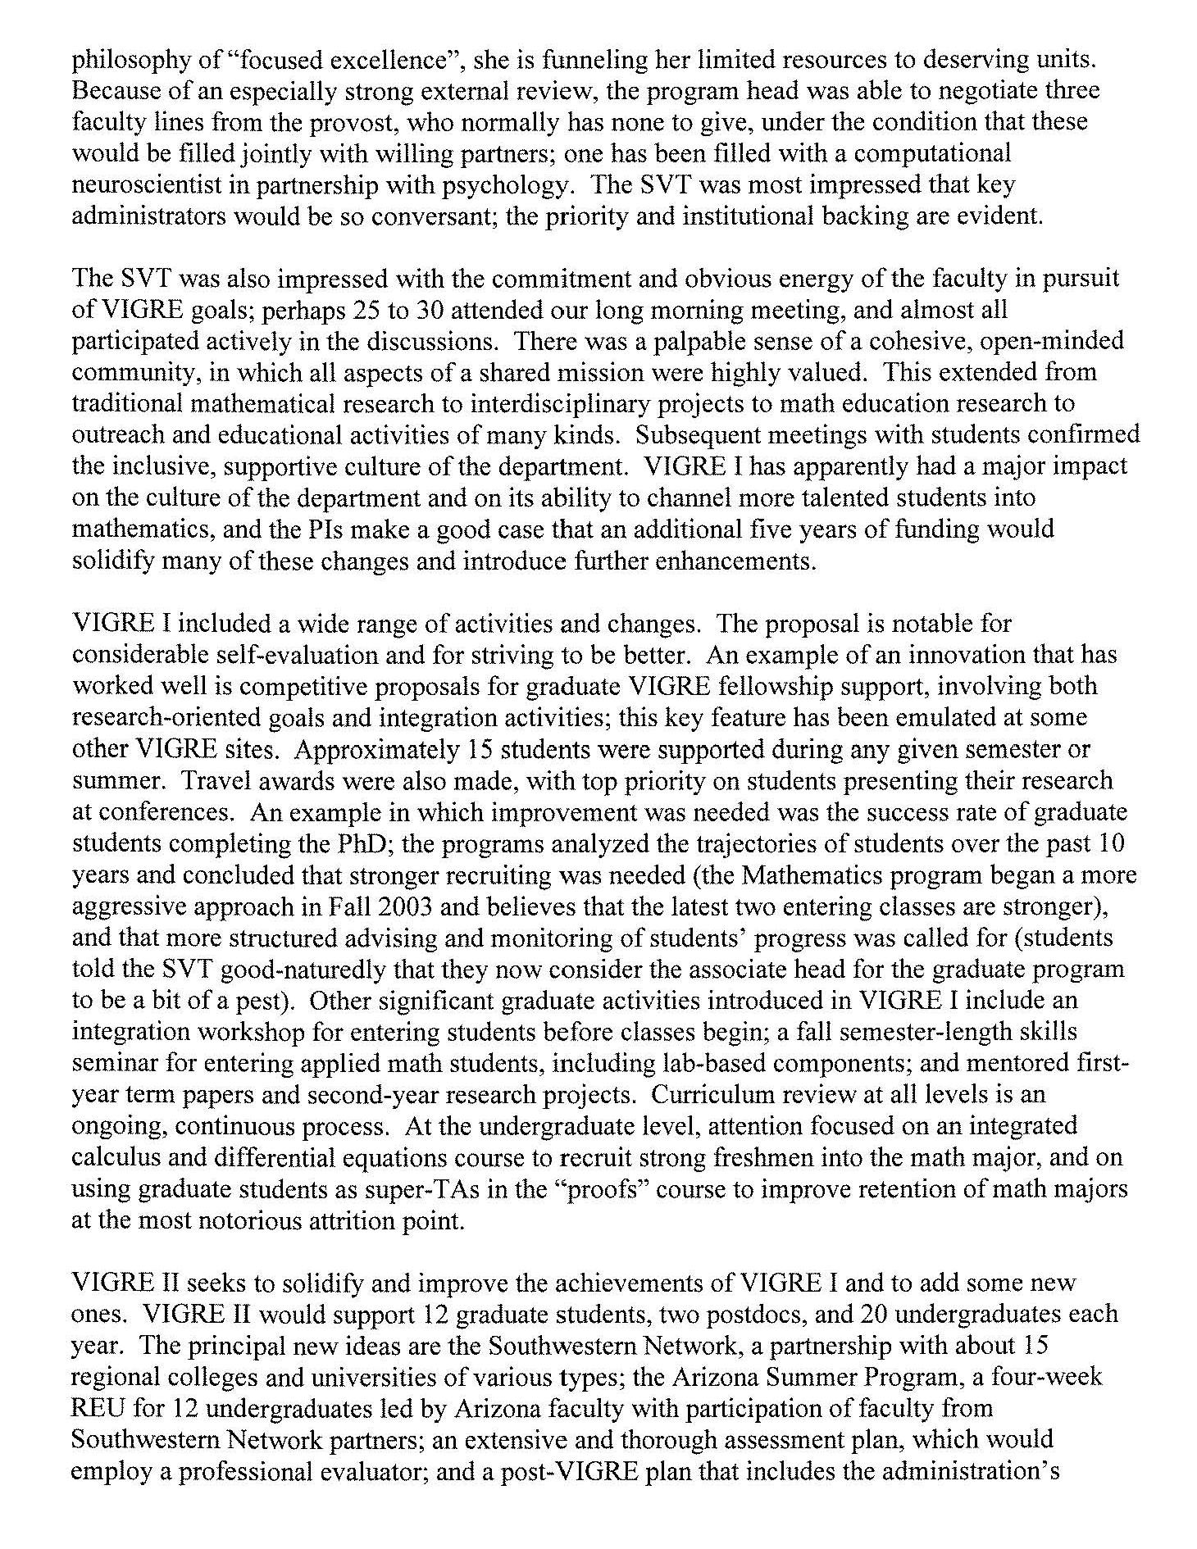
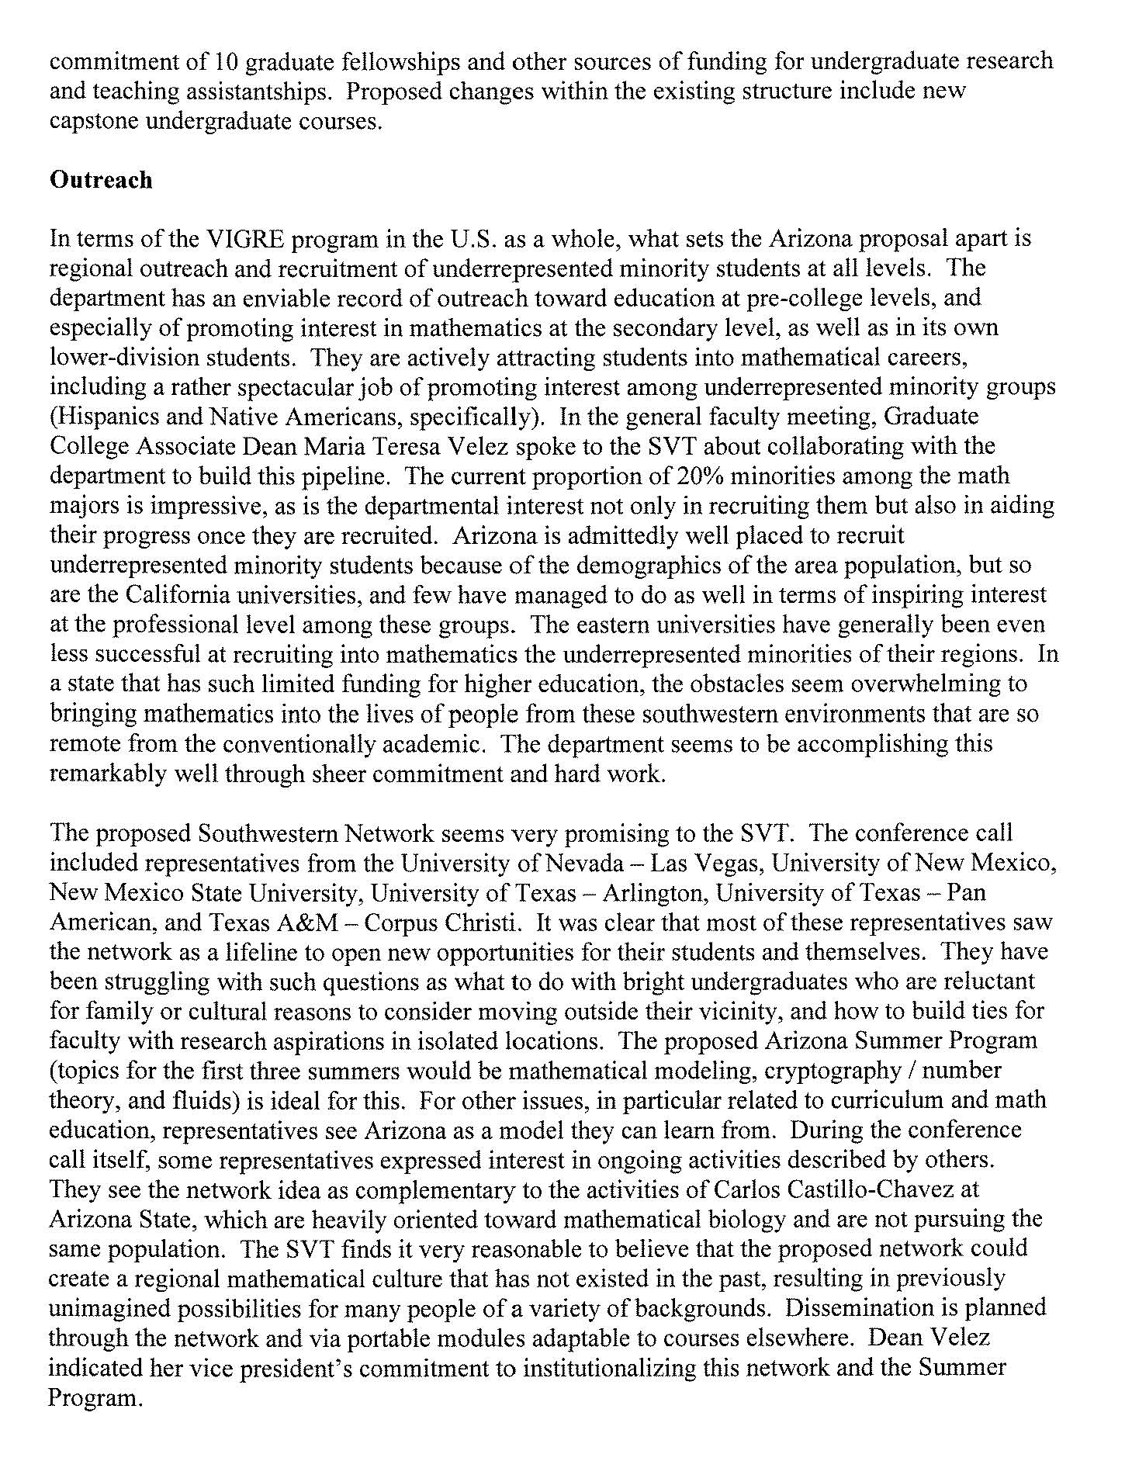
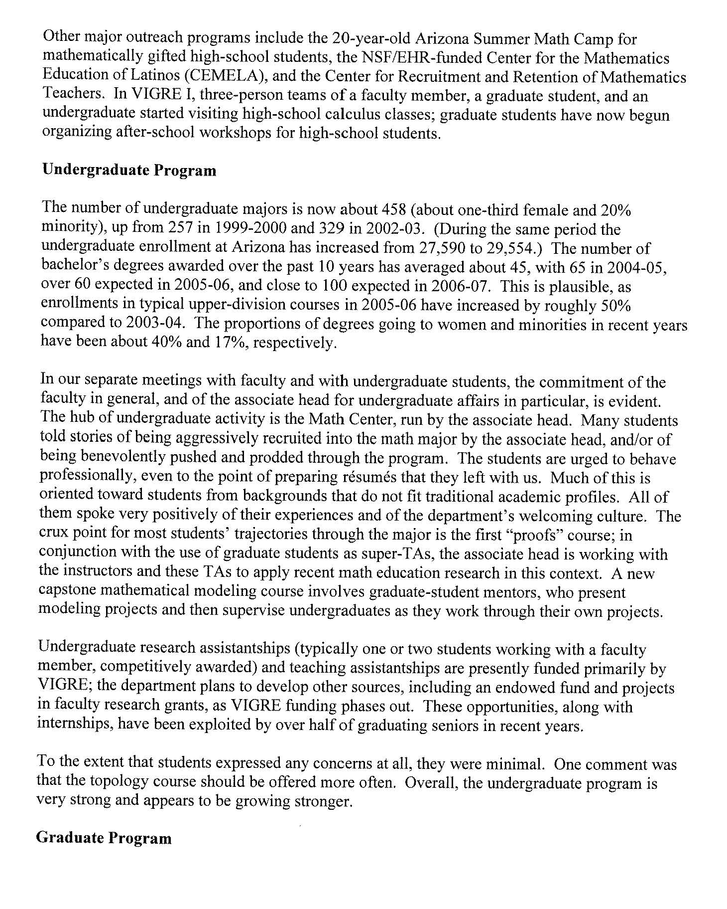

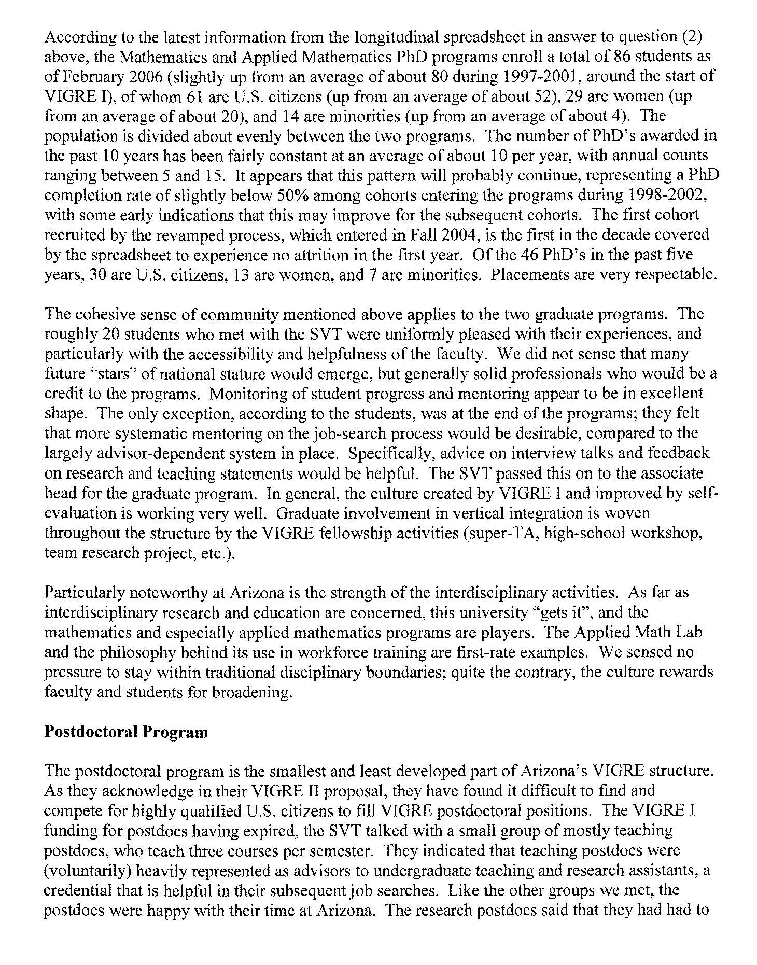

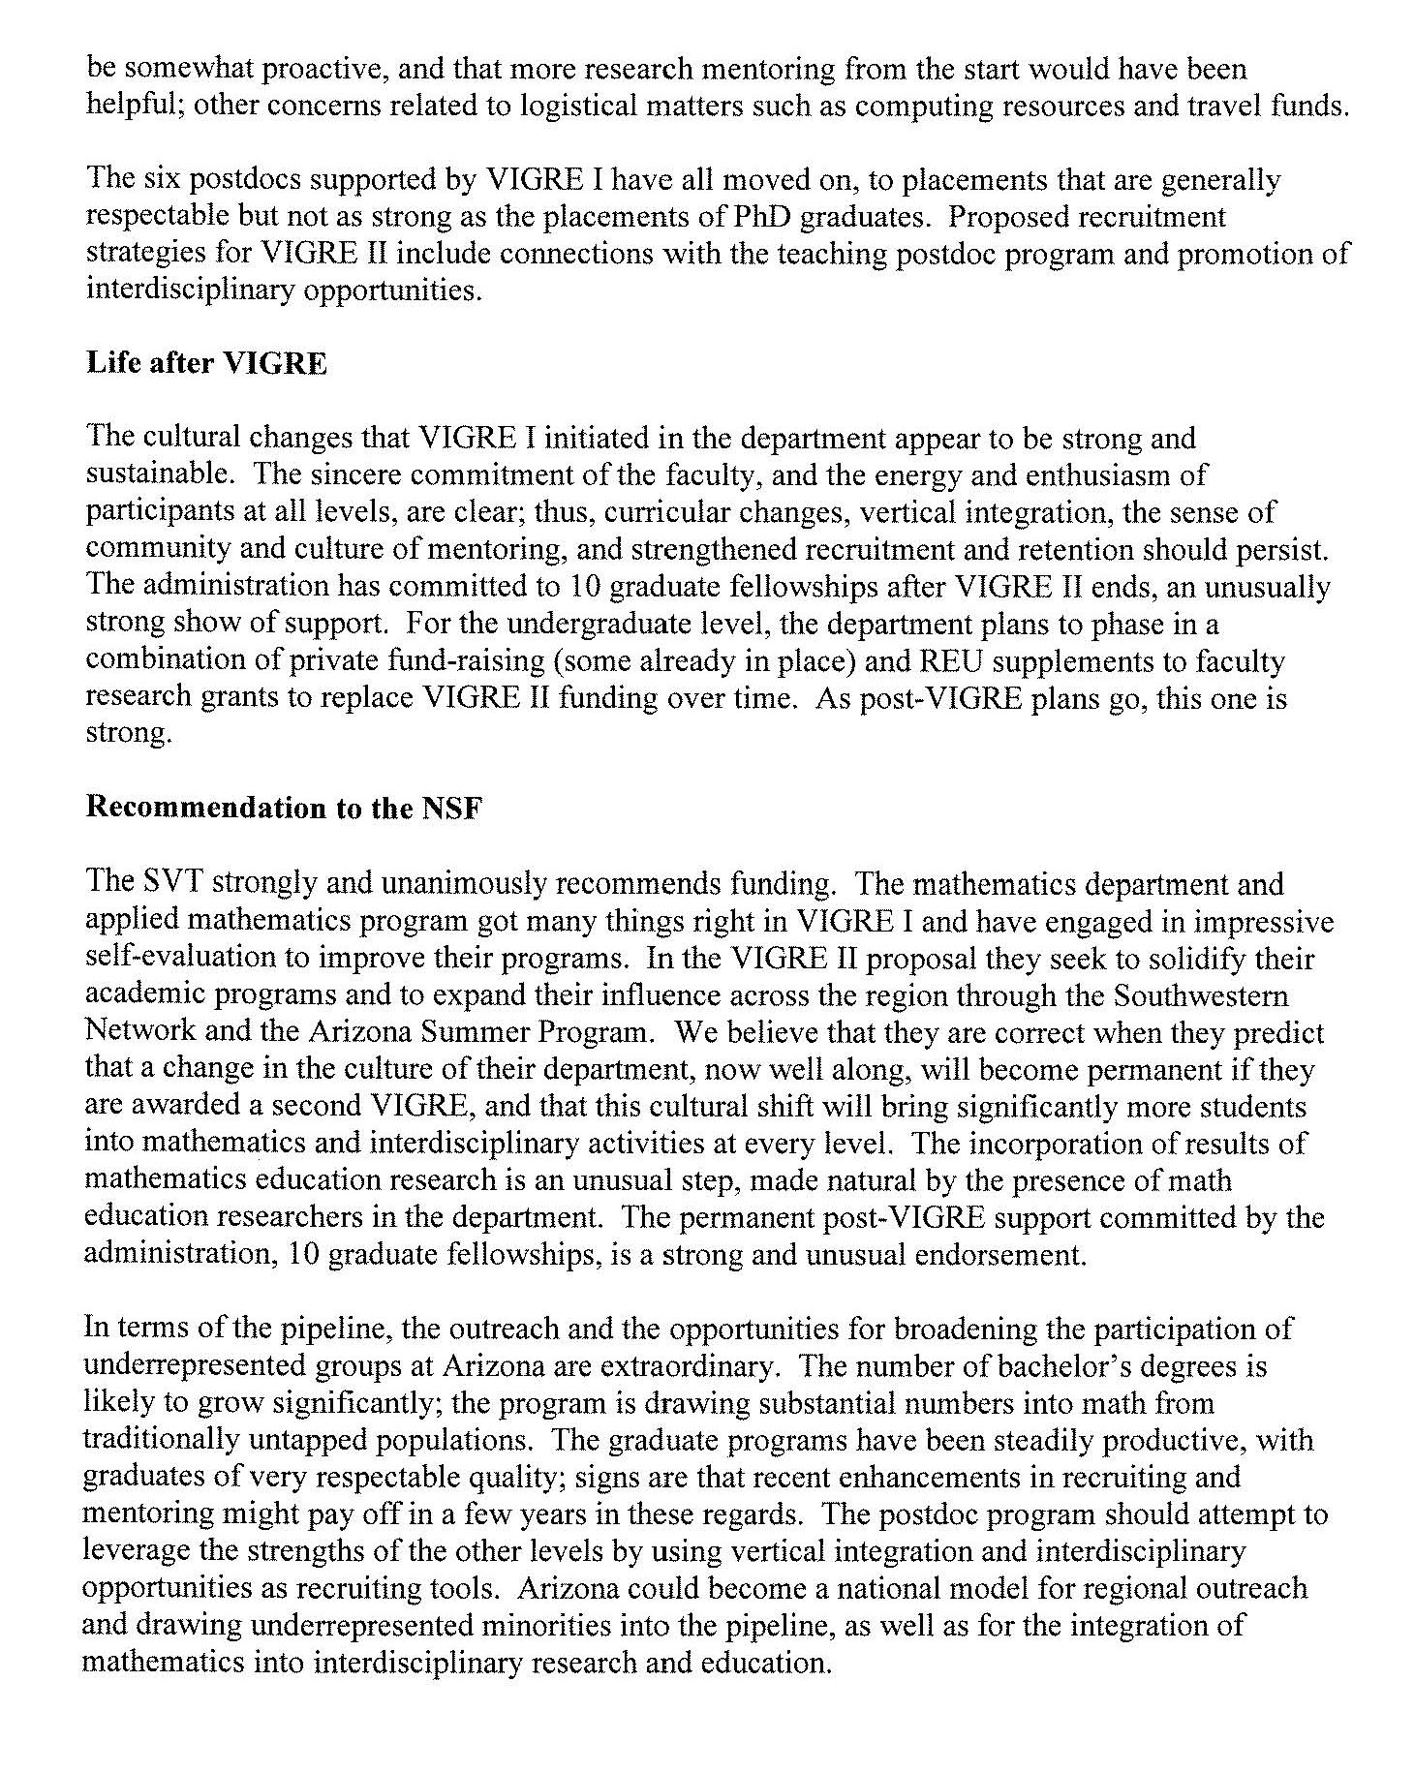

Section C – Program History

Previous External APR Findings & Recommendations

University of Arizona, Department of Mathematics
Visiting Committee Report, March 5-6, 2001

Membership of the Committee.

Ron Askin, Professor and Head, Department of Systems and Industrial Engineering
University of Arizona

Thomas Baldwin, Professor and Head, Department of Biochemistry
University of Arizona

Annalisa Maria Calini, Assistant Professor, Department of Mathematics,
College of Charleston, Charleston, SC

Eric H. Erickson, Professor and Director, Carl Hayden Bee Research Center,
Tucson, AZ

Roger Howe, Professor, Department of Mathematics
Yale University, New Haven, CT

Thomas C. Spencer, Professor, Institute for Advanced Study
Princeton, NJ

B. A. Taylor, Professor and Chair, Department of Mathematics
University of Michigan, Ann Arbor, MI

I. Major findings.

For its energetic combination of teaching, outreach and research, the University of Arizona Department of Mathematics is an exemplary department. It deserves strong praise for substantial accomplishment on lean resources. By any measure, the Department has few organic problems.
Collegiality, among senior faculty, between senior and junior faculty, between faculty, staff and graduate students, is a strong and uniting feature of departmental life. Especially commendable is the strong mutual respect of the pure and applied mathematicians, and of the research mathematicians and mathematics educators. In fact, the relations between these groups extends beyond respect to mutually beneficial interactions. The Department is also notable for the strong interdisciplinary component of its research activities, with ties to many other departments. Dean
Joaquin Ruiz referred to the Department as a “gem", and we concur.

However, the department is under severe stress due to insufficient resources. Low salary levels, tight space, and low and haphazard funding for computer support are threatening the success of the department's efforts. The teaching capacity of the department is stretched to its limits, or perhaps even beyond. In all its main efforts, the Department is suffering from deferred maintenance.

1. Faculty retention and recruitment

The most serious threat to continued intellectual and research excellence is the Department's low salary structure. This provides rich opportunities for competing departments to woo the department's best research personnel, and this has been happening with some regularity. In recent years, the department has lost five of their best faculty and is in grave danger of losing three more who are currently on leave. While salaries for beginning faculty are competitive, the very top salary in the department is only at the 83rd percentile nationally of Group I Public Mathematics Departments, and except for the top 3 professors, all salaries are noticeably below the mean for Group I Public Departments. (This comparison is apt: the Department's most distinguished faculty would merit positions in the top departments nationally.) Without considerable increases in the salaries available, the outlook for maintaining the department's current (considerable) strengths is bleak, and there is no hope of building excellence across a broad spectrum of areas. The salary structure was flagged as a critical issue in the 1992 report of the External Review Committee. We understand that since that time, the University as a whole has undergone some very lean years. The result is that now the situation has reached a critical point, with serious recent faculty losses, and even worse: key faculty members are currently contemplating offers. We note that Dean Ruiz understands the peril posed by the current salary structure, and has already last year provided funds to improve the situation. We hope that this can continue for several more years.

In increasing salaries, there is an issue of how to proceed. To prevent or forestall likely losses of particular individuals, or to attract high quality senior faculty, selected salaries may have to be set considerably higher than the broad departmental range. Creating special Chairs for the most distinguished researchers might be an effective strategy for stabilizing the research leadership of the department. (We see from the Self-Study Report, that there are two University Professors in the Department. However, both these positions are for distinction in teaching.) On the other hand, it is desirable over the long run to reduce potential conflicts due to salary inequality by adjusting the departmental average upward.

Given the Department's heavy teaching duties, and the incompleteness of its coverage of the total range of mathematical research, it would be desirable for the number of faculty in the department to increase. We recognize the difficulty of doing this while also increasing salaries and improving other resources.

2. Infrastructure

A. Space

The department's space problems have been well documented in the Self-Study Report (p. 16-20). Instructional service space has had to be cannibalized to create even minimal offices for graduate teaching assistants and the adjunct faculty. Lack of privacy in current offices makes office hours and similar individualized services difficult to provide. More space, convenient to the main mathematics building, is of high priority. Dean Ruiz indicated to us that he believed he had a solution to the space problem in the form of a storage building adjacent to the current
Mathematics Building. This Committee hopes that this solution can be implemented, and will prove satisfactory to the Department. We suggest that the Department be consulted in the planning of renovations.

B. Computer infrastructure

Problems with resources for computer services have also been well documented in the Self-Study Report. Our main observation is that the nature of computer use has changed totally since the advent of the personal computer in the early 1980s, and dramatically even since the last External Review. From being exotic and expensive research tools, computers have become routine instruments of personal communication, document creation, and instruction delivery. It is time for the University to recognize this transition, and to treat computers as part of infrastructure that it routinely supports. Within this context, the Mathematics Department will probably still present special problems because of its extensive use of computers for both instruction and research. Dean Ruiz has stated that he believes the Department's computer support problems are solvable. We recommend that the Department formulate a plan for creating and maintaining necessary computer infrastructure, and present it to Dean Ruiz. The plan should be formulated by a faculty committee in consultation with Robert Condon (who has shown amazing resourcefulness in patching varied hardware together to create usable systems), and presented by the Head. Presumably, plans for computer clusters should be part and parcel of designing the newly identified Department space.

We observe that computer infrastructure was cited as a serious problem in the 1992 External Review. The recommendations made there seem to have been implemented. The current problems stem from continuing rapid growth of computer use, especially in instruction. An example of this is the Department's new business mathematics course, which depends throughout on Powerpoint and Excel software. This underscores the need for a new overall policy for computer infrastructure. We also remark that a significant investment in new hardware could vastly simplify the maintenance demands of the departmental system, and free up support staff time to meet the
needs of individual staff or faculty users.

C. Teaching Mission

The Arizona Mathematics Department has a remarkably strong and innovative teaching program. Its admirable development of a new business mathematics course continues a tradition of commitment to high quality service courses. Also, it has brought the issue of staffing undergraduate courses to a head. We applaud the Department's policy of teaching all courses in sections of small to moderate size (up to 35). Sizes larger than this significantly reduce opportunities for the kind of direct interaction which promote the changes in thinking patterns entailed in real mathematics learning. However, this format does necessitate a large instructional corps, well beyond the size of the regular faculty. The Department has been highly creative in assembling the required staff, including the co-operative teachers from local high schools and the Adjunct Faculty, and highly successful in molding them into an effective teaching corps. The high level of student satisfaction in the entry level courses is exceptional, and a legitimate source of pride, for the Department and the University. We would be loath to see this jeopardized by wholesale increases in section size. Nevertheless, without this, additional teaching staff seems essential.

Although adding regular faculty is desirable, as noted above, the least expensive means of adding teaching staff would be to expand the Adjunct Faculty. Indeed, we expect that demographic and economic pressures will make the Adjunct Faculty more and more essential to the department's mission. However, just as for retention of senior faculty, recruitment of adjuncts seems to be limited by low salaries. There are other aspects of the Adjunct Faculty positions which decrease their desirability, and which are in the purview of the University. These include the highly provisional status of the job, the need to reapply each year, and so forth. We recommend that the
status of the Adjunct Faculty be regularized by making multi-year contracts standard. Any small surplus in teaching staff due to fluctuations in enrollment could be used to relieve selected regular faculty of teaching on a spot basis. We also recommend that salaries for Adjunct Faculty be increased to a level which will create a sufficient supply.

Beyond the immediate problem of recruitment, the presence of Adjunct Faculty raises other issues internal to the Department; these will be addressed in Part II.

3. National Context

The shortages described above, in salaries, infrastructure and teaching staff, not only adversely affect the Department in all of its missions of research, teaching and outreach, they also have national implications. The American Mathematical Society has recently published the book Towards Excellence, to promote productive policies for mathematics departments during the
coming decade. It begins as follows:
“We have a simple message: To ensure their institution's commitment to excellence
in mathematics research, doctoral departments must pursue excellence in their
instructional program."
Towards Excellence singles out the Department for special praise:
“Arizona is an excellent example of a mathematics department that understands
its role within its university and performs this role with distinction. "
Unfortunately, the implicit quid pro quo, that being a good university citizen will guarantee the resources a department needs to pursue a strong research program, is not currently operating at the
University of Arizona. If this situation persists, it could be used by skeptics to vitiate the argument of Towards Excellence, and undermine the movement nationally towards increased recognition for the teaching mission.

II. Additional findings.

The Department spent much effort in preparing a thorough APR self-study report. They have well identified the successes and challenges facing it. They have established good
goals and priorities (see Appendix I, p. 97). There is no need for us to repeat these points. However, in addition to the major points enunciated in Section I, we add a few comments organized according to the format of the self-study.

Faculty and Research

A. Recruitment and Retention

We endorse the hiring plan, given as a Departmental goal (p. 8 and again on p. 97), which sets as priorities maintaining strength in applied and computational mathematics, replacing
retiring faculty in mathematics education, and making carefully chosen appointments that enhance current active research groups and extend the areas of fundamental mathematics represented in the department. The large number of retirements on the horizon presents an opportunity if sufficient resources are available for a vigorous hiring effort, or a threat if not. While we cannot tell the future, it seems likely that with the present decline in graduate mathematics enrollments, recruiting and retention will become more difficult over the next few years.

As noted in the last APR, the Department is rather small for the size of the University, and has notable gaps in its coverage of some fundamental areas of mathematics. The strategy has been to build by opportunistic hiring that builds bridges between existing research groups, as opposed to targeting a specific area, e.g., topology, and hiring the best available candidate. We endorse this overall strategy, which is most effective when guided by strong leadership. Hiring in narrowly focussed areas is less necessary in mathematics than in other fields, since most undergraduate teaching is service teaching, most of which can be done by most faculty. Narrowly defining a field for hiring can seriously limit the pool of available talent, and thereby result in a weaker department overall. It is again to the Department's credit, and a byproduct of its collegial internal culture,
that it can adopt this catholic hiring strategy.

Applied mathematics at Arizona has traditionally had a very strong interdisciplinary component that helps the department's good relations with other units on campus and assists them in recruiting faculty with mathematical interests. The IDP in applied mathematics and its apparently seamless integration with the Mathematics Department is a great strength. The recent development of the Biomathematics IDP is another example that contributes to the research program of the entire university. It should also help math and other departments in recruiting, e.g. applied probability, computational biology. The Department should continue to cover the applied mathematics spectrum, from faculty whose work is strongly interdisciplinary through those whose work might be viewed as applicable mathematics, such as harmonic analysis or probability theory.

On the national scene, the external research funding environment for mathematics has not improved much for several years. The prospect for improvement is hopeful, given that NSF Director Rita Collwell has established a mathematical sciences initiative. On the other hand, President Bush at the moment has assigned rather low priority to the National Science Foundation. Nevertheless, in recent years, there has been a trend toward more funding for interdisciplinary work and for more work supporting the training of future scientists (e.g, GIG, VIGRE, IGERT). The faculty is to be commended and congratulated for their vigorous pursuit of such grants. It is by far the most successful of its peers in obtaining such funds.

Internal opportunities for support, such as that available for nonlinear Optics through Proposition 301 funds, should also be actively pursued.

B. Mathematics Education

The substantial group of faculty working in and with mathematics education benefits the Department in several ways. Mathematics education faculty support the University's role in training K-12 mathematics teachers and actively maintain departmental links with this community. They provide regular seminars where the teaching of undergraduate mathematics can be discussed by graduate students, postdocs, and adjunct and regular faculty. The unique and beneficial co-op program brings high school teachers into the mix. In particular, the mathematics education group serves as a bridge between the research faculty and the largely instructional Adjunct Faculty, and makes the Adjunct Faculty program viable.

With regard to teaching, the Department's attention to it is admirable. It was unclear to us, however, how focused the Department's efforts to improve teaching are, and whether they have clear themes. We suggest that one such theme could be teaching as interaction. As vague as this suggestion may seem, it has tangible implications. For example, it emphasizes where the potential value-added lies in the Department's policy of small sections. It suggests that an instructor must actively seek input from students, and must regularly evaluate what they can do and potential obstacles to their mastery of new material. It questions whether a strict lecture mode, however
well-prepared the lectures, can succeed without a means for checking how well the lectures fit the class needs and state of preparedness. It emphasizes the desirability of challenging students to learn by engaging them directly to confront the subtler aspects of the course material.

The program for teaching postdocs also seems to be working well. They seem very well integrated into the department's teaching and educational program. We note, however, that these days even faculty at small colleges are expected to maintain an active intellectual life. Teaching three courses per term is a heavy load, and makes keeping scholarly momentum difficult. The seminars we advocate in the next section may help on this score. However, we feel that the department should consider scheduling a lighter teaching load during some terms of the teaching postdoctoral appointment, to encourage their scholarly growth and enhance their later academic opportunities.

C. Adjunct Faculty

Perhaps the largest exception to the general feeling of collegiality and unity in the Department is that the Adjunct Faculty feel somewhat out of the loop. There does not seem to be a regular mechanism for information to flow from the regular faculty to the adjuncts, or vice versa. This has several negative consequences. One is that the adjuncts sometimes feel that directives come to them as faits accompli, with no consideration for their views. Another is that the department does not benefit from the experience and insights of the adjuncts in designing courses. This can result in having to revamp parts of courses, resulting in extra effort, loss of time and at least temporarily reduced teaching effectiveness. Since outside pressures seem to be toward increased dependence on Adjunct Faculty, we recommend, for the continued health of the department, that a management plan be developed for more closely integrating them into the departmental structure. The plan should provide for developing stronger avenues of communication, and for giving them greater opportunity for input regarding their activities and related departmental planning.

The Adjunct Faculty also resent the encumbrances surrounding their employment, leading to the need for yearly reapplication for positions, and last-minute uncertainties about the existence of jobs. Regularization and simplification of their employment status seems called for. We recommend that the department explore mechanisms currently available within the University to accomplish this goal.

Reliance on Adjunct Faculty, in addition to Graduate Teaching Assistants and Co-operative Teachers from the community, endangers department stability in another way, threatening a separation of function between teaching and research, with a possibility of loss of research. We feel that it is important for the Department to make clear its intellectual leadership of the whole enterprise. One way to do this might be to make teaching the Entry Level courses a source of intellectual growth for all staff. The Department already does this to some extent, through its Entry Level Colloquium, and the regular meetings devoted to dealing with issues of running the individual Entry Level courses. We would like to suggest an extension or amplification of this activity - - the development of seminars which, in addition to dealing with nuts-and-bolts issues related to running a given course, could treat more general issues of pedagogy, and also of subject matter. There are many, many mathematical topics which are highly interesting, and which enrich
the perspective of an instructor, but which are rarely presented, either in the courses themselves, or in later undergraduate or graduate instruction. A selection of these could be the subjects of meetings of the seminar we have in mind. It should be possible to identify enough topics to support several years of seminar lectures without repetition, so that even experienced TAs, postdocs and adjuncts could find continuing intellectual stimulation in these seminars. Topics should be selected which emphasize connections between subject which are normally separated in the standard curriculum. The seminars could also be venues for systematic exploration of teaching issues, and presentation of relevant research findings in mathematical education. The running of such a seminar should count as part of a faculty member's course load, rather than as simply part of general departmental service.

Graduate Program (p. 40-45)

The general structure of the graduate program, the level of qualifying examinations, and the integration with the program in applied mathematics all seem appropriate. The stated goals for
the program (p. 97 and p. 45) are commendable and worth striving for. The VIGRE grant has allowed the Department to let their students alternate semesters of teaching with semesters devoted to research, supported by a VIGRE fellowship. As a result, the morale among graduate students is high.

We understand that graduate stipends have been improved in recent years so that health insurance is included as well as tuition for at least the first year. Obtaining tuition coverage in
later years should be a high priority for graduate student support.

There appears to be some danger that the Department will not be able to give sufficient graduate courses if the enrollment limit of seven students per course is strictly enforced. Therefore, we suggest that programmatic considerations be taken into account and that, in some circumstances, the requirement be relaxed. It is our understanding that this is a University-wide rule and perhaps best approached on a University-wide basis.

Recruiting high-quality graduate students is a key factor in the success of the graduate program. We applaud the department for their vigorous work in recruitment, a task that is becoming more difficult as graduate enrollments in mathematics and science continue to decline. The department has done a good job in resisting this trend and in particular in recruiting US citizen graduate students. The percentage of US citizen graduate students is very high compared to national standards. The graduate director suggested that faculty members paying research visits to other departments should request the opportunity to give a recruiting talk to their undergraduate majors, and we endorse this suggestion. Recruiting may also be aided by the new Professional Masters degree program in the College of Science with its emphasis on internships.

The VIGRE program (and IGERT in Biomathematics) has greatly improved the support of graduate students and should have a very positive impact on time-to-degree. Such programs begin to bring support for graduate students in mathematics closer to the normal modes of support in other areas of science and engineering. At the same time, it must be realized that these programs also increase stress in many areas of the department. The teaching that would have been done by
GAT's now on fellowship must be replaced and in the short term this can only be done by recruiting additional adjunct faculty thereby increasing demand for office space, computers, and staff support. Further, almost all of the projects supported by VIGRE, such as Research Experiences for Undergraduates, call for additional student mentoring from the research active faculty. While rewarding, such work also consumes much faculty time. The obvious solution, more faculty, staff, and space, is expensive and likely impossible to achieve on any reasonably short term scale.

Undergraduate Program (p. 46-63)

This is another area where the department does exemplary work. The entry-level program is clearly designed and administered with the goal of giving each student a course appropriate for his/her needs. Consultation with client departments is ongoing. The Self-Study reported that the average student rating of departmental courses was over 4.0 on a 5 point scale, indicating a high degree of satisfaction with the mathematics instruction.

While student satisfaction is high and client departments seem to be well-served, a number of people involved in teaching calculus, both junior and senior, expressed dissatisfaction with the current textbook, or at least with it being used for all calculus courses. This is perhaps expected in large multisection courses in which faculty may have different views as to the goals of the courses and differing degrees of experience and involvement with them, and in which the students vary greatly in their abilities and objectives in taking the course. Given the size of the Department, discussion of such issues in full faculty meetings is likely to be counter productive, but serious discussions could take place in the seminars on educational issues. One idea for possible discussion is creation of an honors calculus sequence using a traditional text for students who would prefer a more rigorous preparation for advanced courses. We recommend against creating directly competing alternate tracks for the mainstream calculus course since in such situations, the least demanding track will drive out more challenging ones. Further, the administrative cost of managing competing tracks is substantial.

As commented earlier, the business math course is an innovative project that integrates the teaching and use of Information Technology in mathematics. Development of web-based competency exams, homework delivery with instant feedback and course supplements, and chat rooms/tutoring may lead to increased efficiency in the job of teaching elementary mathematics to large numbers of students. Experimentation with such ideas, especially those with possible increased instructional efficiency, should be encouraged. And, when support is provided for such work, an effective strategy for evaluation must also be designed as part of the project.

Teaching of computation and computational tools will continue to increase in upper division and graduate mathematics courses.

The program for mathematics majors has a sufficient offering of courses and an abundance of opportunities for research and teaching assistantships. A broad range of options is provided to accommodate different student career paths. We are convinced that faculty are supportive and accessible. The departmental web page supplies a wealth of information for students including internship opportunities, information that is rarely available to students at comparable universities and commend the faculty who have made this available. We did have a concern about the focus of the work of the undergraduate teaching assistants who we interviewed. While they were enthusiastic about their tutoring experiences, our impression was that their work was primarily grading along with some tutoring. Certainly, undergraduate work supported by VIGRE funds must be focused on enriching the experience of the student and not as a replacement for University support of routine grading.

Administration (p. 68-73)

We were pleased to meet with departmental staff and find their commitment to serving the Arizona faculty and students. The department clearly benefits from the dedicated work of several long-term staff members.

The level of staff support seems appropriate for a department of its size and complexity. The department is most at risk in its heavy dependence on the exceptional talents of one person, Robert Condon, for the management of its computer facilities.

The department has a large number of Associate Heads and Directors of programs but this structure seems to work well and assists the Head in administering the important functions of the
department. We have no recommendations for changes.

Resources (p. 81-88)

As reported previously, the space and computer support infrastructures of the department are at a critical stage. We were pleased to hear that the space problem may soon be alleviated and
have already recommended that a realistic long-term computer support plan be worked out in
collaboration with the administration. We repeat that an enhanced computer support infrastructure is necessary to serve both the educational needs of Arizona students and to maintain a competitive research environment for faculty.

Concerns were raised by a staff member regarding possible environmental health hazards stemming from exposure to asbestos and inadequate ventilation and cooling. This committee is not qualified to verify the existence or seriousness of these problems, but, noting the opportunity for
frequent exposure stemming from the need for rewiring and repairs due to inadequate building design, we believe the situation deserves evaluation by experts.

Outreach (p. 77-80)

The wealth of its outreach activities is another distinguishing feature of the Department, and another reason for commendation. We do not know another mathematics department with a comparable record in this area. Evaluation of such activities is difficult, as it may take years for their effects to be felt. However, we are persuaded that several outreach projects, such as SWRIMS, the Apache Math Camp, and the co-op program for high school teachers, are making a significant contribution to mathematics education in Arizona.

On the other hand, running a small program is an expensive use of a mathematician's time. It is no secret that mathematics education in the United States is not in satisfactory condition, and that improving it presents many difficult problems. We believe that university mathematicians have a lot to offer to K-12 education, and could efficiently do this at the state or large district level, by offering professional input about the mathematical content of standards, tests, texts, teacher development programs, and so on. The Department's strong record of outreach should lend credibility to an effort to establish regular consultative arrangements with the state or large districts. Such consultation should involve research faculty as well as mathematics education specialists, and could provide another link between the two groups.

Affirmative Action (p. 94-96)

Recruitment of mathematics majors, graduate students, and faculty from under-represented groups remains one of the most pressing problems in mathematics and science education. The department is fortunate to have a faculty member whose work in the mentoring of minority students has been recognized by a Presidential Award. The department does well with women students with 40% and 30% representation in its undergraduate and graduate programs, respectively. However, as with almost all mathematics and science programs, there are very small numbers of minority students. There are four women who are regular faculty members.

All these numbers are good when compared to national averages. Vigorous recruitment of underrepresented groups at all levels must continue as a departmental goal.

III. Recommendations and Conclusions

We repeat our observation that the Arizona Mathematics Department is exemplary for its excellence across a broad range of educational and research activities. To maintain and possibly enhance this record will require both continuing strong leadership by the next Head of the Department and support from the University. We call attention to the departmental goals and priorities given on pp. 97-98 of the APR self study and also emphasize the following four
recommendations, most of which are already called for in the self-study.

1. Salaries, for recruitment and retention, must be improved to avoid losing even more
of the department's best faculty and to recruit equally qualified faculty.

2. Follow the departmental hiring plan, with its recommendation to maintain the
traditional areas of strength in applied and interdisciplinary mathematics and mathematics education and ideas for building in other areas of fundamental mathematics.

3. Upgrade departmental space and computing infrastructure to levels commensurate with educational and research needs. Particularly,
(i) The plan for additional space announced by Dean Ruiz during our visit should be implemented as soon as possible, with attention paid to the quality of the space. For example, suitable climate control must be present in space where expensive computing equipment is housed.
(ii) The department and College of Science administration should agree upon a plan for computer support that will upgrade the department's computing facilities to support its educational and research functions. In particular, at least some researchers will soon require high speed connections (Internet II speeds) to remain viable in the competition for external research funding.

3. Given the large and important role played by adjunct faculty in the teaching of the department, the funding for their teaching should be stabilized and their employment status should be regularized.

4. The departmental leadership should be aggressive in taking advantage of internal funding opportunities, such as Proposition 301 funding, and proactive in focusing outreach activities in areas of greatest benefit to the department and the university.

Faculty Turnover

Losses | in | to | Hires | in | at rank
Beals | 2000 | DIMACS | Pinson | 2001 | Assoc Prof
Hsu | 2000 | resigned | Vasiu | 2001 | Asst Prof
May | 2000 | retired | Hu | 2001 | Assoc Prof
Scott(0.5 FTE) | 2000 | retired | Wiles | 2001 | Asst Prof
Levermore | 2000 | Maryland | Bressler | 2001 | Asst Prof
Xin | 2000 | UT Austin | Kunyansky | 2001 | Asst Prof
Brillhart | 2001 | retired | Glassner | 2002 | Asst Prof
Willoughby | 2001 | retired | McGraw | 2002 | Asst Prof
Eyink | 2002 | Johns Hopkins | Gabitov | 2002 | Full Prof
Greenlee | 2003 | retired | Horak | 2002 | Assoc Prof
Lu | 2003 | UHK | Bhattacharya | 2002 | Full Prof
Lovelock | 2003 | retired | Glickenstein | 2003 | Asst Prof
Bressler | 2005 |  | Ueltschi | 2003 | Asst Prof
Gay | 2005 | Retired | Indik | 2004 | Assoc Prof
Thompson | 2005 | retired | Venkataramani | 2004 | Assoc Prof
Kim | 2006 | Purdue | Fatkullin | 2005 | Asst Prof
Wiles | 2006 | resigned | Savitt | 2005 | Asst Prof
Wright | 2006 | retired | Choi | 2006 | Asst Prof
Wojtkowski | 2006 | retired | Stepanov | 2006 | Asst Prof
Grove | 2006 | deceased | Piegorsch | 2006 | Full Prof
Vasiu | 2007 |  | Castravet | 2007 | Asst Prof
Toubassi | 2007 | retired | Lin | 2007 | Asst Prof
Ueltschi | 2007 | Warwick | Simonsen | 2007 | Assoc Prof
Leonard | 2007 | retired | Suidan | 2007 | Asst Prof
Mittal | 2008 | retired | Sims | 2008 | Asst Prof
DeVito | 2008 | retired | Peng | 2008 | Asst Prof
 |  |  | Tiep | 2008 | Full Prof
 |  |  | Sharifi | 2008 | Assoc Prof
 |  |  | vice-Wiles
 |  |  | vice-Wright
 |  |  | vice-Mittal

Budget Cut History
Fiscal Year | Budget Line | Amount
2002-03
 | 1 Faculty Line | 95,049
 | Co-Op Pool | 102,000
 | 1 TPD Line | 39,450
 | Graders | 40,000
Subtotal |  | 276,499
2003-04
 | Bus Math Ops | 33,405
 | Adjunct Pool | 107,460
 | 1 TPD Line | 47,103
Subtotal |  | 187,968
2005-06
 | Bus Math Ops | 10,997
 | Adjunct Pool | 62,000
 | 1.5 TPD Lines | 61,500
Subtotal |  | 134,497
2006-07
 | Journals | 6,500
 | General Ops | 41245
 | Subtotal | 47,745
2007-08
 | 1.75TPD Lines | 71,371
2008-09
 | General Ops | 20,696
 | Lecturer Pool | 124,445
Subtotal |  | 145,141
Total |  | 863,221

Pima Community College Salary Schedule for Instructional Faculty
Title | Department | F/T or P/T | Salary
Lecturer Sr (My) | Math & Stats | F | $79,823
Lecturer Sr (My) | Math & Stats | F | $66,152
Lecturer Sr (My) | Math & Stats | F | $64,793
Lecturer Sr (My) | Math & Stats | F | $63,450
Lecturer Sr (My) | Math & Stats | F | $62,162
Lecturer Sr (My) | Math & Stats | F | $62,162
Lecturer Sr (My) | Math & Stats | F | $62,147
Lecturer Sr (My) | Math & Stats | F | $61,519
Lecturer Sr (My) | Math & Stats | F | $60,107
Lecturer Sr (My) | Math & Stats | F | $55,089
Lecturer Sr (My) | Math & Stats | F | $54,959
Lecturer Sr (My) | Math & Stats | F | $51,342
Lecturer Sr (My) | Math & Stats | F | $51,268
Lecturer (My) | Math & Stats | F | $61,745
Lecturer (My) | Math & Stats | F | $58,261
Lecturer (My) | Math & Stats | F | $57,379
Lecturer (My) | Math & Stats | F | $57,362
Lecturer (My) | Math & Stats | F | $56,780
Lecturer (My) | Math & Stats | F | $56,290
Lecturer (My) | Math & Stats | F | $56,250
Lecturer (My) | Math & Stats | F | $56,223
Lecturer (My) | Math & Stats | F | $55,382
Lecturer (My) | Math & Stats | F | $55,357
Lecturer (My) | Math & Stats | F | $55,204
Lecturer (My) | Math & Stats | F | $54,271
Lecturer (My) | Math & Stats | F | $54,270
Lecturer (My) | Math & Stats | F | $54,168
Lecturer (My) | Math & Stats | F | $54,166
Lecturer (My) | Math & Stats | F | $53,927
Lecturer (My) | Math & Stats | F | $53,927
Lecturer (My) | Math & Stats | F | $53,672
Lecturer (My) | Math & Stats | F | $53,136
Lecturer (My) | Math & Stats | F | $49,412
Lecturer (My) | Math & Stats | F | $46,287
Lecturer (My) | Math & Stats | F | $44,175
Instructor | Math & Stats | F | $45,564
Instructor | Math & Stats | F | $45,563
Instructor | Math & Stats | F | $45,563
Instructor | Math & Stats | F | $45,563
Instructor | Math & Stats | F | $45,349
Instructor | Math & Stats | F | $45,349
Instructor | Math & Stats | F | $45,349
Instructor | Math & Stats | F | $45,349
Instructor | Math & Stats | F | $45,349
Instructor | Math & Stats | F | $45,349
Instructor | Math & Stats | F | $44,492
Instructor | Math & Stats | F | $44,492
Instructor | Math & Stats | F | $42,000
Instructor | Math & Stats | F | $42,000
Instructor | Math & Stats | F | $42,000
Instructor | Math & Stats | F | $42,000
Instructor | Math & Stats | F | $42,000

Projected Annual Department Operations Commitments and Budget

Summary Cash Flow 2007-2008
FY 07/08 | Projected | Actuals | State | Overhead | SmrSsn | Other
Budgeted Expenditures
Bldg Maintenance | (15,000) | (17,661) | x
Colloquia | (14,000) | (14,670) |  | x
Computer Technology | (50,000) | (42,576) |  | x | x
Library | 0 | (1,500) | x
Photocopy | (15,000) | (18,540) | x
Postage, FedEx | (6,000) | (1,986) | x
Recruitment | (30,000) | (38,093) |  | x
Refreshments for Activities | (5,000) | (5,822) |  | x
Students: Graders | (20,000) | (19,562) |  |  | x
Supplies/Misc | (35,000) | (30,451) | x
Telephone Equip and LD | (83,000) | (75,759) | x
Total | (273,000) | (266,620)
Hiring Commitments
1-2 Reg Fac @3000 ea over 2 yrs | (9,000) | (19,240) |  | x
6 TPD @2500 ea over 3 yrs | (13,500) | (8,800) |  | x
Total | (22,500) | (28,040) |  | x
Head Commitments
Computer Area | (20,000) | (78,831) | x
Grad Program | (38,000) | (35,100) |  | x | x
Grant Matching,Conferences | 0 | 0 |  | x
Research Groups | (64,000) | (49,337) |  | x
Travel | (6,000) | (5,224) |  | x
UG Program/MathCenter | (9,000) | (5,248) |  |  | x
Misc | (10,000) | (1,400) | x | x | x
Total | (147,000) | (175,140)
ICR Credit to Pis | (30,000) | (33,810) |  | x
Staff SA incl ERE @43% | (253,102) | (251,006) |  |  | x
Income
State | 116,584 | 159,792 | x
Indirect Cost Return Estimate | 160,000 | 222,566 |  | x
Summer Session Revenue Estimate | 180,000 | 161,914 |  |  | x
Total | 456,584 | 544,272
Total Commitments + BudExp | (725,602) | (754,616) | x | x | x | x
Total Income | 456,584 | 544,272
End-of-Yr Deficit | (269,018) | (210,344)

TRIF/Optical Science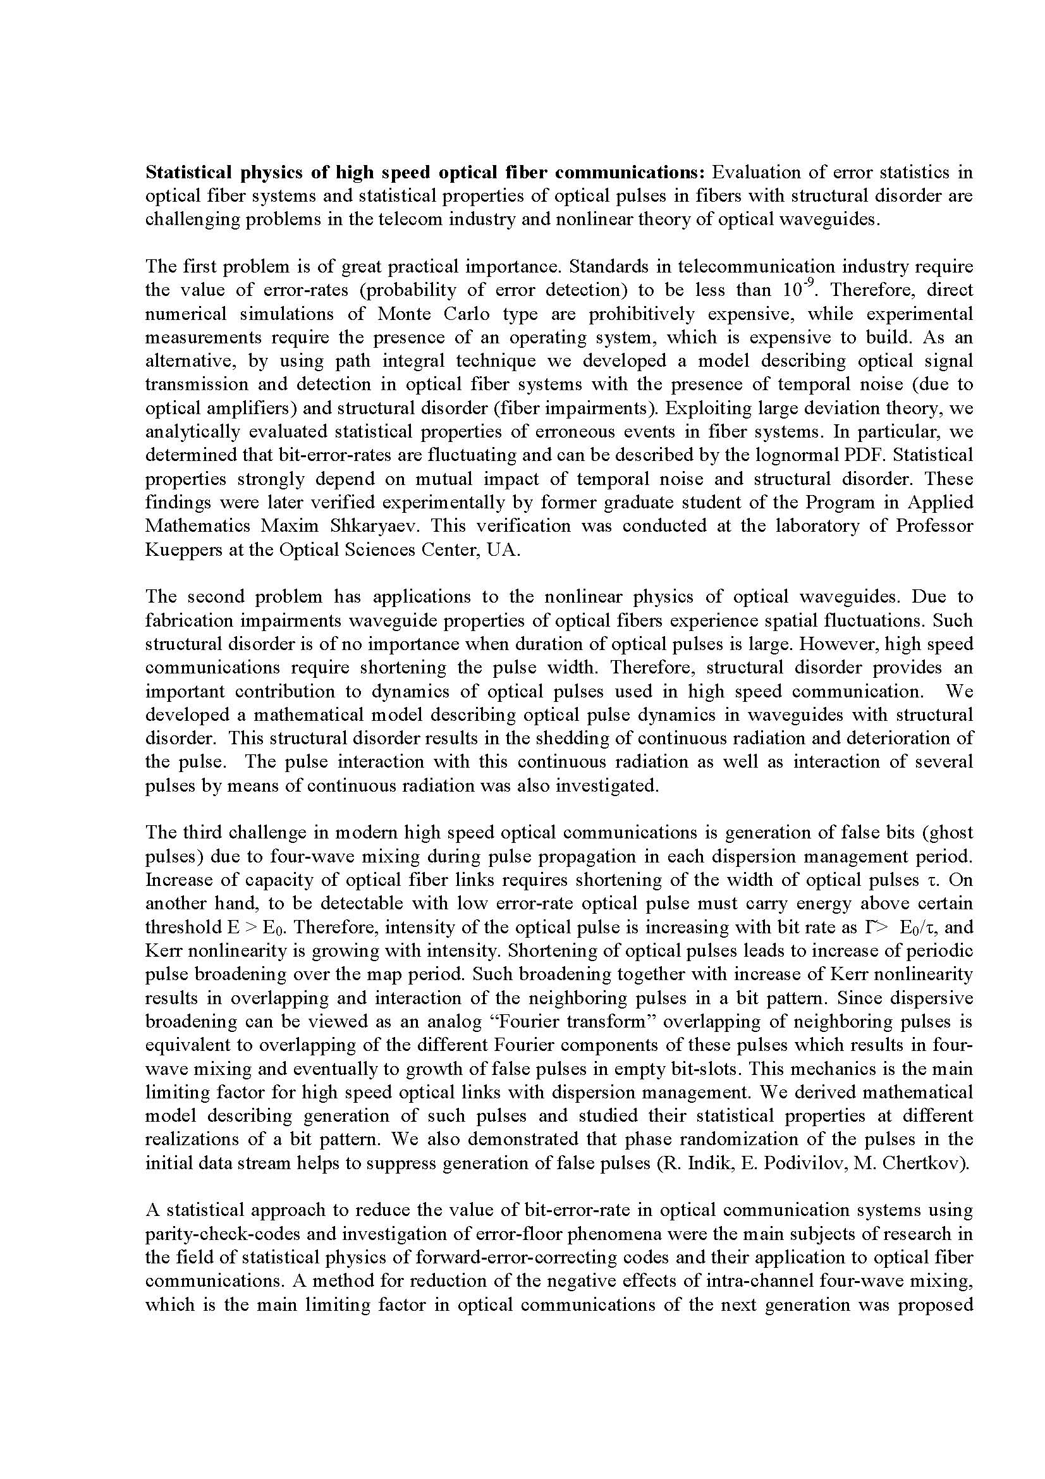

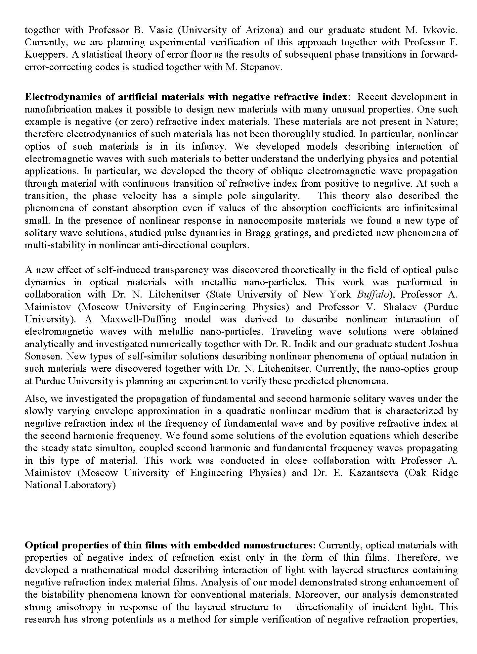

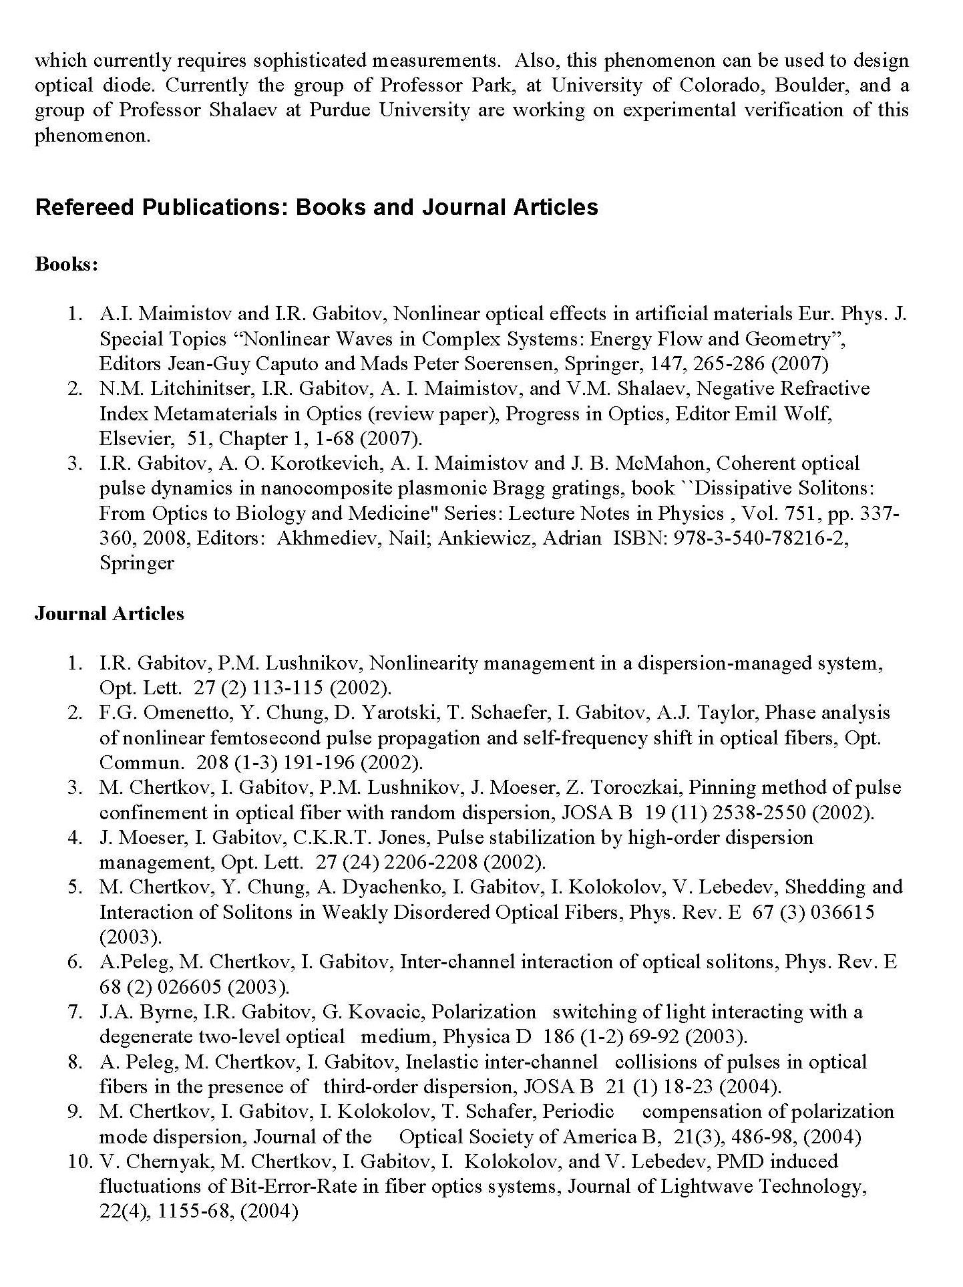

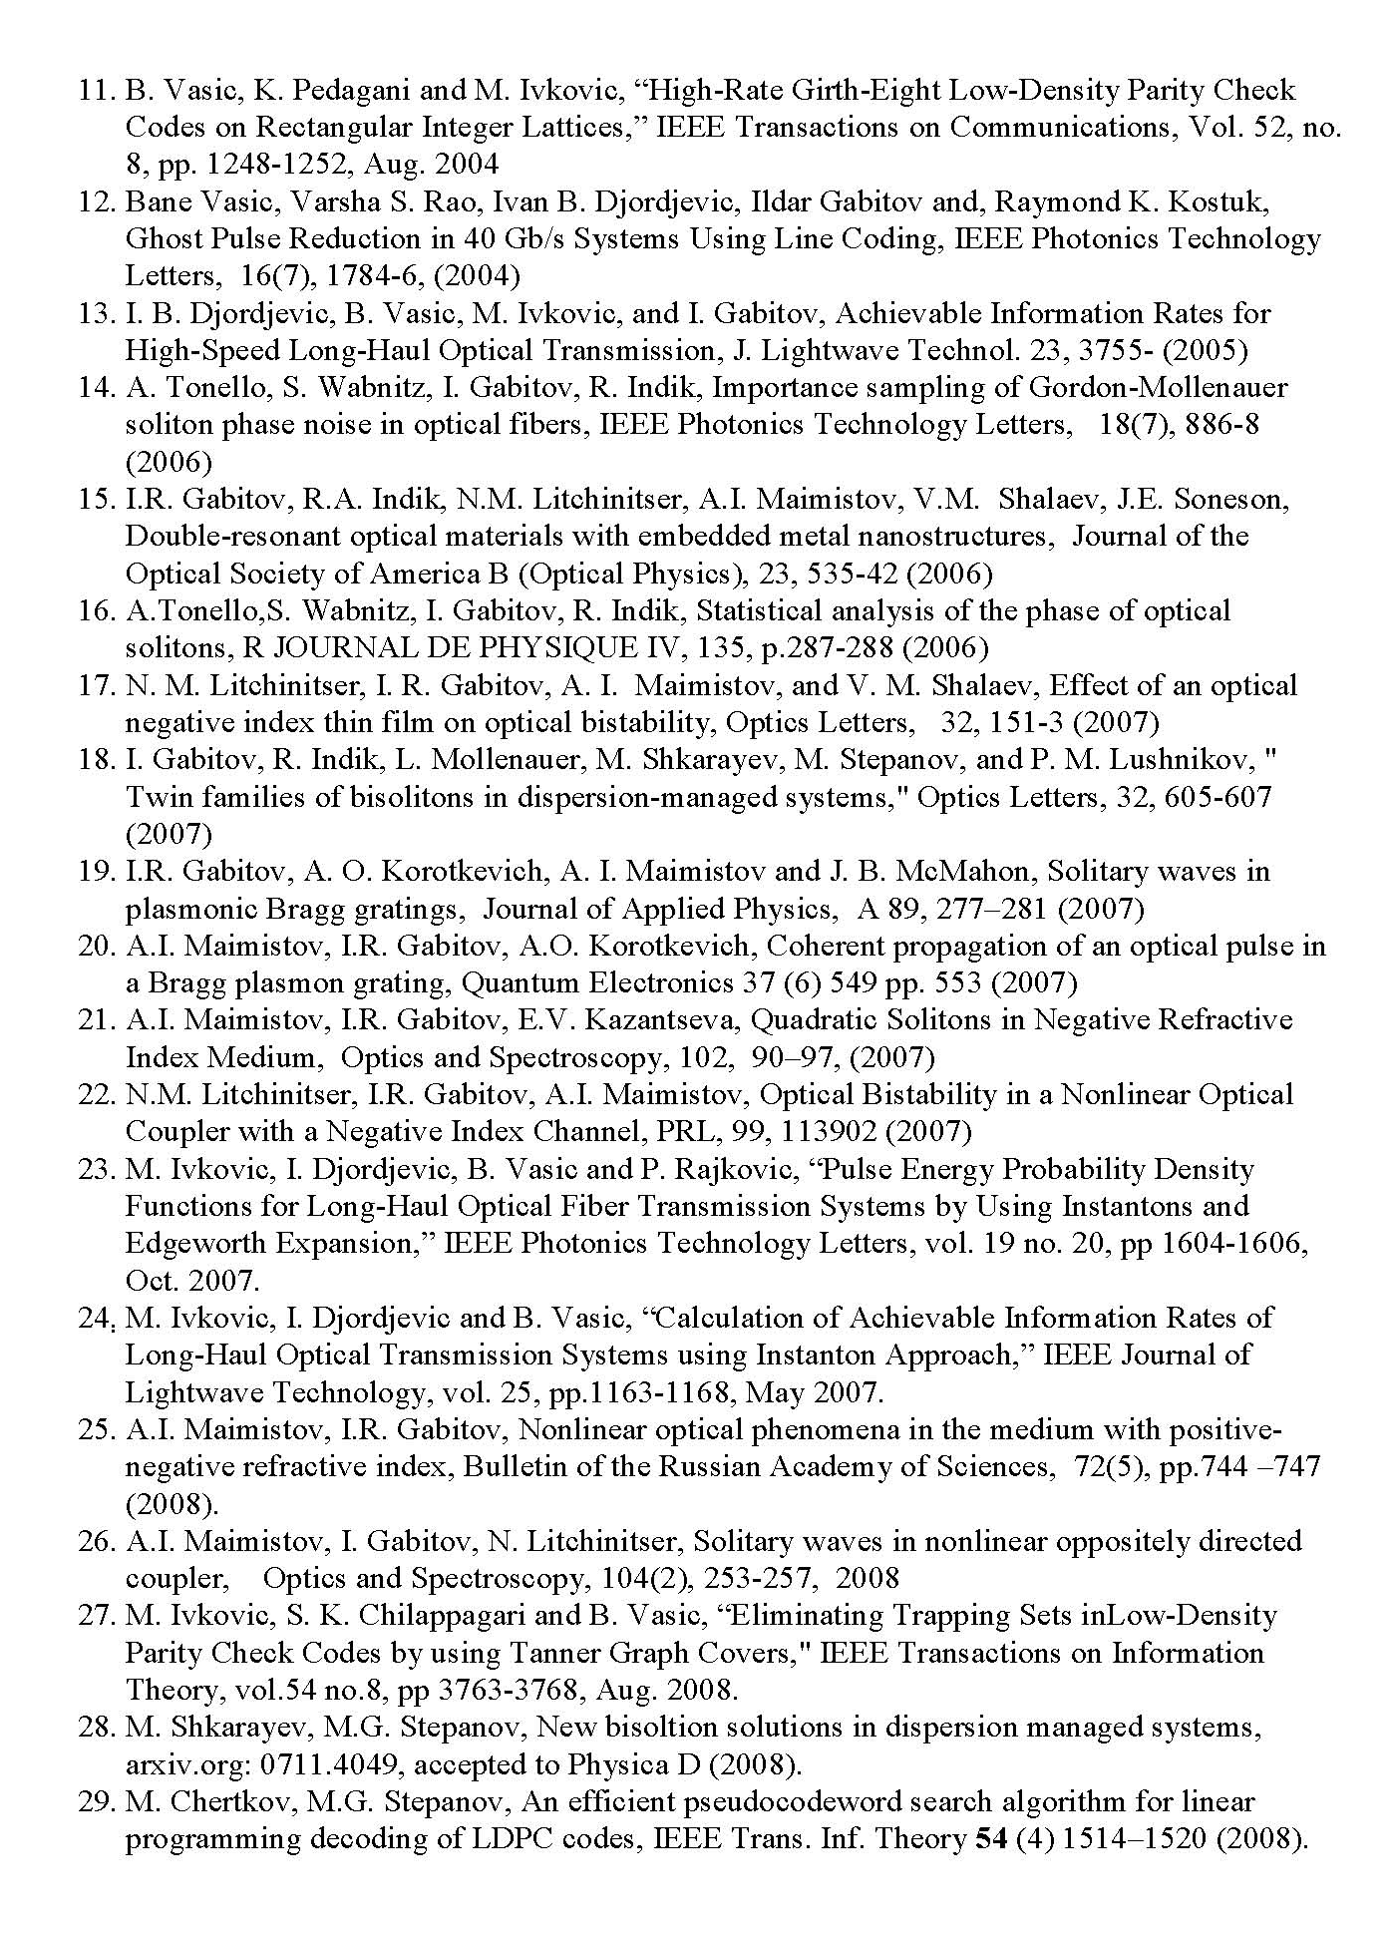

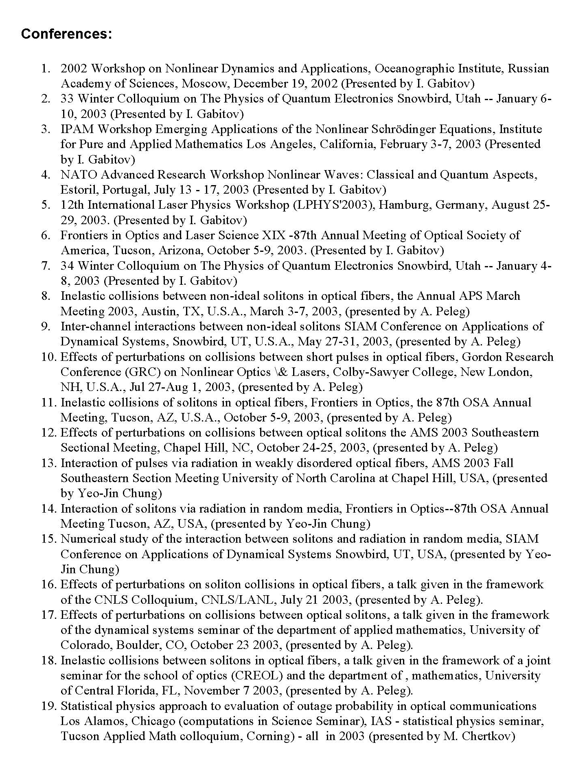
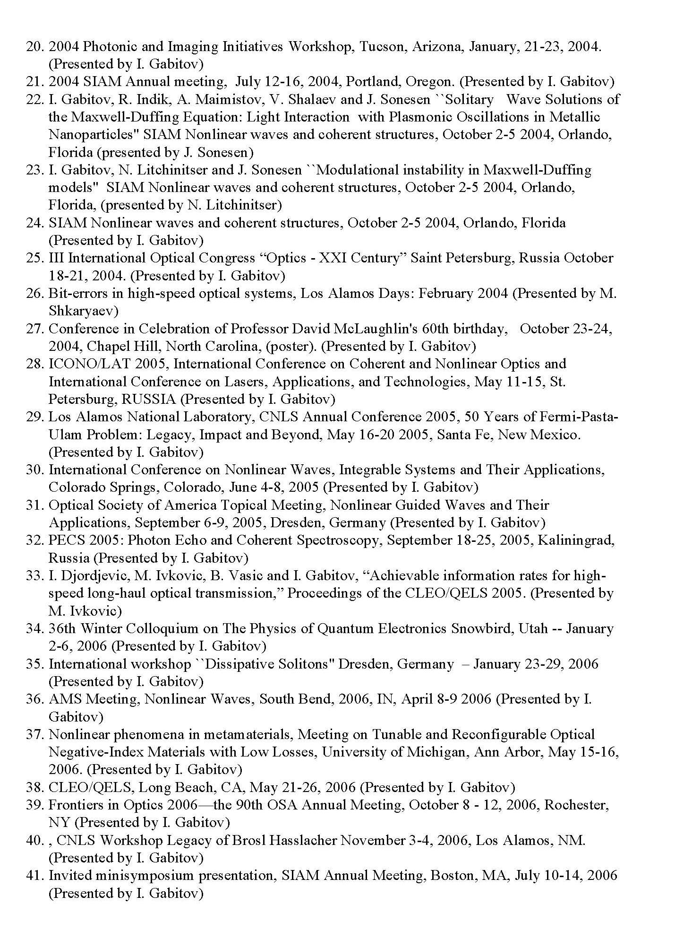
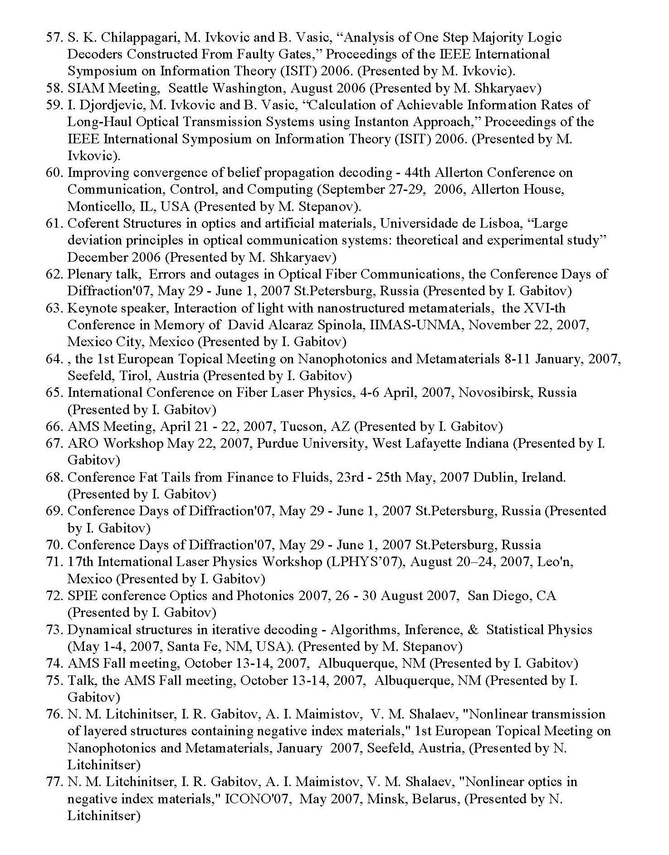
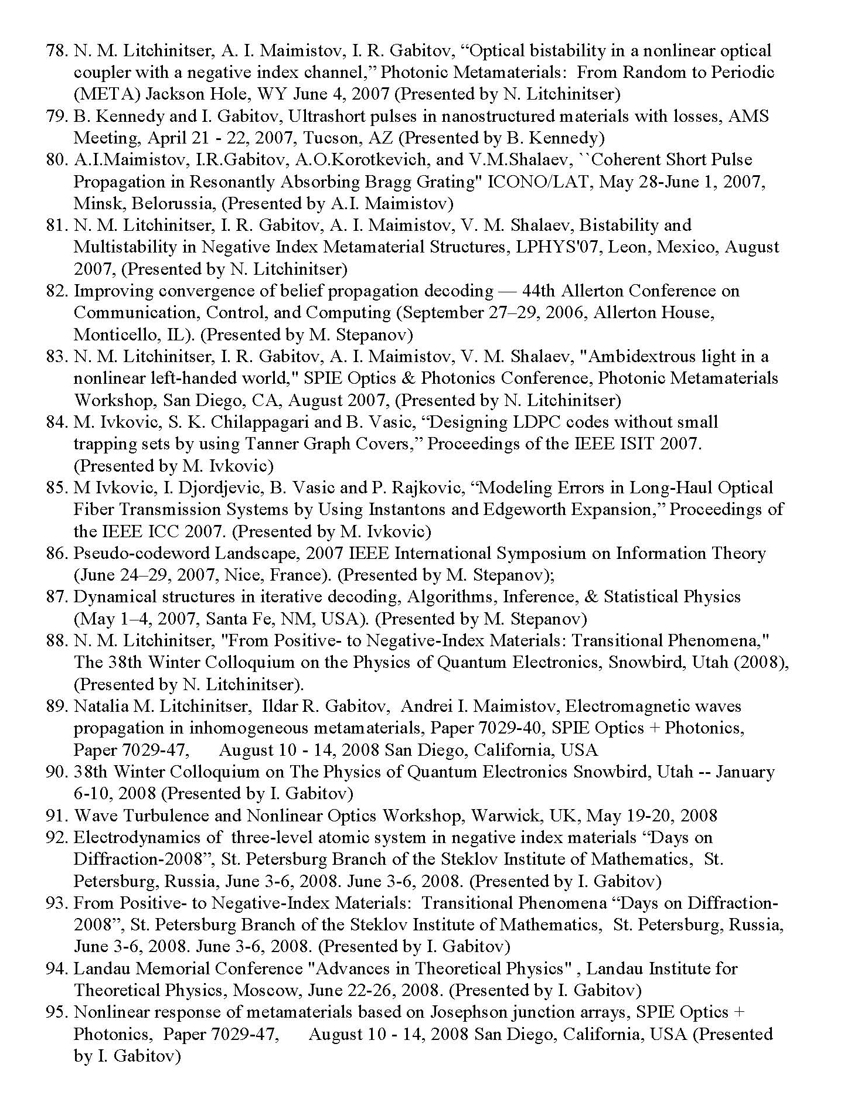
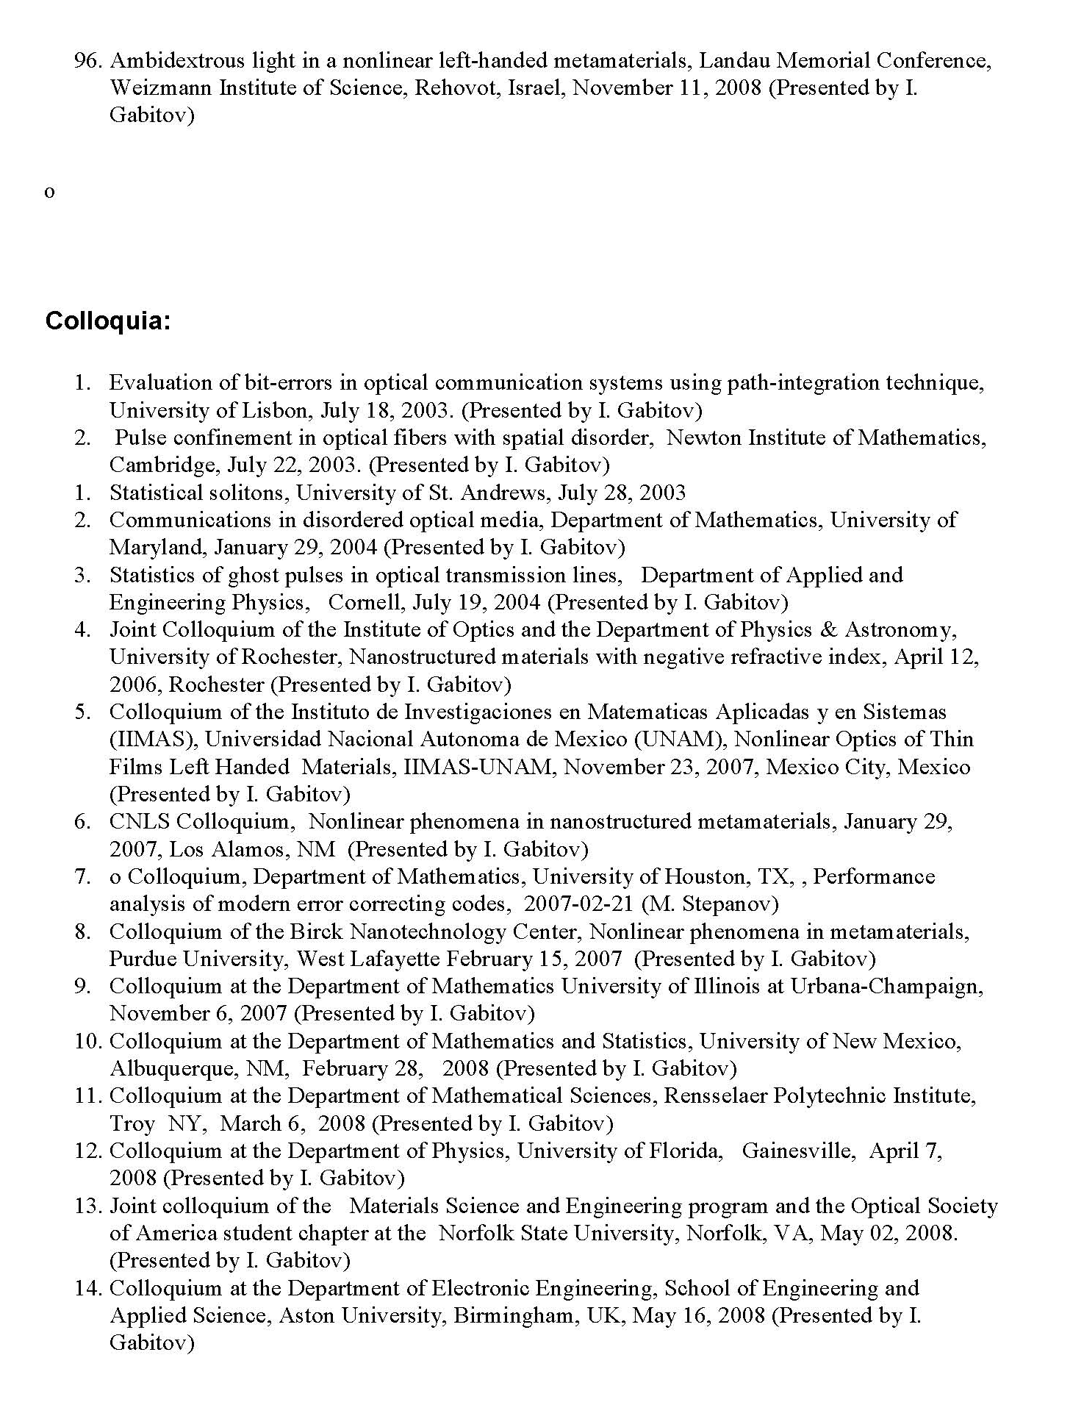
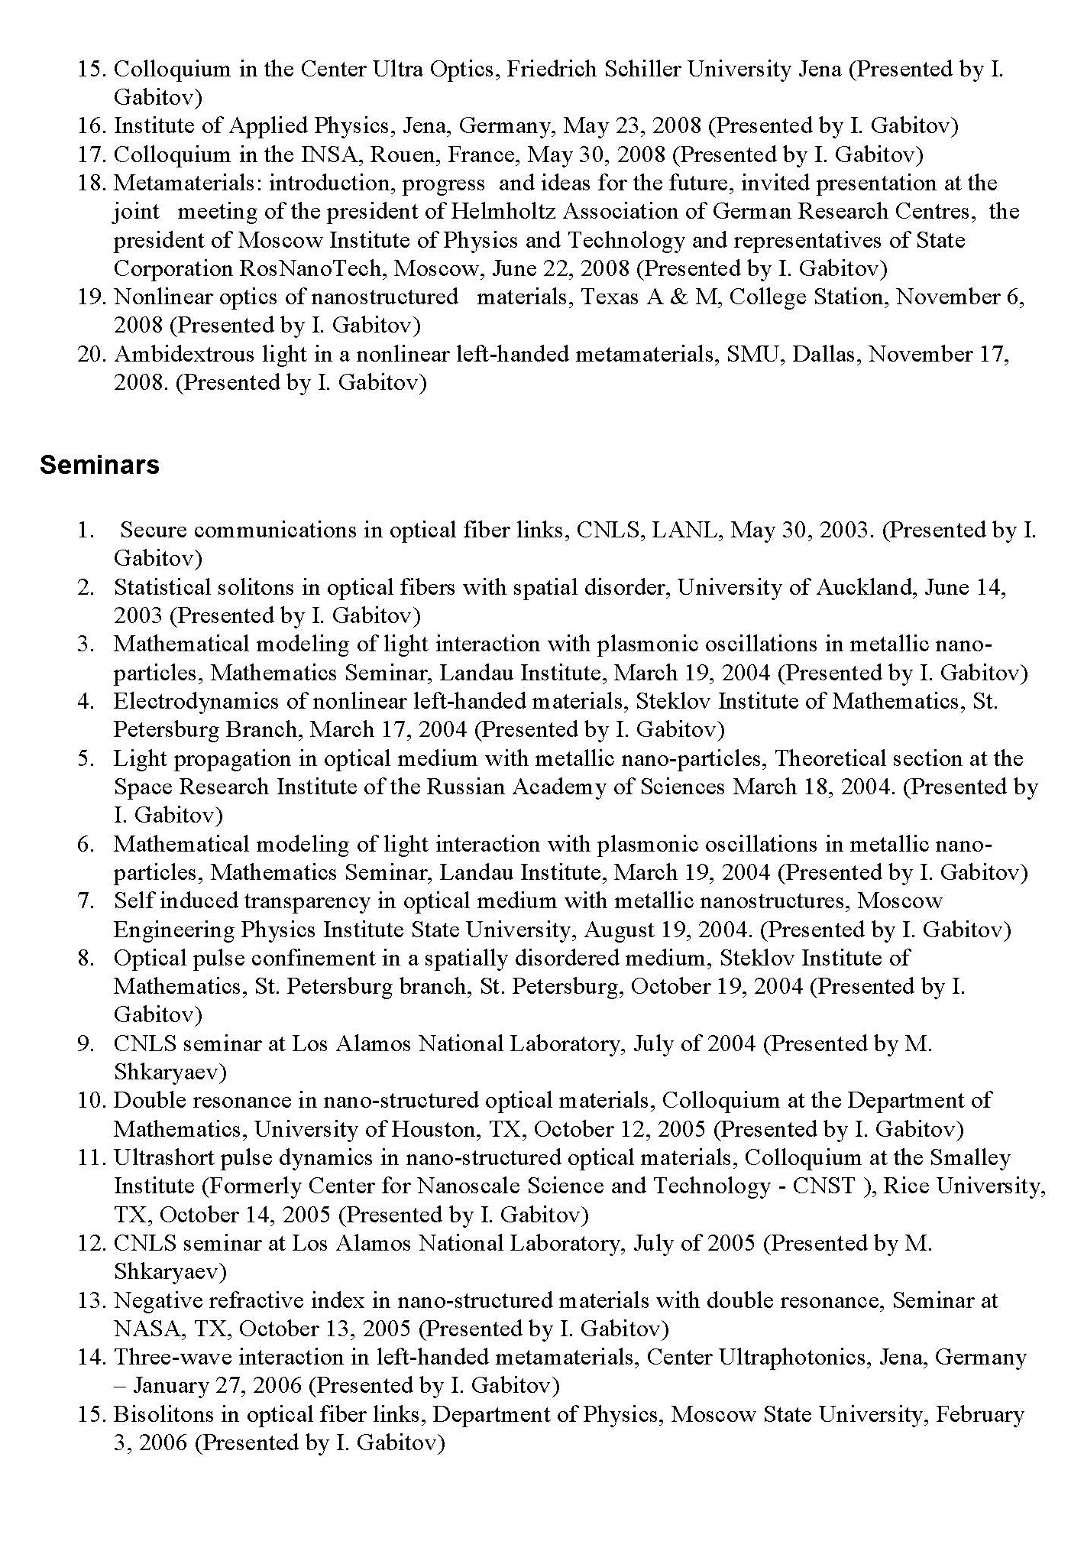
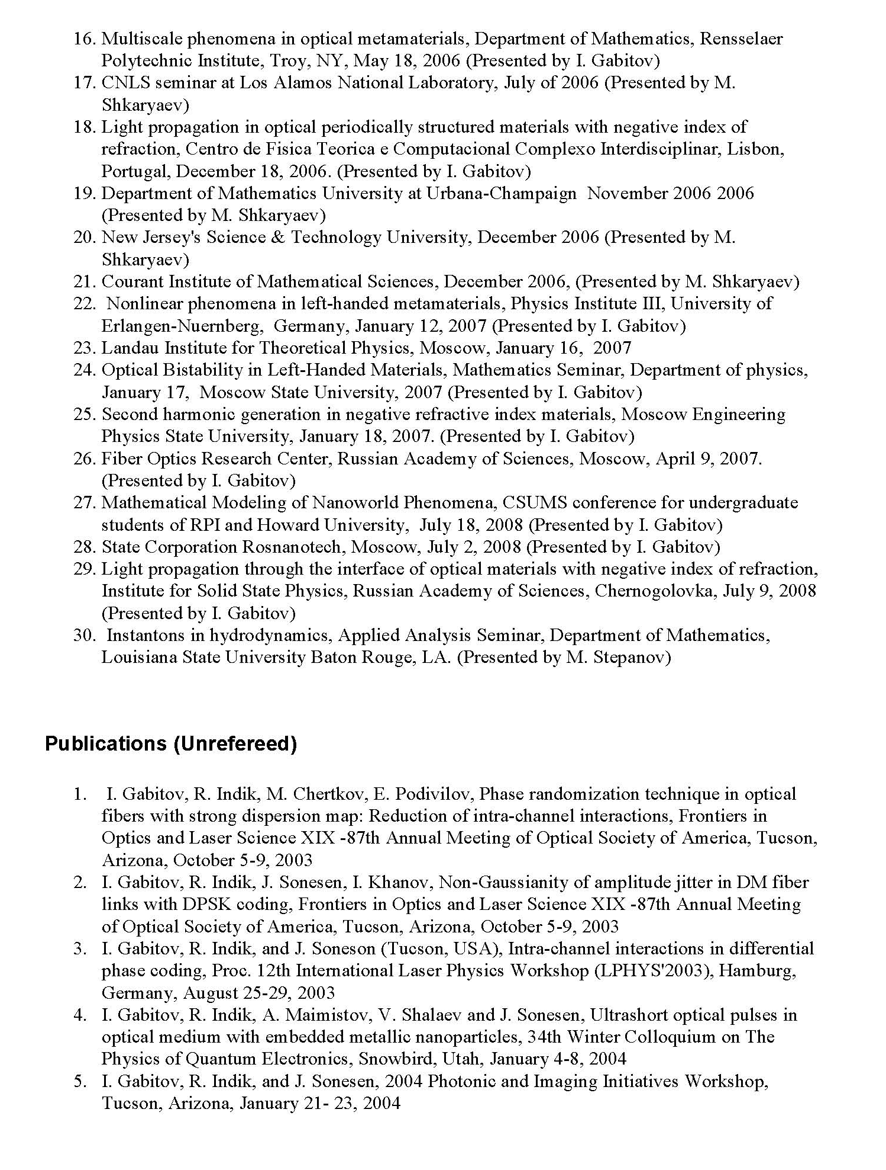
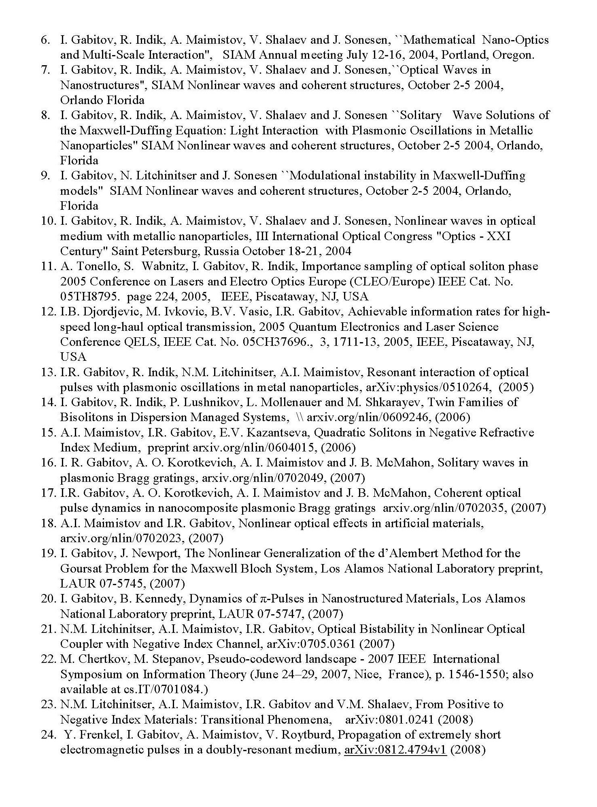

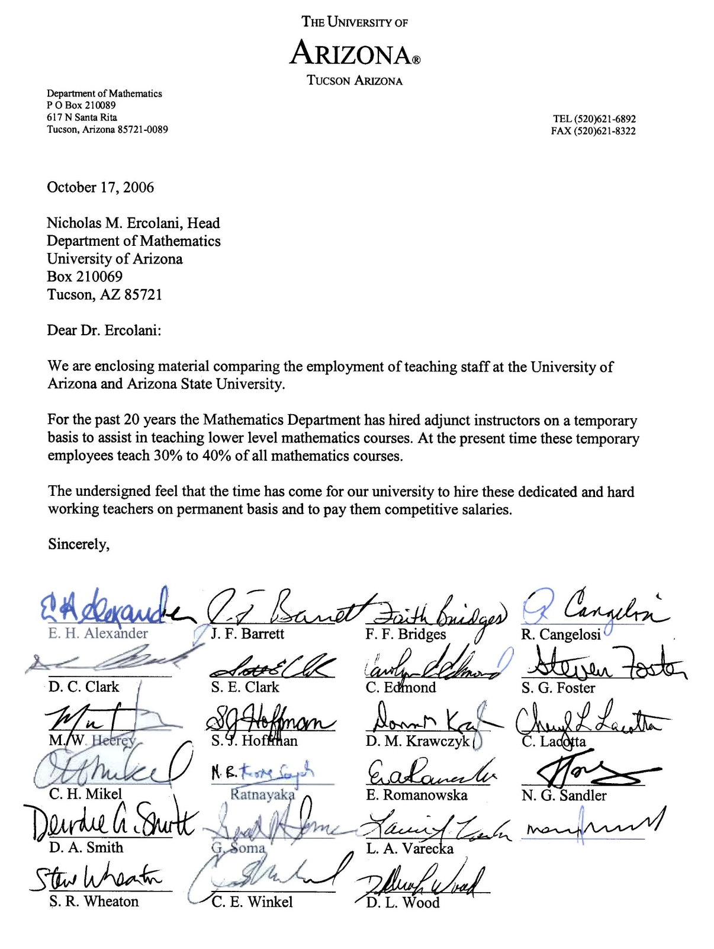
Instructional Salary Petition to Juan Garcia

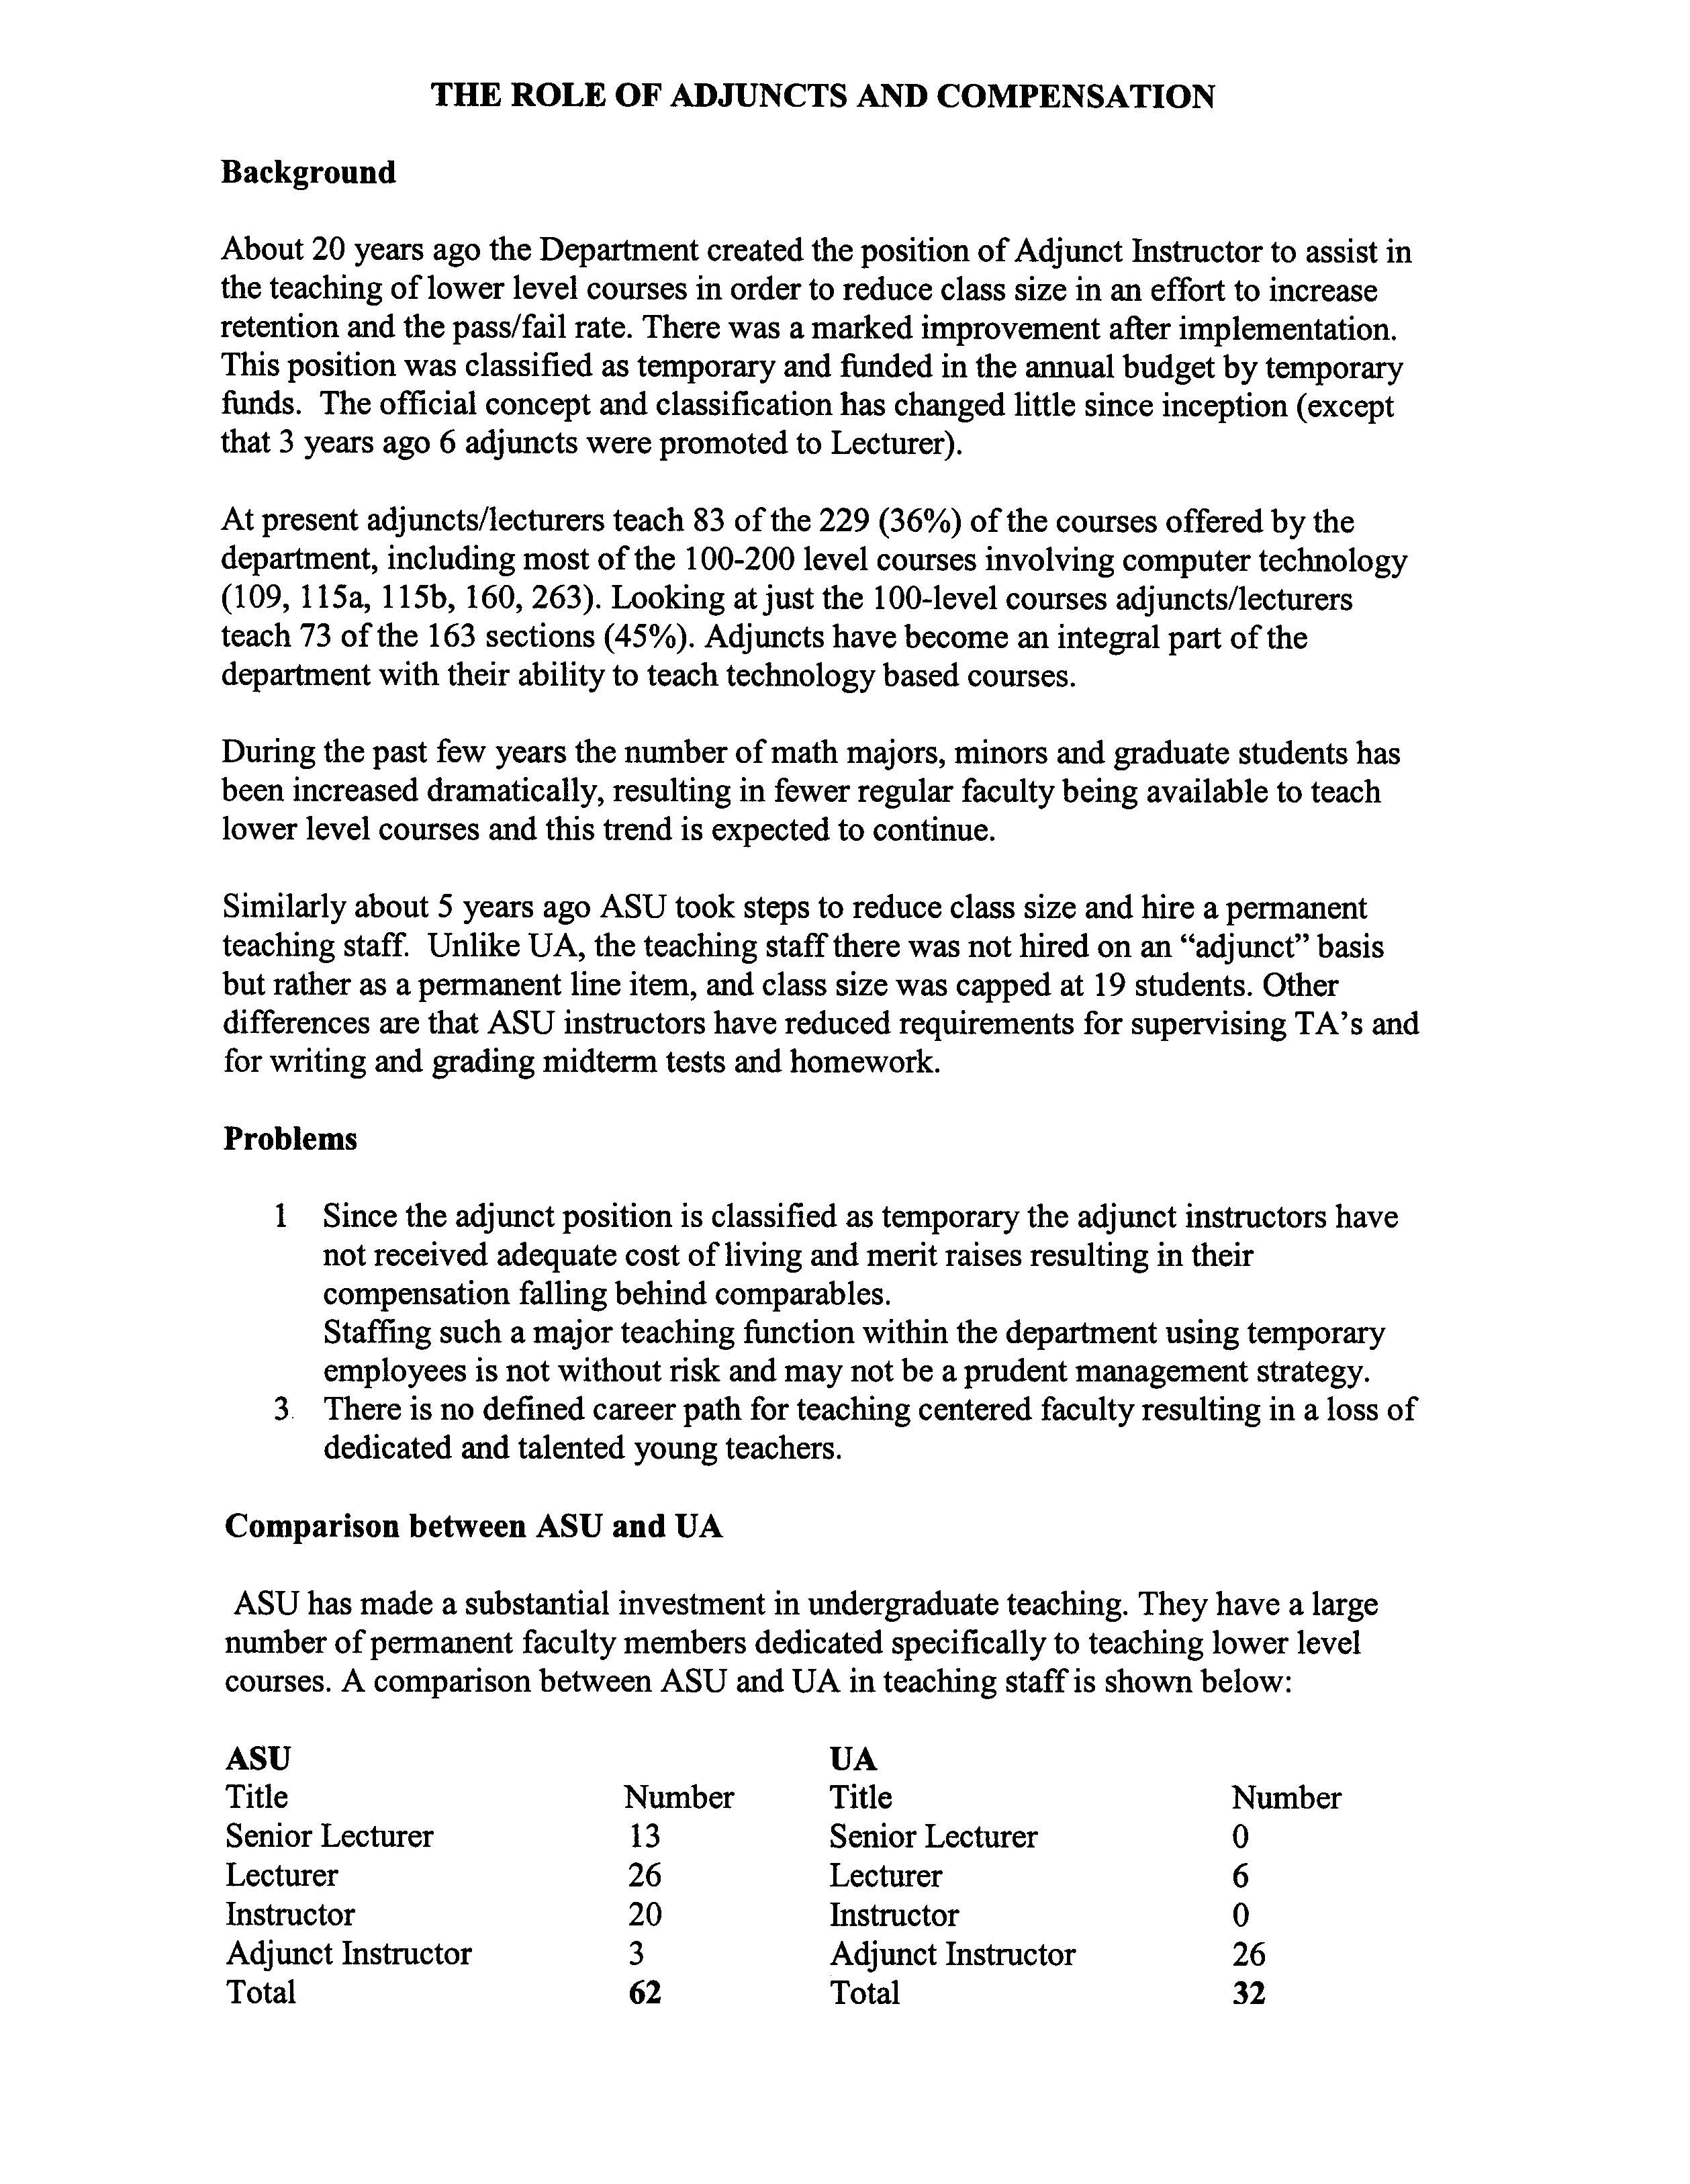
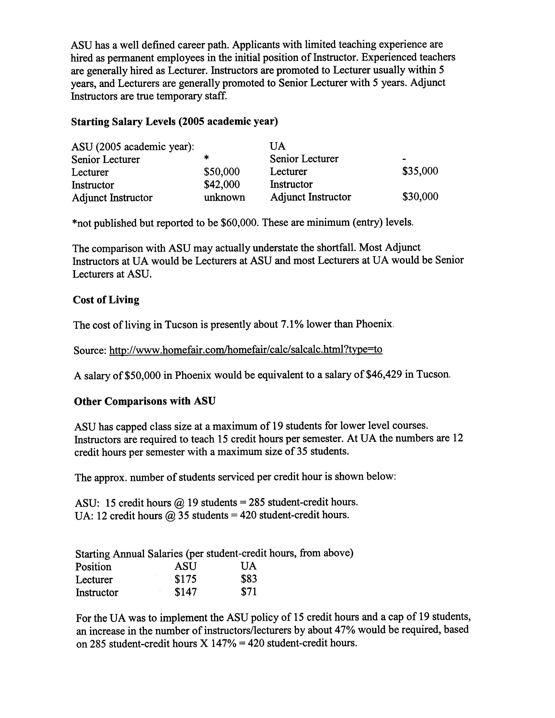
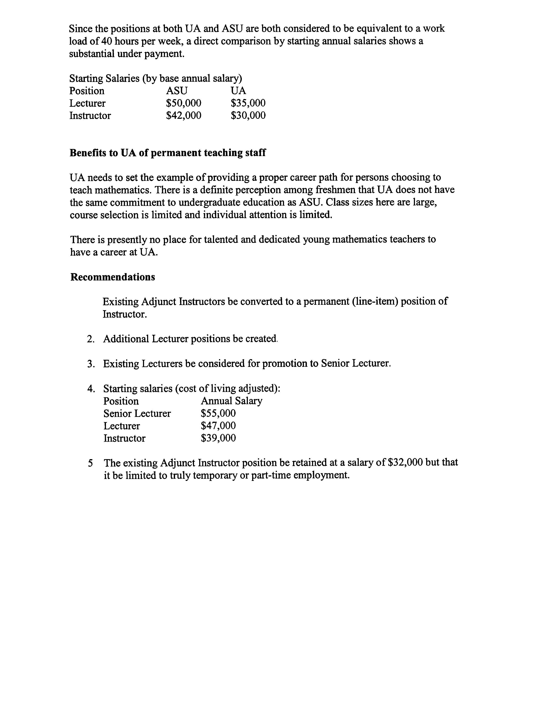

Math Instruction Colloquium

Date | Speaker Name | Affiliation | Title of Talk
2006-08-22 |  |  | Organizational Meeting
2006-08-29 | José María Menéndez | UA Mathematics | Peer-Mentoring Programs
2006-09-05 | William McCallum | UA Mathematics | The Institute for Mathematics and Education at Arizona
2006-09-12 | Arlo Caine | UA Mathematics | Preceptors in Vector Calculus:The potential of Vertically Integrated Instruction
2006-09-19 | Bruce Bayly | UA Mathematics | The PHYSICS FACTORY Science Outreach Project
2006-09-26 | James P. Cossey | UA Mathematics | Route 66 to Catalan
2006-10-03 | Matthew Salomone | UA Mathematics | Integrating the Sciences
2006-10-17 | Nick Rogers | UA Mathematics | Pythagorean Triples and Pell's Equation
2006-10-24 | Joceline Lega | UA Mathematics | CSUMS: A research track for undergraduates
2006-10-31 | Fred Stevenson, Sue Adams, and Ann Modica | UA Mathematics | The Center of Recruitment and Retention: Then (2001) and Now (2006)
2006-11-07 | Cynthia Anhalt, Matt Ondrus, and Virginia Horak | UA Mathematics | Reflections on a Course Co-taught by a Mathematician and a Mathematics Educator
2006-11-14 | Veronika Furst | UA Mathematics | Basic Wavelets
2006-11-21 | Ksenija Simic-Muller | UA Mathematics | Infinitesimals in your calculus class and elsewhere
2006-11-28 | Taliesin Sutton | UA Mathematics | The 302A Experience
2007-02-07 | Thomas Ricks | Mathematics, The University of Georgia | The Mathematics Class as a Mathematizing Complex System
2007-02-13 | Deborah Hughes Hallett | UA Mathematics | Big Ideas: What Mathematics Do Students Really Need to Know for College?
2007-02-20 | Elon Kohlberg | Prof of Business Admin, Harvard Business School | Arithmetic in the Way of Mathematics
2007-02-27 | CEMELA fellows | UA Mathematics | CEMELA: Who we are and what we do
2007-03-06 | Ted Laetsch | UA Mathematics | Why an introduction to proofs course?
2007-03-20 | James Cossey | UA Mathematics | A first try at the Moore method
2007-03-27 | Dr. Deane Arganbright | Korea Adv Inst of Science &Tech, Univ/Vienna | Mathematical Modeling, Visualization, and Conceptualization with Excel
2007-04-03 | Matt Ondrus | UA Mathematics | Some nice facts I didn't know about triangles
2007-04-10 |  |  | Outreach to Native Communities
2007-04-24 | Nathan Carlson | UA Mathematics | What is a MathCircle, anyway?
2007-05-01 | Dorin Dumitrascu | UA Mathematics | An overview of guided discovery
2007-08-27 |  |  | Organizational Meeting
2007-09-04 | Guershon Harel | Mathematics, Univ/California - San Diego | The Necessity Principle and Its Implementation in Mathematics Instruction
2007-09-11 | William McCallum | UA Mathematics
2007-09-18 | Stephen Gagola | UA Mathematics | Brainstorming an MAA Special Session
2007-09-25 | Ji Li | UA Mathematics | Everything You Wanted to Know About Math Tutoring (but Didn't Know to Ask)
2007-10-02 | James Cossey | UA Mathematics | Summer TIME in the City
2007-10-02 | J. P. Cossey | UA Mathematics | Summer TIME in the City
2007-10-09 | Taliesin Sutton | UA Mathematics | What Counts as Math?
2007-10-16 | The S_STEM Team | UA Mathematics | Town hall meeting on improving the first-year teaching experience for TAs
2007-10-23 |  |  | Facilitating the Transition between High School and College Math: An Open Panel Discussion
2007-11-06 | Liana Dawson | UA Mathematics | Hands-on Calculus Activities
2007-11-13 | Bruce MacMillan and Virginia Bohme | UA Mathematics | Modeling Damped Harmonic Motion: A Data Collection Activity for the Precalculus Class
2007-12-04 | Michelle Cirillo | Mathematics, Iowa State University | On Becoming a Geometry Teacher: A Longitudinal Case Study of One Teacher Learning to Teach Proof
2008-01-22 | Dorin Dumitrascu | UA Mathematics | Reflections on the Teaching of Math XYZ
2008-01-29 | NULL |  | Organizational Meeting
2008-02-05 | Deborah Hughes Hallett | UA Mathematics | Drugs and Drug Tests: Understanding through Multiple Representations
2008-02-12 | David Lomen | UA Mathematics | ConcepTests for Algebra - A Means for a More Interactive Classroom
2008-02-26 | Al Cuoco | Educational Development Center | Some options for fourth year high school mathematics courses
2008-03-04 | Barbara Armenta | Mathematics, Pima Comm College | Autograph for Word, SmartBoard, and Interactive Use in the Classroom.
2008-03-11 | Bruce MacMillan, Ginny Bohme, and Ann Modica | UA Mathematics | Engaging Students
2008-04-01 |  |  | Facilitating the Transition between High School and College Math, Part II
2008-04-17 | Paul Zeitz | Mathematics, The Univ/San Francisco | Enrichment for the Already-Enriched vs. Enrichment for the Unenriched
2008-04-17 | Paul Zeitz | Mathematics, The Univ/San Francisco | Enrichment for the Already-Enriched vs. Enrichment for the Unenriched
2008-04-22 | Jeffrey Bennett |  | Mathematics for Life: Are You Teaching Students What They Really Need?
2008-05-06 | Matthew Salomone | UA Mathematics | Writing About Mathematics
2008-08-26 | NULL | UA Mathematics | Organizational Meeting
2008-09-16 | Nathan Carlson | UA Mathematics | The Tucson Teachers' Circle at one year
2008-09-23 | Robert Schmidt | UA Mathematics | Utilizing the SMART Board for Mathematics Education
2008-09-30 | Linda Simonsen | UA Mathematics | Distance Learning: Budget Panacea or Authentic Learning?
2008-10-07 | Bruce MacMillan | UA Mathematics | Modeling Projectile Motion
2008-10-14 | Dr. William McCullum | UA Mathematics | What should the new required fourth year of high school math look like?
2008-10-21 | Kimberly Gray | UA Mathematics | Geogebra
2008-10-28 | Walter Piegorsch | UA Mathematics | Understanding the Statistics Behind Voting Polls
2008-11-04 | Dr. Caroline Wright | UA Mathematics | Math Education Standards in Georgia
2008-11-18 | Dr. Elizabeth Arnot-Hopffer, Victor Mercado, and Crystal Bartels | Tucson GEAR UP, UA | Culturally Relevant Pedagogy: Teaching Mathematics Through Mariachi Music
2008-11-25 | Dr. William Yslas Vélez | UA Mathematics | Increasing the number of mathematics majors
2008-12-02 | Dr. Bruce Bayly | UA Mathematics | The Mathematics Factory: Vision for a Mobile Outreach Program
2008-12-09 | Stephen Gagola & Tina Deemer | UA Mathematics | How students prepare for exams

Task Force Report
Report and Recommendations on
Core Mathematics Education at The University of Arizona
Submitted by Drs. William McCallum, Jerrold Hogle, and Joaquin Ruiz, Co-Chairs,
for the University-wide Task Force on Core Mathematics

January 30, 2007

Introduction: History and Process

Due to a thoughtful request from the Department of Mathematics and the College of Science in the late Fall of 2005, Provost George Davis charged this Task Force, starting in December 2005, with studying, and making recommendations about, the Mathematics Department’s role in the dissemination of mathematical knowledge within the University. There were – and remain – two primary and fundamental academic purposes behind the initial request and the charge to the Task Force: (1) dealing effectively with the many intellectual relationships that mathematics has with a wide range of other University fields – both in research and in teaching -- and (2) making sure that all the levels of math-seeking students, with their different ranges of preparation in and need for math, are reasonably well served at the UA within the University’s resources and within the Math Department’s mission to be a high-level teaching and research unit serving majors, graduate students, and the wider educational community (locally, nationally, and internationally) as well as the general undergraduate here. Hence one function of the Task Force has been to make recommendations on how the Math Department should best deal with the many requests that come to it for math preparation instruction for areas outside Math itself, including majors ranging from Business to Engineering and beyond, as well as General Education. The other main Task Force function has been to consider how the “core” (mostly lower-division) Mathematics courses and sequences at the University of Arizona might best be configured and prepared for to better serve different populations of students and to improve math learning and instruction, as appropriate, across our entire student population. Accordingly, the Task Force membership (see the attached Appendix), appointed by the co-chairs in consultation with the Provost and the Chair of the Faculty, has been drawn from all the colleges, the student support services (including the Office of Retention), and those members of the local professional community, as well as from members of the student body, who have significant connections to core math education.
This process has therefore involved a sweeping look at the mathematics core as it stands and its relation to many other areas: math-intensive majors and disciplines in numerous units in and outside the College of Science; the basic math requirement and the options for meeting it in the University-wide General Education Program; community-college and high-school math preparation in Arizona; the recruitment and retention of students at the UA; the need of different kinds of math education for different subject areas; and the UA’s future in serving an expanding college-seeking population both in our core and in our outreach programs (see more on these concerns below). This range of focus has made it logical that the co-chairs of the Task Force encompass the University level (Vice Provost Hogle), the College level (Dean of Science Ruiz), and the department level (Distinguished Professor McCallum from the Department of Mathematics).
The Math Department itself also helped to set up this wider examination in two special ways. First, four internal working groups in that department, each comprised of three or more faculty members, prepared reports on interactions with other academic areas, based on discussions with faculty and students outside of Math. Each one of these groups, as a result, has a representative on the Task Force (indicated in parentheses in what now follows). One such group focused on the transition from high school (Elias Toubassi), one on the physical sciences and engineering (David Lomen), one on the biological sciences (Joceline Lega), and one on business and the social and behavioral sciences (David Glickenstein). Reports from these groups were used as valuable and important starting points by the Task Force, even as it collected statistical information and other data about the ability of students to move (or fail to move) between levels of mathematics from high school to community college to the university. All of this information, including records of the Task Force’s discussions (divided by subject area) over this past year, can be found online at http://www.math.arizona.edu/~wmc/taskforce. Meanwhile, on a second front, the Math Department representatives on the Task Force (of which there were several, quite intentionally) provided information on the culture and operations of the department, while also serving as liaisons between Task Force and Departmental discussions, which continually informed each other throughout 2006.

Out of these beginnings, then, came an extensive Task Force examination, with the aid of experts, of Math at the University of Arizona and its many points of connection with other interests. We are grateful to all the people who led, staffed, and worked on the Task Force, as well as to the several subcommittees who worked outside of general group meetings on various segments of the recommendations included below and to the Office of the Provost, the Dean’s Office in the College of Science, and the Department Head in Mathematics, Dr. Nick Ercolani, all of whom gave us essential ongoing support and timely assistance with particular problems. With all of the above behind its efforts, the Task Force now makes formal recommendations to the Provost, the Department of Mathematics, the College of Science, and the curricular arms of shared governance here about the structure, options, and sequencing of core mathematics, keeping in mind practical and budgetary, as well as all the essential academic, considerations. Before listing those recommendations, however, we do want to summarize briefly some of the most overarching considerations and fundamental presuppositions behind them.

The Problems the Task Force Set out to Address
and its Overriding Assumptions in Doing So

Towards the above ends, the Task Force has set out to address the following pressing issues:
- The math preparation of incoming students (in relation to the academic standards we decide to uphold)
- Our mathematics entrance requirements (what constitutes “entry level”?)
- The aims and process of math placement at the UA, including prerequisite enforcement
- Is college-level math needed by all students
(as it is now supposed to be in the General Education Program)?
- Different kinds of entry-level math that might be offered for different groups of students, depending on their future plans
- Math courses designed (or not) to serve particular majors
- The degree of course compression there should be to avoid duplication of instruction
- Articulation between math at the UA and at community colleges
- Informed advising across the UA about mathematics and math options
- Class sizes and types of staffing for different levels and kinds of math
- The uses of alternative strategies within processes of curricular renewal
- The sustainability of current course offerings in Math and math-related areas
- Math and instructional technology
- The preparation of K-12 math teachers
- Support for students in math beyond courses (how much? what kinds?)
- The coherence of the student experience at the UA and math’s role in it
* From the student point of view * From the faculty perspective
In working through these issues towards the above ends, the Task Force has also held steadily to the following determinations:
- to proceed from a global view of the Math Department’s curriculum and operations, with respect for and due consideration of the Department’s range of responsibilities
- to arrive at conclusions based on substantial and reliable evidence provided by the Math Department and other expert sources
- to distinguish clearly between those recommendations that can be accomplished with current resources and those that require additional ones (with some attention to how the latter might be obtained)
- to collaborate and consult, as the Math Department has and will continue to do, with departments whose faculty and students use math extensively
- to aim for a coherent curriculum for undergraduates that takes account of where students are coming from and the mathematical terrain of their intended disciplines
- to value mathematics as central to the intellectual endeavor of the University in both its teaching and its research missions

Our Philosophy about the University-Math Department Relationship
Since we all agree, then, that Mathematics is central to the mission of a major research institution at all levels, ranging from the most foundational aspects of undergraduate education to the most sophisticated research, we find ourselves, after considerable study, reaching some overall conclusions about the Mathematics Department itself. This “core” role for Math in the University is best played by a faculty that does not cordon off the scholarship of teaching from the scholarship of research, but rather embraces a culture that embodies teaching and research as different aspects of a unified dedication to increasing human knowledge. The National Science Foundation has recognized this need for integration in major funding initiatives such as the Centers for Learning and Teaching (CLT), Vertical Integration of Research and Education (VIGRE), and the Math and Science Partnership program (MSP). The Mathematics Department at the University of Arizona is widely recognized as carrying out all aspects of its mission with distinction, as noted by President Shelton in his inaugural address:
Our Department of Mathematics, seeing that students need to learn mathematics skills differently to meet the demands of the modern work force, has won major grant funding to redefine the very nature of math instruction at middle school, high school, and college levels.
Indeed, the Department is rare in receiving funding under all three of the major NSF programs aimed at integrating research and education, resulting in a doubling of its external funding over the last 6 years. This melding of research and instructional cultures is responsible for the Department’s decades-long and nationally recognized tradition of innovation and leadership at all levels of mathematics. In education, its activities range from outreach to local schools and the design of innovative undergraduate courses, to the training of graduate students and post-docs in a vertically integrated program which has consistently drawn the best talent from around the country. In research, we recognize, the Department has strong and active groups working in areas of fundamental mathematics as well as through the full spectrum of applications and interdisciplinary activities.
We believe that the Department has taken steps to maintain its integrated culture. It has provided rewards for faculty who choose to focus on teaching a dynamic curriculum to students in majors requiring mathematics, but has also increased its research profile in its areas of national and international importance. It has developed an innovative Teaching Postdoc Program which attracts Ph. D. mathematicians with an interest in combining their research careers with a focus on instruction. It has pursued opportunities for partnered hires with other departments and units, and in its regular hiring has valued candidates who maintain its dual culture of excellence in research and teaching. This culture has enabled the Department to thrive despite a teaching load that is relatively high in its college.
It was in part to ensure the continued flourishing of this long tradition of excellence and innovation, as noted above, that the Task Force took on the charge of examining the interactions between the Department and other disciplines on campus. This initiative has been made opportune, perhaps even imperative, we also understand, by several new directions at the UA and nationally in which mathematics, statistics, and other disciplines interact in powerful ways. Examples include increased use of high-level mathematics and statistics in traditionally mathematics-intensive subjects such as chemistry and engineering; emerging use of sophisticated quantitative methods in the life sciences; developments in mathematical finance and the impact of new mathematical insights in economics, physiology, and the social and behavioral sciences.
Exploiting the opportunities presented by these new developments and maintaining the Mathematics Department's ability to carry out its mission effectively raise many intellectually powerful and organizationally complicated issues. Intellectual relationships—the lifeblood of all significant undertakings at the University—must continue to flourish within Mathematics and across campus. Curricula must continue to be developed for future practitioners and researchers in a variety of fields, ranging from the traditional physical sciences and engineering to the life sciences, education, business and economics, and the social sciences. The Task Force recommendations on how to handle this work are summarized in section I of “Recommend-ations” below.
Moreover, the University needs to recognize that high quality must be maintained throughout the full spectrum of the Department’s responsibilities, from the Department’s programs for students in its entry level courses to its interactions with research colleagues. Entry level courses need special attention due to their large enrollment. The Task Force’s recommendations for these courses are summarized in section II of what follows.
Finally, the University as a whole needs to decide what is desirable, what is essential, and what it is willing and able to support in the area of mathematics. The Department also needs to decide what it wants to do well, and it needs to be realistic about what is possible within the resources the University and the College of Science are willing to provide. The Task Force asks all parties to be mindful that quality mathematics instruction is not an unlimited commodity and needs reliable and appropriate resources.

Task Force Recommendations
I. Recommendations on the Interface between Mathematics and Other Programs
The Task Force finds great complexity in the many pressures on the Math Department to provide math for a raft of other majors, as well as for the general student. The first course we want to urge, then, is the establishment of a group and a process to deal systematically with current and future requests for mathematics instruction beyond what math majors receive. We thus recommend as follows:
a. To ensure a rational approach to the Department’s work in maintaining, enhancing, or developing instruction for students in majors requiring mathematics (those classified as “M”- or “S”-strand [see below]), the Task Force recommends a standing Interdepartmental Mathematics Advisory Committee (or IMAC) set up jointly by, and reporting to, the Head of the Department, the Dean of the College, and the Vice Provost for Instruction, who should also sit with the Committee, whenever possible, ex-officio.
b. The IMAC should consist of representative faculty from different units (including Mathematics) whose students need college-level mathematics preparation, such as the Colleges of Science, Agriculture and Life Sciences, Education, Engineering, Management, and Medicine. It should normally be chaired by a senior Professor of Mathematics with established links to research and instruction in other departments and programs.
c. The IMAC should
  - 1) take advantage of existing intellectual connections, including research, between Mathematics and other disciplines, and foster new ones;
  - 2) help set University priorities about Mathematics (what does the University want from the Department, what does it need, and what can it afford?) ;
  - 3) help the Department in setting priorities (what does the Department want to do and what can it do within its budget constraints?);
  - 4) help reconcile the University’s and Department’s priorities.

- The Department should formalize its communications with other departments in which
mathematics plays an important role, in order to
  - 1) evaluate requests for specialized courses from other departments within the stipulations under III below;
  - 2) coordinate, and (when necessary) suggest modifications to, the articulation between Mathematics courses and courses in other departments;
  - 3) provide a standing method by which instructors of follow-on courses can raise concerns about mathematics preparation;
  - 4) review available data, provided as described in (e), to see how mathematics preparation schemes and prerequisites are working and to generate recommendations for change out of such assessments.

- e. The Department and the IMAC, to accomplish the goals above, should facilitate and receive, with assistance from the Office of Institutional Research (OIRE), regular reporting on
  - 1) success rates in core Mathematics classes;
  - 2) pre-requisite compliance in follow-on classes;
  - 3) success rates and grades in follow-on classes;
  - 4) learning outcomes and their assessment in related departments;
  - 5) national trends in the involvement of mathematics with newly-forming or changing disciplines.

II. Recommendations on General Education and Entry-Level Issues
The Task Force has come to feel strongly (a) that mathematics instruction before college needs to be adjusted in a number of ways so that students come in better prepared and (b) that the University ought to differentiate even more than it now does between what it already calls “G-strand” or General students (those majors, such as ones in Fine Arts or Humanities, who need to demonstrate only minimum college competency), “M-Strand”or Moderate students (those majors, such as some in Business, who need a moderate amount of college-level math), and “S-strand” or Serious-about-Math students (those who need it as one essential basis of their chosen discipline and should thus take advanced Mathematics). In addition, we feel that students who are admitted to the UA with Math problems should not be so frustrated or so dispatched over to Pima College that they become Retention risks on those grounds alone. On the other hand, students should not be encouraged to take and keep failing the same Math class over and over, nor should the Department be forced to serve those students indefinitely without more funding support. Consequently, all things considered, we recommend the following:

a. The Mathematics component of the University General Education Requirement should become a proficiency-based requirement for those “G-strand” students whose only reason for taking mathematics is the General Education Requirement. Proficiency will be defined on the basis of historical data, developed by the Mathematics Department and approved by appropriate University authorities. PHIL 110 and LING 178 should remain options for satisfying this requirement. Achieving proficiency will not provide credit for any specific UA Mathematics course unless a credit-bearing course is used to establish proficiency. Students should be encouraged to attain proficiency in their first year, but in any case, this should be accomplished by the time a student completes 30 units of credit at UA.
b. The Office of Admissions, Orientation personnel, and other University authorities should provide early notice to high school students to take algebra-based college-preparatory Mathematics courses in their senior year. Mailings and outreach materials should include information provided by departments that require placement for incoming students. Admitted students should be encouraged to take the Mathematics Readiness Test during their senior year, either through the local high school MRT program, or on the UA campus during open testing dates in the Spring semester.
c. Students admitted with Mathematics deficiencies should be clearly notified by the Office of Admissions about what can be done to bring them up to University of Arizona admission standards. This should happen before students arrive for Orientation.
d. The enrollment of entering students into pre-UA level Mathematics should be made more seamless, both as to placement and payment. The mathematics placement process that takes place during Orientation should be expanded to include placement into Pima Math 092 and Pima Math 122. PCC and the UA should continue their new arrangement whereby UA students taking Math 092 and Math 122 through PCC on the UA campus can pay their PCC fees in the same manner and at the same time as UA fees are paid.
e. Students taking Pima Math 122 should be able to have that course count towards full-time student status for the purposes of financial aid, housing, etc. This course could be counted as general transfer credit towards 120 units without counting towards any particular graduation requirement.
f. For students who have taken any University class twice and either failed it or dropped out both times, a fee—covering the cost of the class per student and sent to the instructing department—should be charged for the taking of that class starting the third time a student registers for it.
III. Recommended Principles for Balancing Needs and Services
Assuming all of the above, the Task Force recognizes that some organizational and resource issues still need to be addressed for fair and successful changes to occur, inside and outside the Department of Mathematics. While we find some issues – such as class sizes and course curricula --to be so strictly internal that they should be decided by the experts in the Department and its College, other organizational matters have wider implications and should be addressed by University-level recommendations. In particular, we feel that the Mathematics Department needs predictable and adequate financial support for serving so many students beyond its own and that it and the University should make good use of the new IMAC to work out questions of how much the Department of Mathematics should reasonably be expected to do for the rest of the University, given the inevitability of resource limitations. Therefore:
a. The Task Force recommends a more timely and predictable funding of lecturers, adjunct instructors, Teaching Postdocs, and Graduate Assistants in Teaching (GATs), with funding decisions coming from the College and the Provost early enough for good hires to be made for the following year and enough continuity of funding to enable the hiring of more three-year renewable lecturers invested in the curriculum and the teaching of core mathematics to our students.
b. Ideas from other units for increased mathematics support should be generally welcomed with enthusiasm by the department. However, given current levels of budgetary support, units must make a case to the IMAC about the real need for and the intensive use of mathematics in that discipline that is so convincing as to motivate either increased funding from the University or a reallocation of existing resources.
c. The Department of Mathematics, the College of Science, and the IMAC together should prioritize the services that the Math Department provides, taking into account the availability of resources (and the possibility that a requesting area may be asked to provide some), the need to maintain the Department’s research and outreach missions, and the portion of its teaching mission devoted to math majors and graduate students.
d. The Provost should initiate a publicity campaign to inform all relevant colleges that the purpose of core mathematics instruction is to give students the Mathematics they need to know for their major, minor, or certificate program, not to filter them out of those programs. Requests to use mathematics as an element in pre-major requirements should, from now on, be vetted through the IMAC and be subject to the approval of those to whom the IMAC reports. Existing pre-major requirements should also be reviewed by the same group.

Official Communications on Space
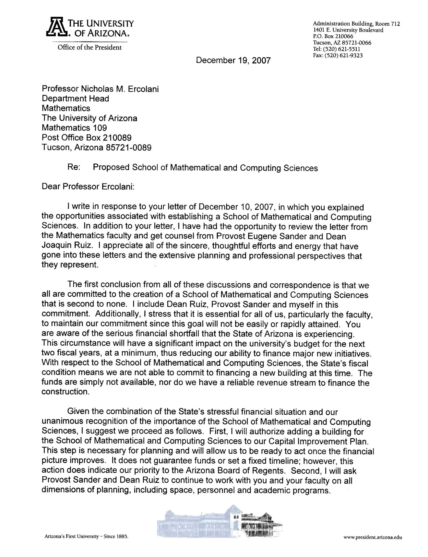

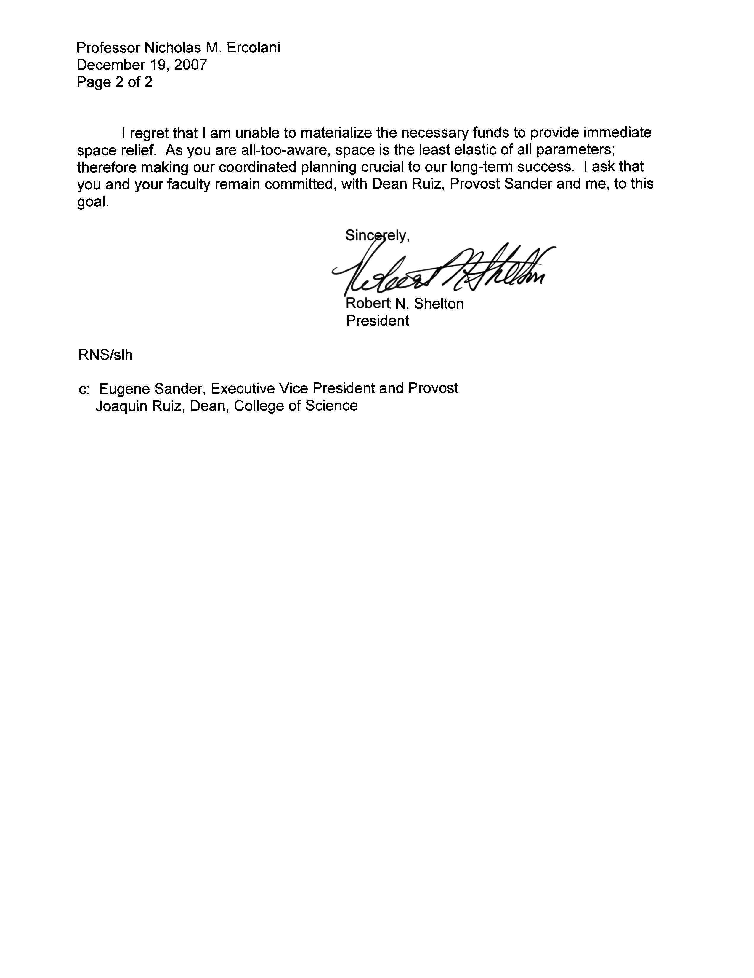

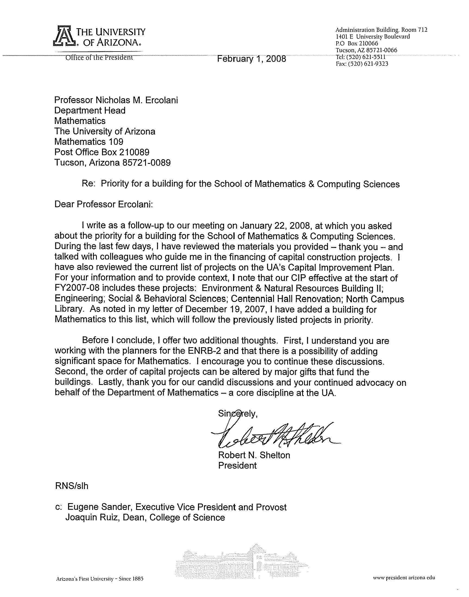

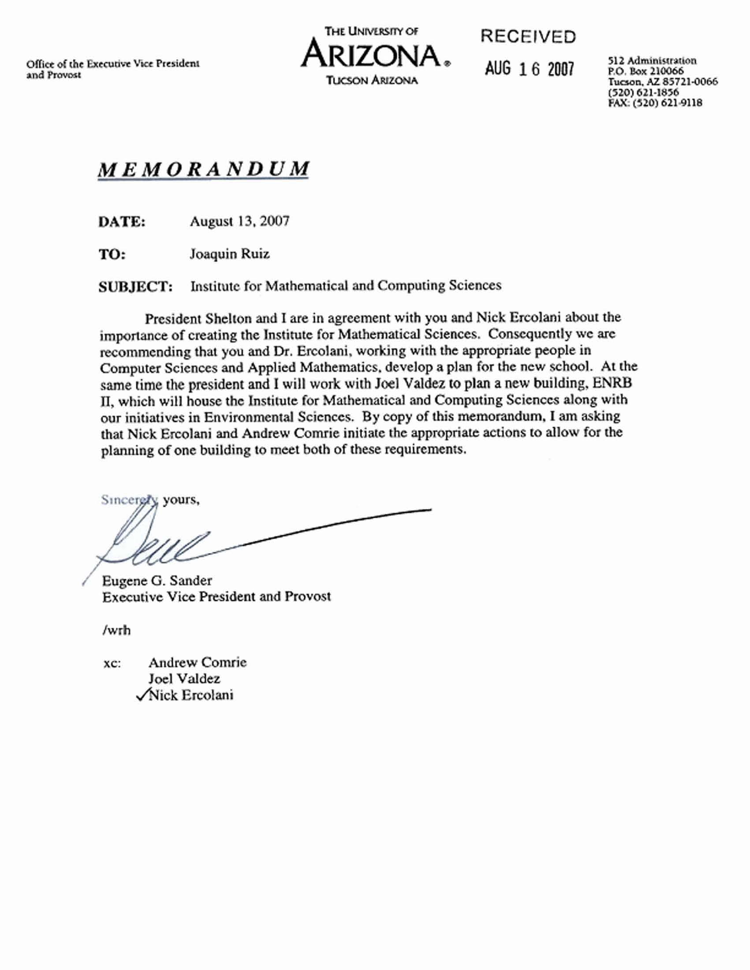

Section D – Faculty

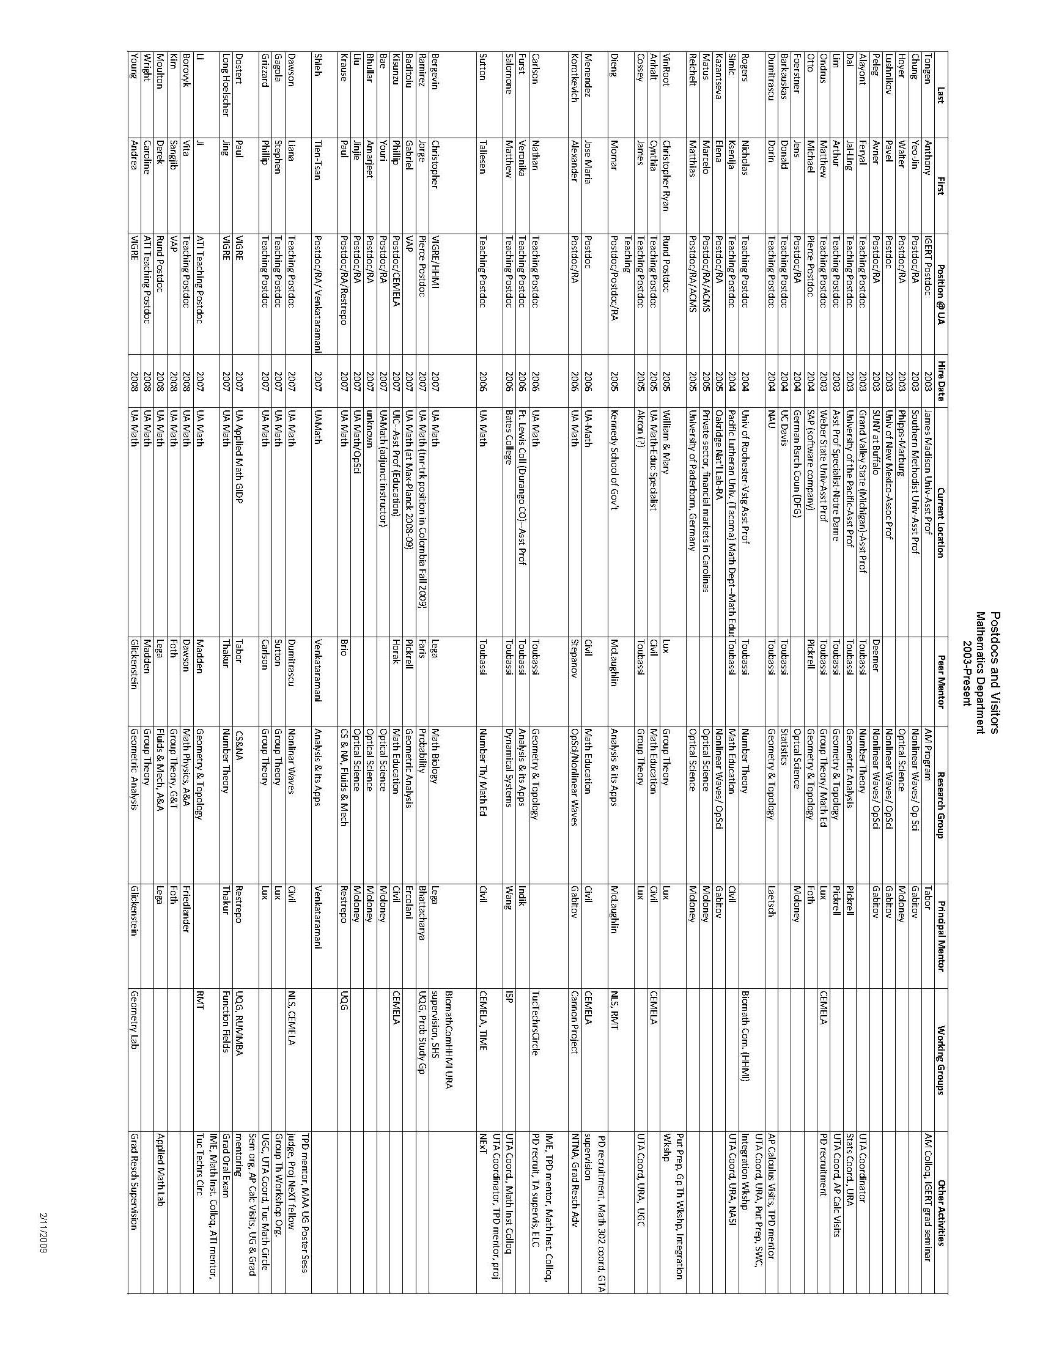
Postdocs and Visitors

Peer Review Statistics
Calendar Year 2000 (Completed in 2001)
Total Tenured Faculty Reviewed in 2000-01: 46
 |  |  |  | Overall
Ratings: | Teaching | Scholarship | Service | Performance
Truly Exceptional | 2 | 11 | 10 | See Note 1
Exceeds Expectations | 29 | 16 | 18 | See Note 1
Meets Expectations | 13 | 15 | 16 | See Note 1
Needs Improvement
Unsatisfactory
Not applicable/not rated in this category-See Note 2 | 2 | 4 | 2 | See Note 1
Total | 46 | 46 | 46
Note 1: In the Mathematics Department, we give an overall rating of either "Satisfactory" or "Unsatisfactory." All 46 persons reviewed received a Satisfactory rating.
Note 2: The two listed in "Teaching" and in "Service" are for professors who are on sabbatical.
The 4 under "Scholarship" are due to workloads that focus the individual's time on teaching & service.
Calendar Year 2001 (Completed in 2002)
Total Tenured Faculty Reviewed in 2000-01: 50
 |  |  |  |  |  |  | Overall
Ratings: |  | Teaching |  | Scholarship | Service |  | Performance
Truly Exceptional |  | 2 |  | 7 | 3 |  | See Note 1
Exceeds Expectations |  | 25 |  | 22 | 22 |  | See Note 1
Meets Expectations |  | 22 |  | 20 | 24 |  | See Note 1
Needs Improvement |  | 0
Unsatisfactory |  | 0
Not applicable/not rated in this category-See Note 2 |  | 1 |  | 1 | 1 |  | See Note 1
Total |  | 50 |  | 50 | 50
Note 1: In the Mathematics Department, we give an overall rating of either "Satisfactory" or "Unsatisfactory." All 49 persons reviewed received a Satisfactory rating.

Note 2: Regarding Not Applicable ratings: The Department Head's review was conducted by the Dean so is not included here.
Calendar Year 2002 (Completed in 2003)
(Audit Year)
Total Tenured Faculty Reviewed: 50
 |  |  |  |  |  |  | Overall
Ratings: |  | Teaching |  | Scholarship | Service |  | Performance
Truly Exceptional |  | 1 |  | 7 | 4 |  | See Note 1
Exceeds Expectations |  | 24 |  | 24 | 29 |  | See Note 1
Meets Expectations |  | 23 |  | 17 | 15 |  | See Note 1
Needs Improvement |  | 0 |  | 0 | 0 |  | See Note 1
Unsatisfactory |  | 0 |  | 0 | 0 |  | See Note 1
Not applicable/not rated in this category-See Note 2 |  | 1 |  | 1 | 1 |  | See Note 1
Total |  | 49 |  | 49 | 49
Note 1: In the Mathematics Department, we give an overall rating of either "Satisfactory" or "Unsatisfactory." All 49 persons reviewed received a Satisfactory rating.
Note 2: Regarding Not Applicable ratings: The Department Head's review was conducted by the Dean so is not included here
Calendar Year 2003 (Completed in 2004)
Total Tenured Faculty Reviewed: 49
 |  |  |  | Overall
Ratings: | Teaching | Scholarship | Service | Performance
Truly Exceptional | 1 | 5 | 4 | See Note 1
Exceeds Expectations | 22 | 30 | 28 | See Note 1
Meets Expectations | 26 | 14 | 17 | See Note 1
Needs Improvement | 0 | 0 | 0 | See Note 1
Unsatisfactory | 0 | 0 | 0 | See Note 1
Not applicable/not rated in this category |  |  |  | See Note 1
Total | 49 | 49 | 49

Note 1: In the Mathematics Department, we give an overall rating of either "Satisfactory" or "Unsatisfactory." All 49 persons reviewed received a Satisfactory rating.
Calendar Year 2004 (Completed in 2005)
Total Tenured Faculty Reviewed: 49
 |  |  |  |  |  |  | Overall
Ratings: | Teaching |  | Scholarship |  | Service |  | Performance
Truly Exceptional | 1 |  | 5 |  | 5 |  | See Note 1
Exceeds Expectations | 23 |  | 28 |  | 24 |  | See Note 1
Meets Expectations | 26 |  | 17 |  | 21 |  | See Note 1
Needs Improvement | 0 |  | 0 |  | 0 |  | See Note 1
Unsatisfactory | 0 |  | 0 |  | 0 |  | See Note 1
Not applicable/not rated in this category |  |  |  |  |  |  | See Note 1
Total | 50 |  | 50 |  | 50
Note 1: In the Mathematics Department, we give an overall rating of either "Satisfactory" or "Unsatisfactory." All 50 persons reviewed received a Satisfactory rating.
Calendar Year 2005 (Completed in 2006)
Total Tenured Faculty Reviewed: 51
 |  |  |  |  |  |  | Overall
Ratings: | Teaching |  | Scholarship |  | Service |  | Performance
Truly Exceptional | 2 |  | 3 |  | 3 |  | See Note 1
Exceeds Expectations | 18 |  | 27 |  | 24 |  | See Note 1
Meets Expectations | 31 |  | 21 |  | 24 |  | See Note 1
Needs Improvement | 0 |  | 0 |  | 0 |  | See Note 1
Unsatisfactory | 0 |  | 0 |  | 0 |  | See Note 1
Not applicable/not rated in this category |  |  |  |  |  |  | See Note 1
Total | 51 |  | 51 |  | 51
Note 1: In the Mathematics Department, we give an overall rating of either "Satisfactory" or "Unsatisfactory." All 51 persons reviewed received a Satisfactory rating.
Calendar Year 2006 (Completed in 2007)
Total Tenured & Tenure-Track Faculty Reviewed: 59 | Tenured Faculty
 |  |  |  |  |  |  | Overall
Ratings: | Teaching |  | Scholarship |  |  | Service | Performance
Truly Exceptional | 0 |  | 3 |  |  | 2 | See Note 1
Exceeds Expectations | 20 |  | 26 |  |  | 26 | See Note 1
Meets Expectations | 25 |  | 16 |  |  | 17 | See Note 1
Needs Improvement | 0 |  | 0 |  |  | 0 | See Note 1
Unsatisfactory | 0 |  | 0 |  |  | 0 | See Note 1
Not applicable/not rated in this category-See Note 2 |  |  |  |  |  |  | See Note 1
Total | 45 |  | 45 |  |  | 45
Note 1: In the Mathematics Department, we give an overall rating of either "Satisfactory" or "Unsatisfactory." All 45 persons reviewed received a Satisfactory rating.

Calendar Year 2007 (Completed in 2008)
(Audit Year)
Total Tenured & Tenure-Track Faculty Reviewed: 59 | Tenured Faculty
 |  |  |  | Overall
Ratings: | Teaching | Scholarship | Service | Performance
Truly Exceptional | 0 | 2 | 2 | See Note 1
Exceeds Expectations | 25 | 30 | 26 | See Note 1
Meets Expectations | 24 | 17 | 21 | See Note 1
Needs Improvement | 0 | 0 | 0 | See Note 1
Unsatisfactory | 0 | 0 | 0 | See Note 1
Not applicable/not rated in this category-See Note 2 |  |  |  | See Note 1
Total | 49 | 49 | 49
Note 1: In the Mathematics Department, we give an overall rating of either "Satisfactory" or "Unsatisfactory." All 49 persons reviewed received a Satisfactory rating.

Section E – Undergraduate Program

Winds of Change Article
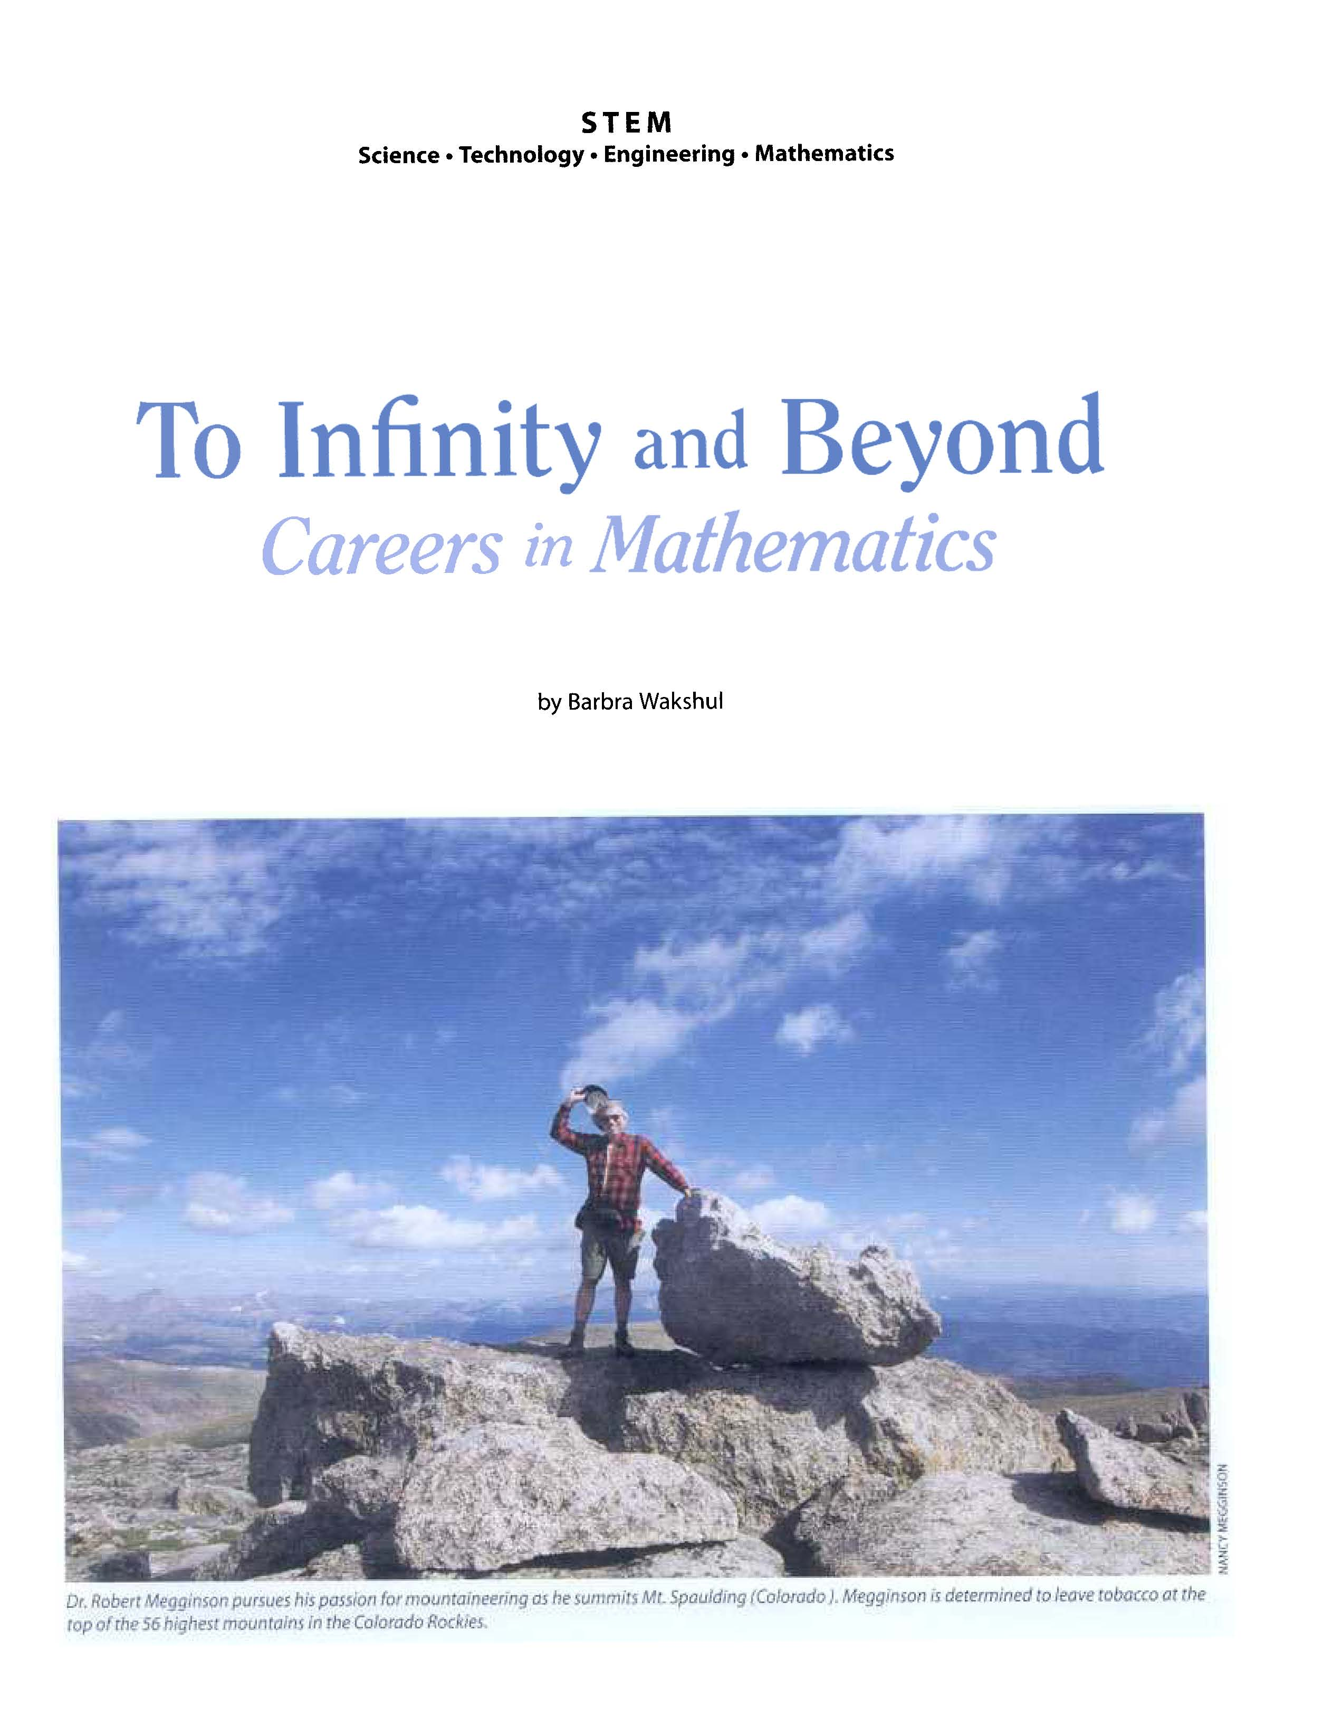

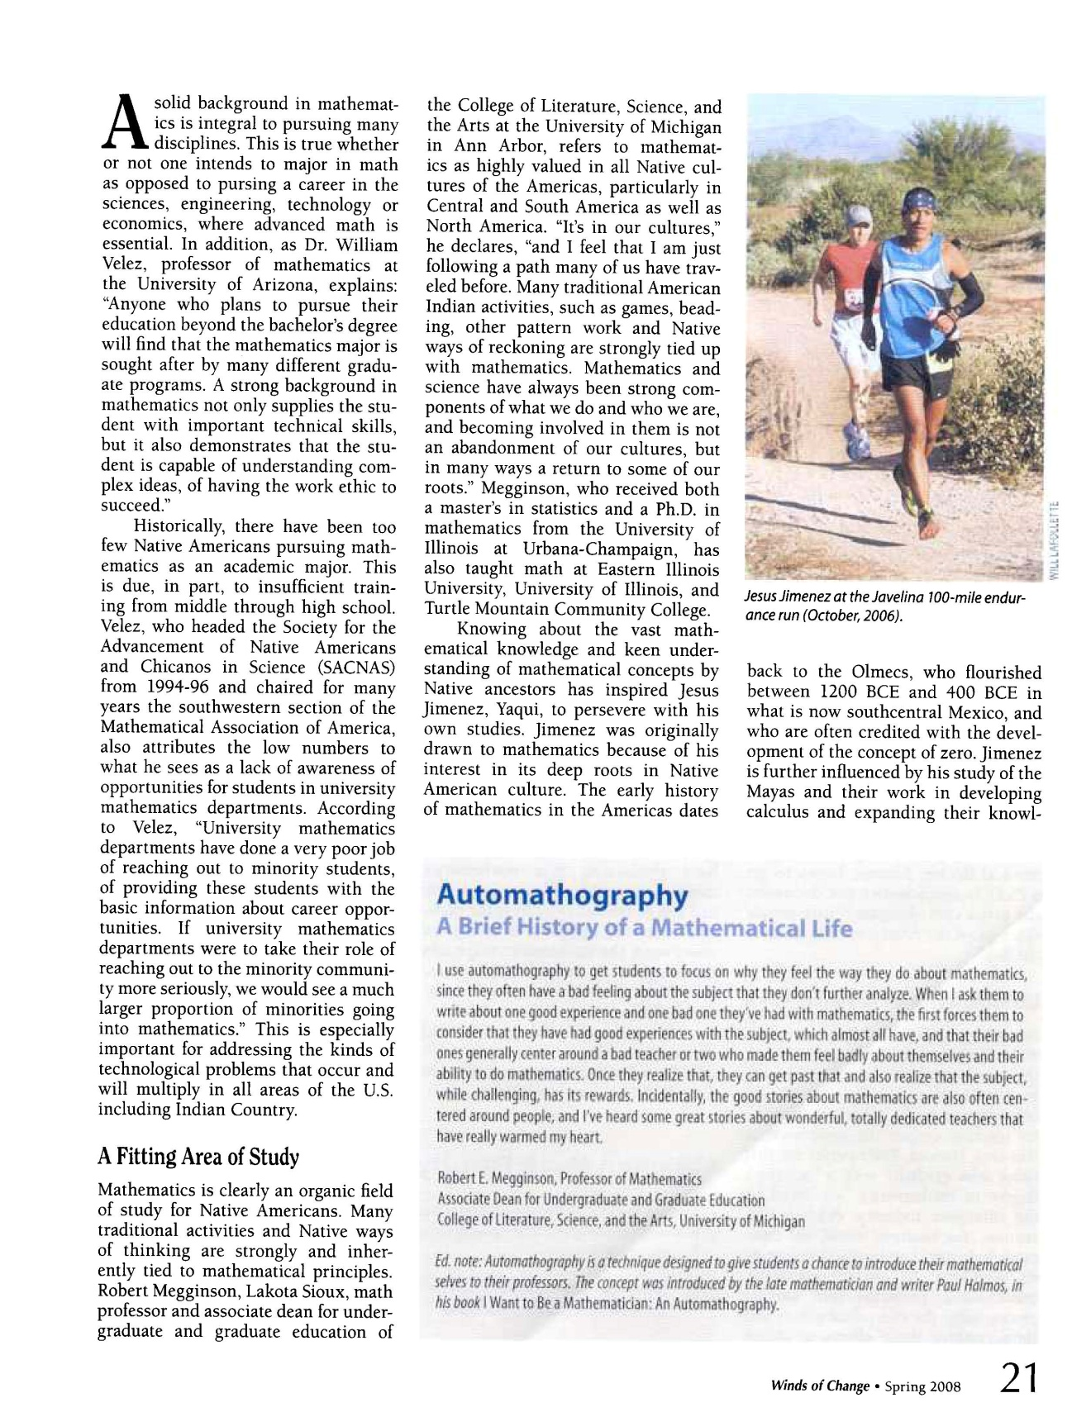

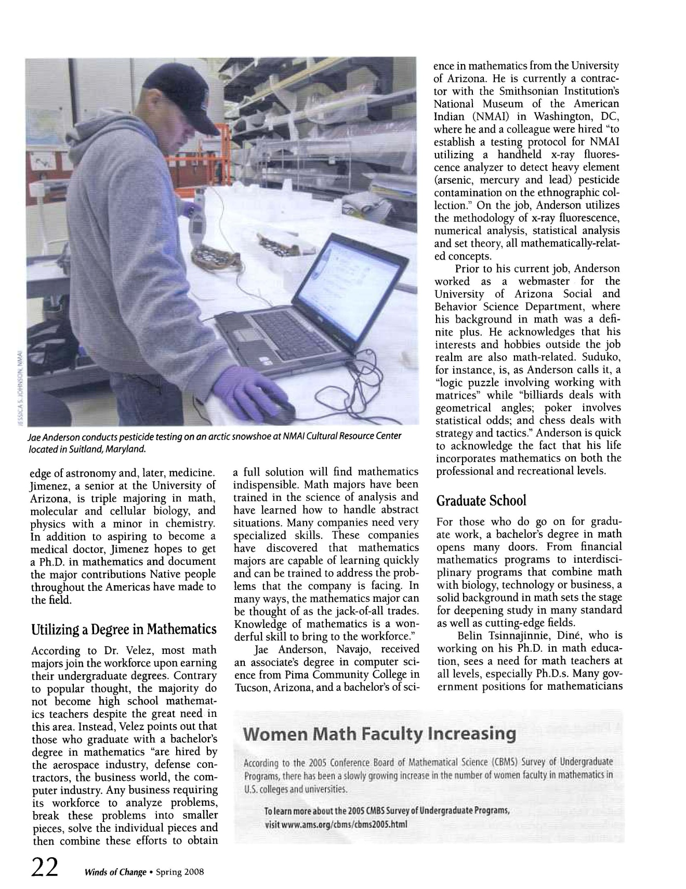

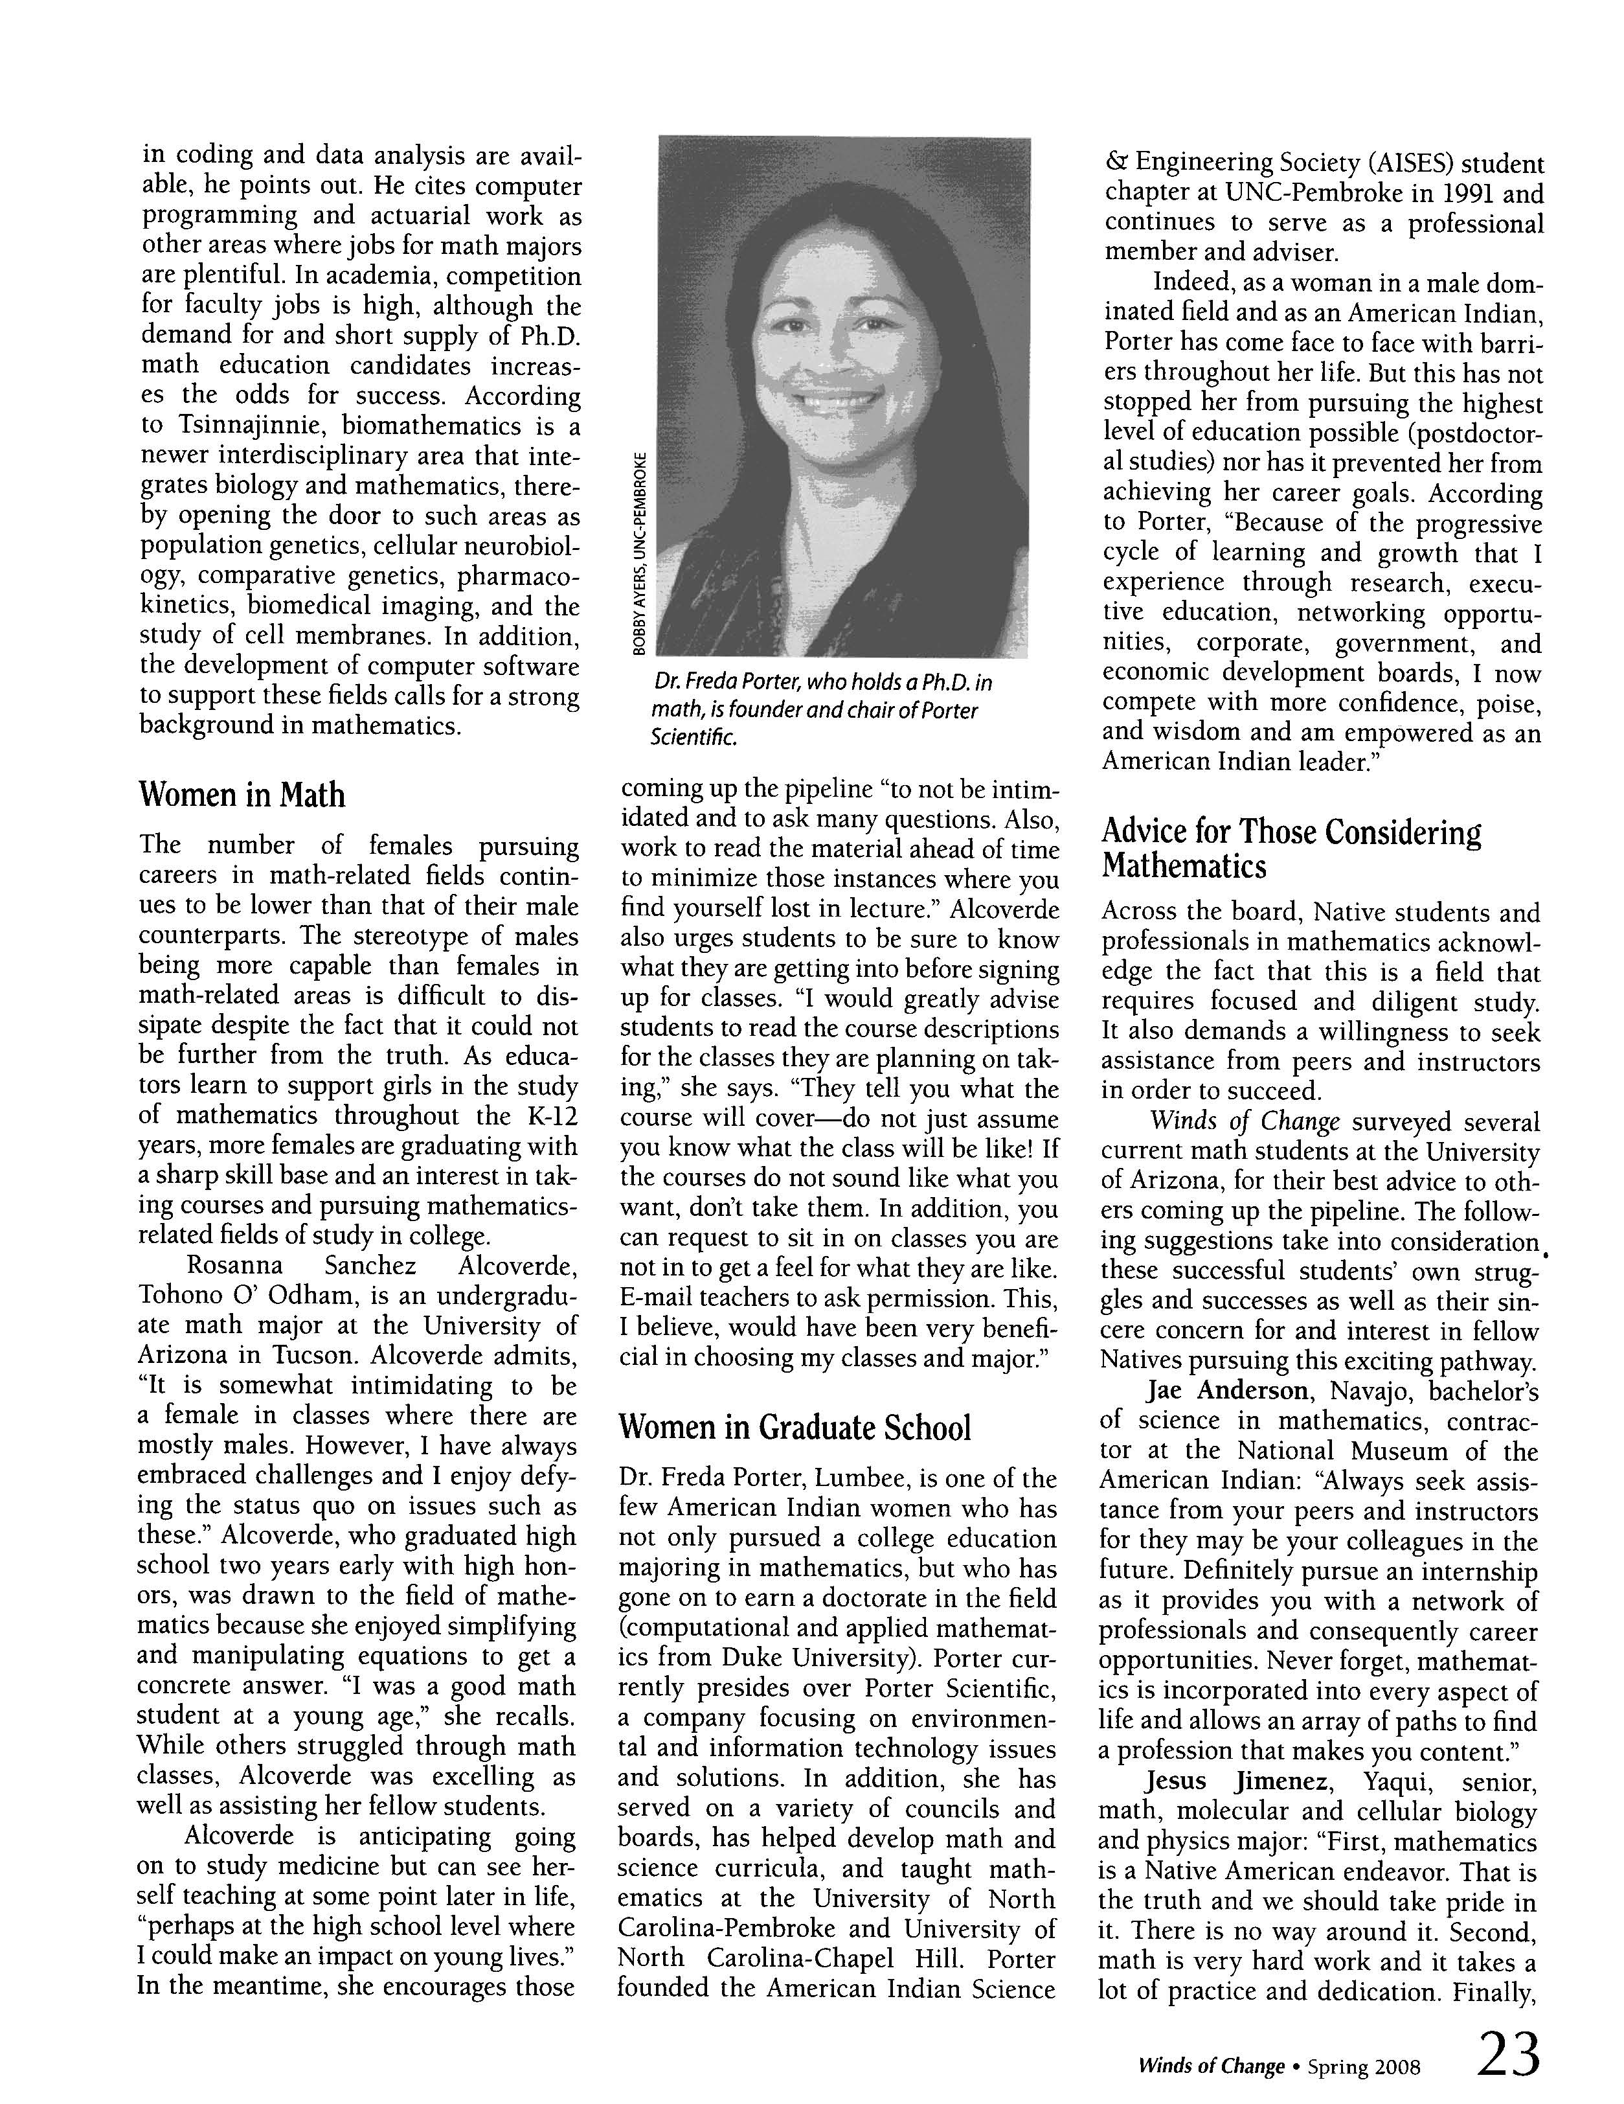

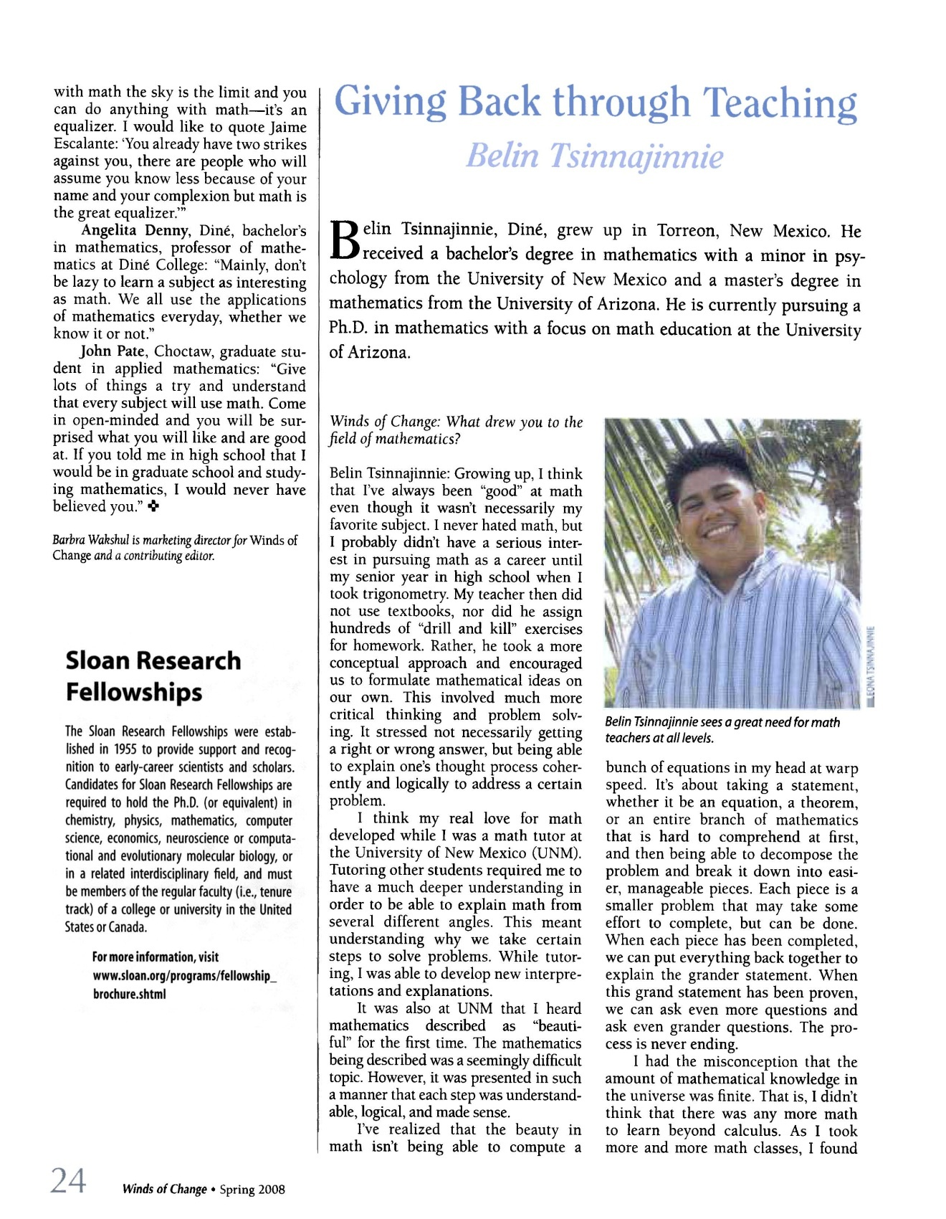

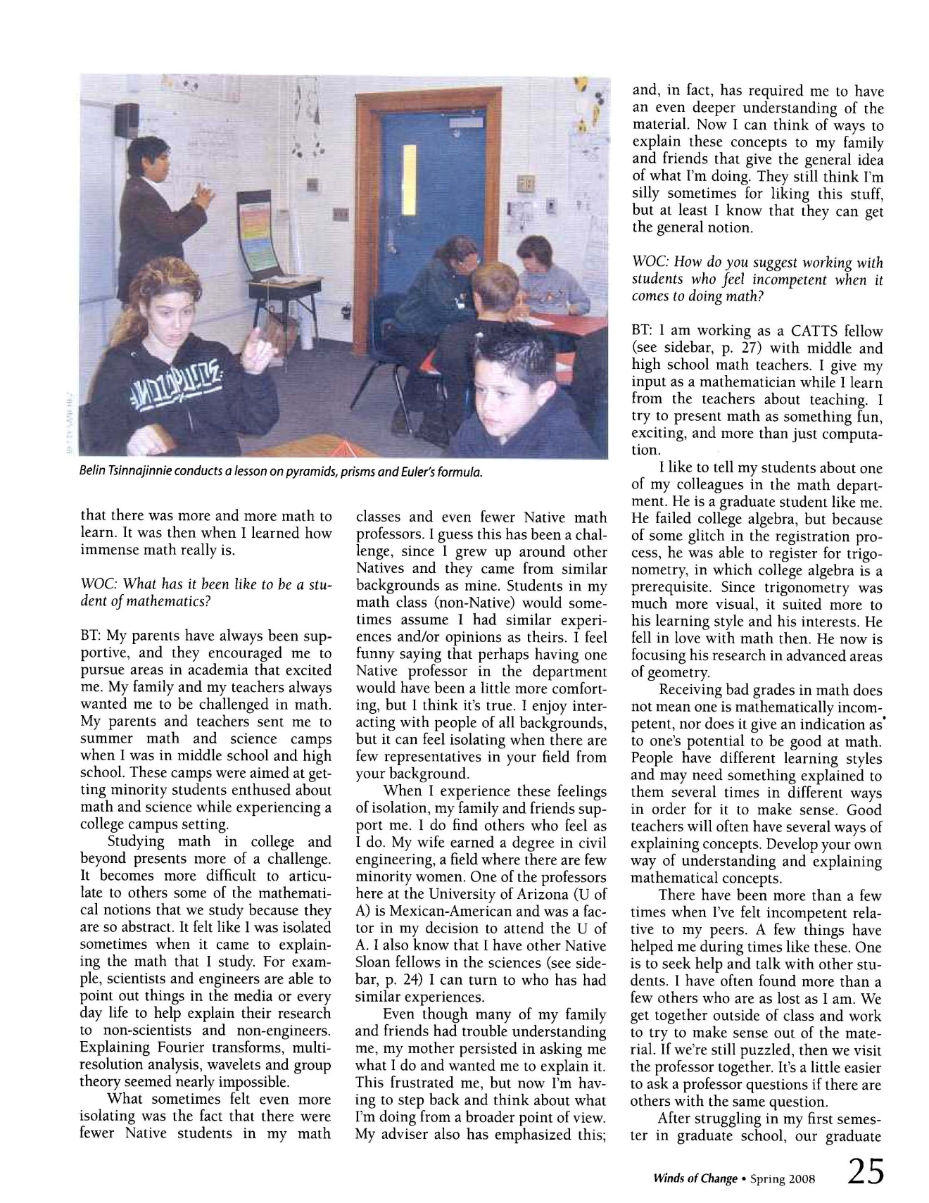

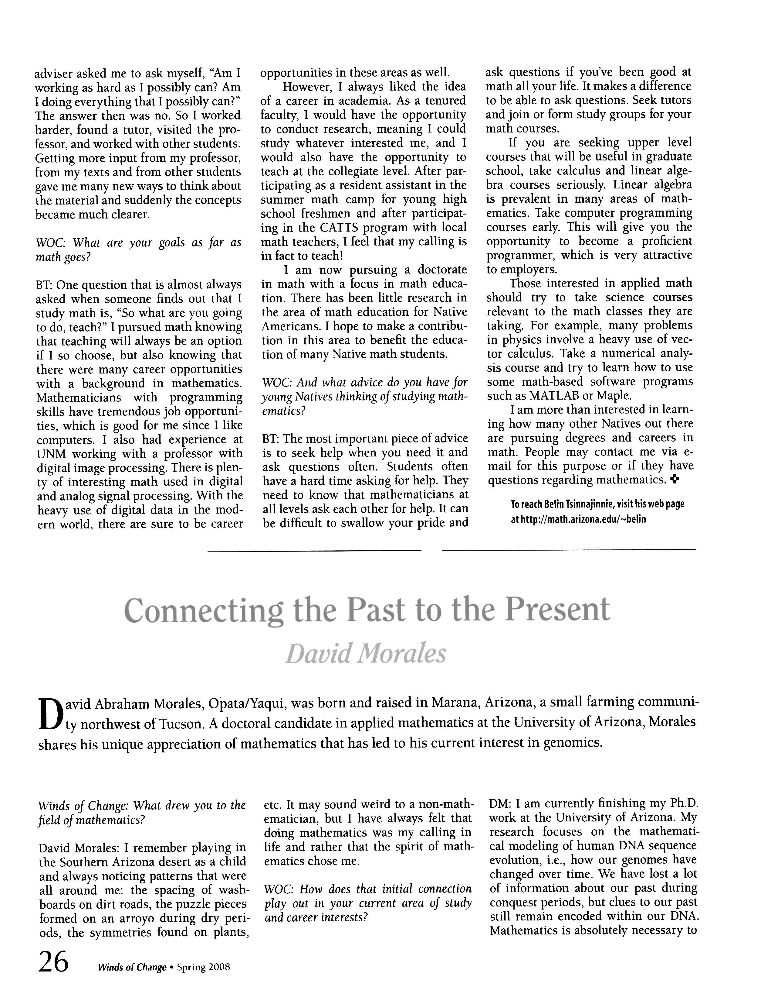

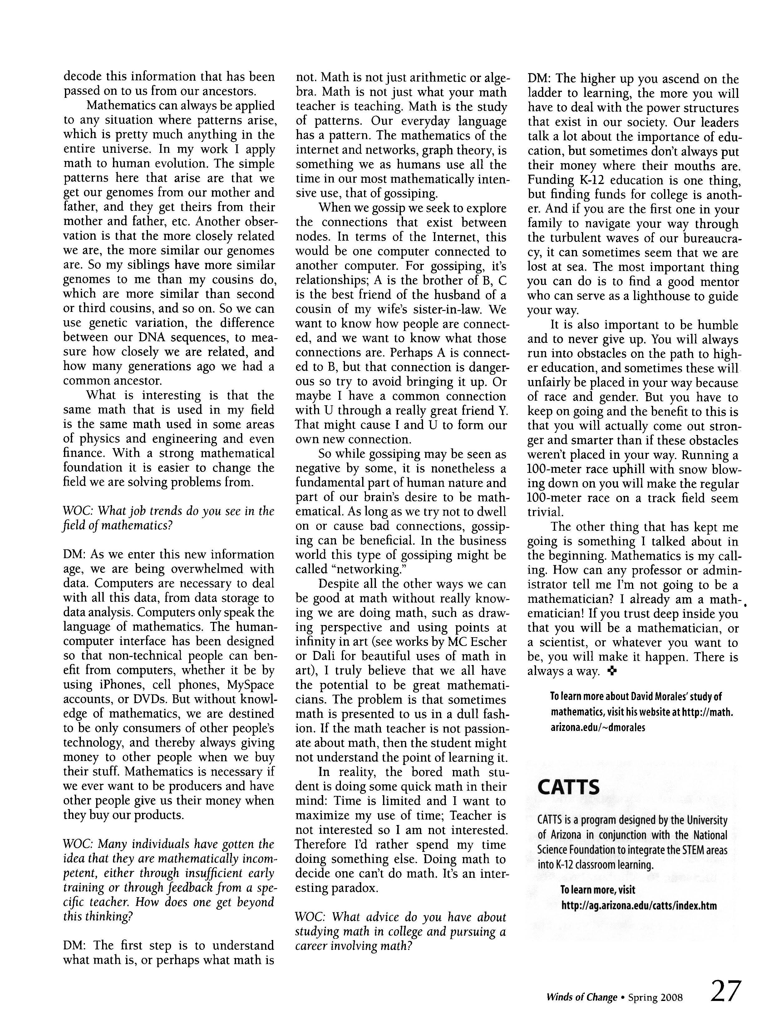

Section F – Graduate Program

Recent Graduates and Placement
Name | Degree awarded | Yr entered | Yr graduated | 1st Placement
McLeman, Cameron | PhD | 2002 | 2008 | Willamette University
Berger, Lisa Anne | PhD | 1999 | 2007 | SUNY at Stony Brook
Caine, John Arlo | PhD | 2001 | 2007 | Max Planck Inst, Bonn, Germany
Fernandes, Anthony | PhD | 2002 | 2007 | University of North Carolina at Charlotte
Ivkovic, Milos | PhD | 2004 | 2007 | LSI Logic Corporation
Lo, Assane | PhD | 2000 | 2007 | King Fahd University, Saudi Arabia
Miller, Justin T. | PhD | 2001 | 2007 | IBM, Tucson
Punosevac, Predrag | PhD | 2003 | 2007 | Adjunct Lecturer, University of Arizona
Habermas, Derek | PhD | 2000 | 2006 | State University of New York, Potsdam
Konstantinou, Panagiota | PhD | 2001 | 2006 | Frederick University, Cyprus
Levitt, Benjamin | PhD | 1999 | 2006 | California State University, Chico
Pawloski, Robert | PhD | 2001 | 2006 | Monmouth University
Spiegler, Adam | PhD | 2000 | 2006 | Visiting Prof, University of Arizona
Belnap, Jason Knight | PhD | 1996 | 2005 | Brigham Young University
Leitner, Frederick Carl, II | PhD | 1999 | 2005 | Ben Gurion University, Israel
Hoffman, Thomas R | PhD | 1998 | 2004 | Coastal Carolina University
Lozano, Guadalupe Ines | PhD | 1996 | 2004 | University of Michigan, Ann Arbor
Perlis, Alexander Russell | PhD | 1994 | 2004 | Computer System Admin, UA
Piatek-Jimenez, Katrina L. | PhD | 1999 | 2004 | Central Michigan University
Pierce, Virgil U | PhD | 1998 | 2004 | Brandeis University
Rasmussen, Christopher J | PhD | 1998 | 2004 | Rice University
Selden, Jeffrey Lee | PhD | 1998 | 2004 | Erwin Schroedinger Int'l Institute, Austria
Shipman, Patrick Daniel | PhD | 1999 | 2004 | Max Planck Inst, Leipzig, Germany
Wootton, Aaron Del | PhD | 1998 | 2004 | University of Portland
Leahy, Jennifer C. | MS | 2005 | 2008 | Rhode Island High School
de Boer, Wieke | MS | 2004 | 2007 | Adjunct Lecturer, University of Arizona
Harris, Donna | MS | 2004 | 2006 | Unknown
Hoffman, Sarah | MS | 2004 | 2006 | Adjunct Lecturer, University of Arizona
Koppens, Melvin | MS | 2004 | 2006 | Unknown
Sinari, Shripad | MS | 2000 | 2005 | Unknown
Alvarado, Alejandra | MS | 2001 | 2004 | ASU PhD Program
Amjad, Ali | MS | 2002 | 2004 | Unknown
Guevara, Cristi Darley | MS | 2001 | 2004 | ASU PhD Program
Kang, Yun | MS | 2002 | 2004 | Unknown
Swenson, Sacha Anne | MS | 2001 | 2004 | Adjunct Lecturer, University of Arizona
Von Herrmann, Alan | MS | 2001 | 2004 | Colorado State University, Ft. Collins
Heerey, Michael Wayne | MA | 2001 | 2004 | Adjunct Lecturer, University of Arizona
Maagoul, Mohamed Habib | MA | 2000 | 2004 | Unknown
Abramson, Megan | PSM | 2006 | 2008
Nangle, John | PSM | 2005 | 2007
Schilz, Matthew | PSM | 2002 | 2007
Zhao, Qiuhong | PSM | 2004 | 2006
Cangelosi, Richard | PSM | 1999 | 2004
Kidd, Michelle | PSM | 2001 | 2003
Ratnayaka, Kerima | PSM | 2001 | 2003
Miller, Matthew | PSM | 1999 | 2001
Patterson, David | PSM | 1999 | 2001

Section I – Academic Outreach

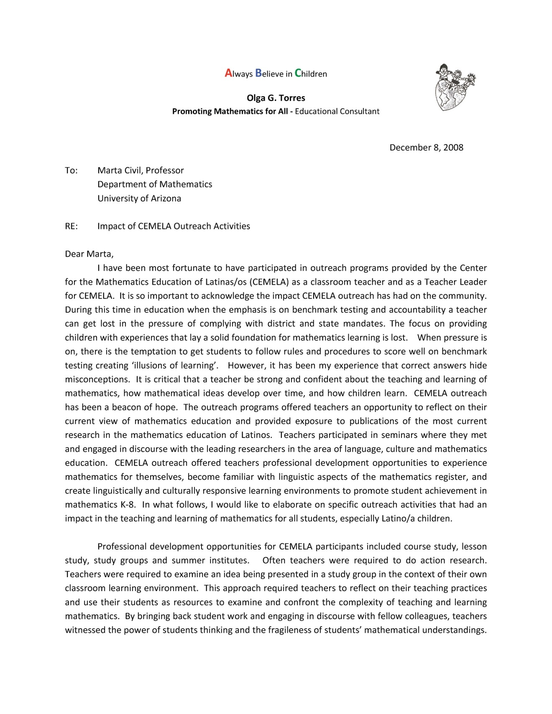
Letters for CEMELA

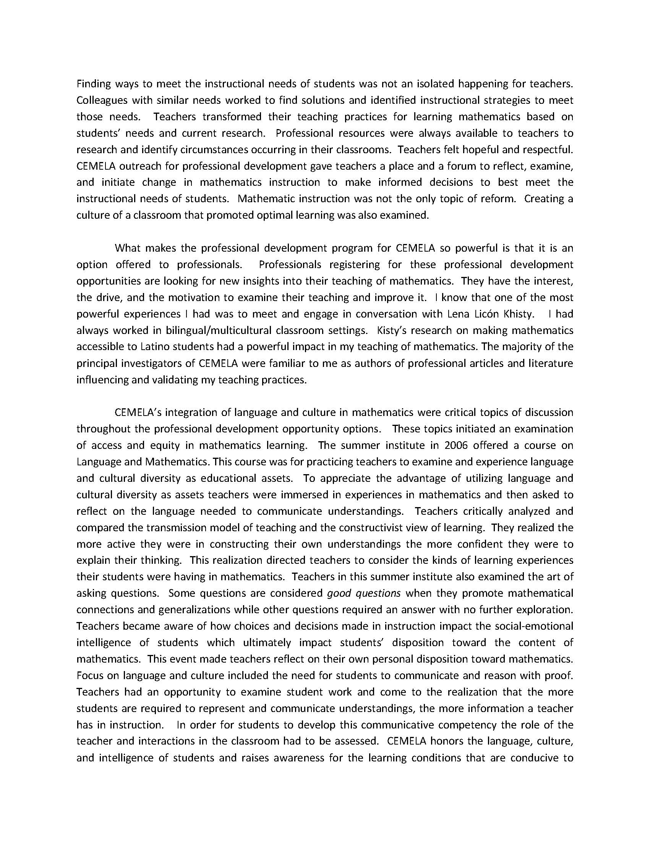

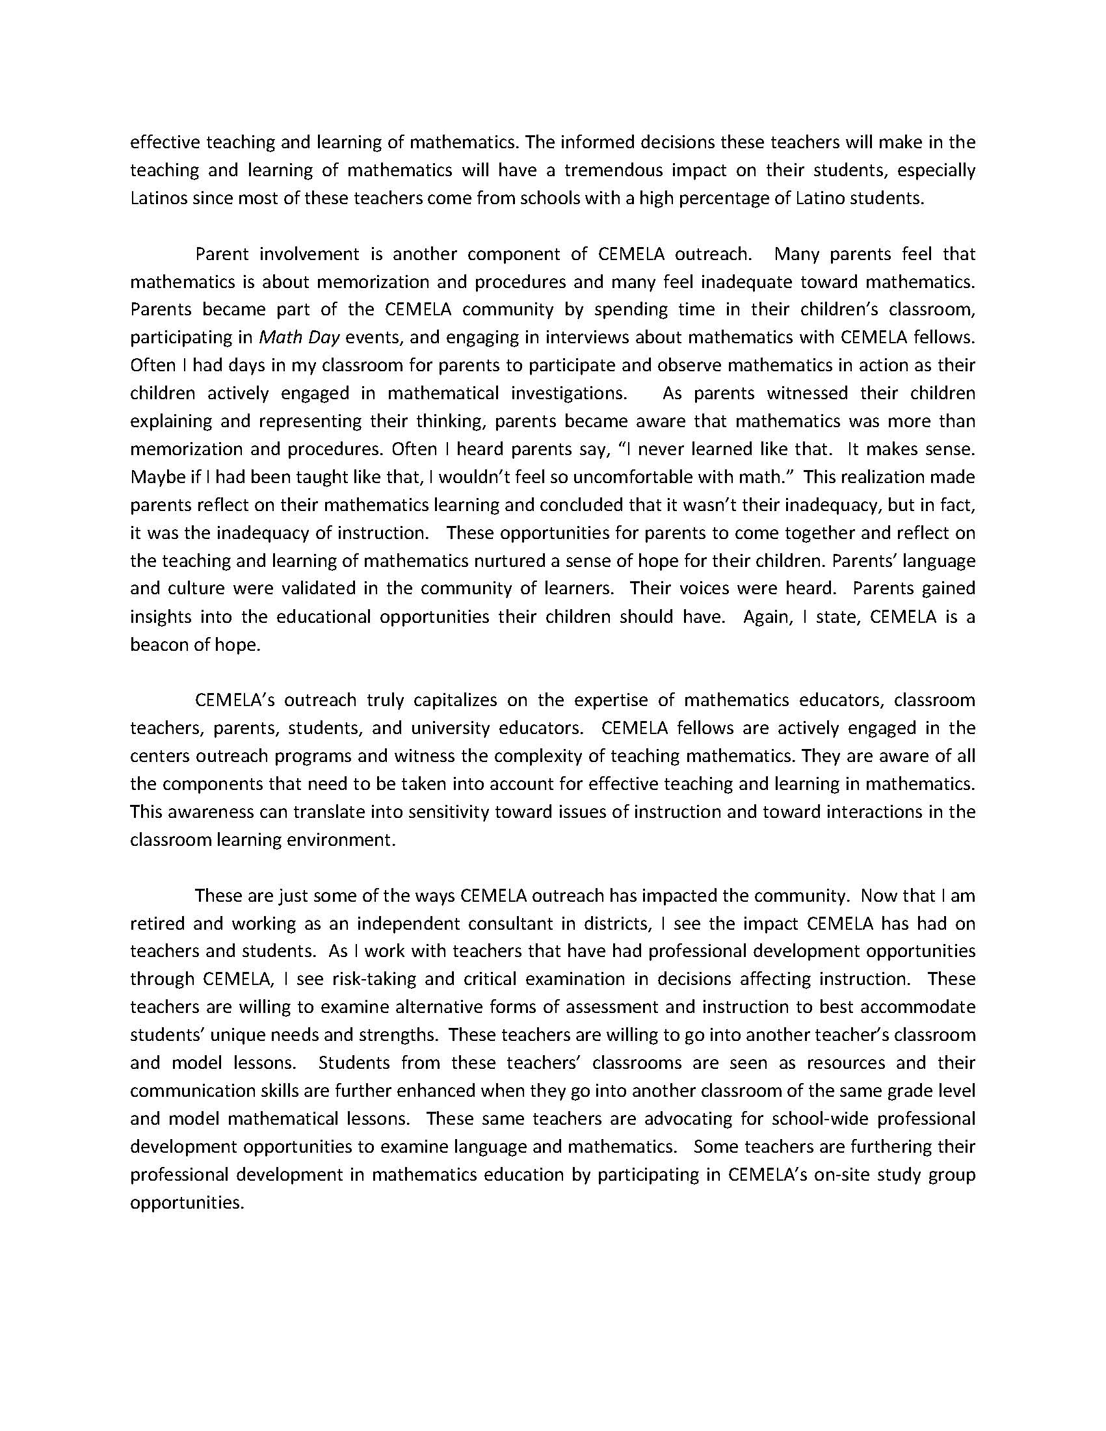

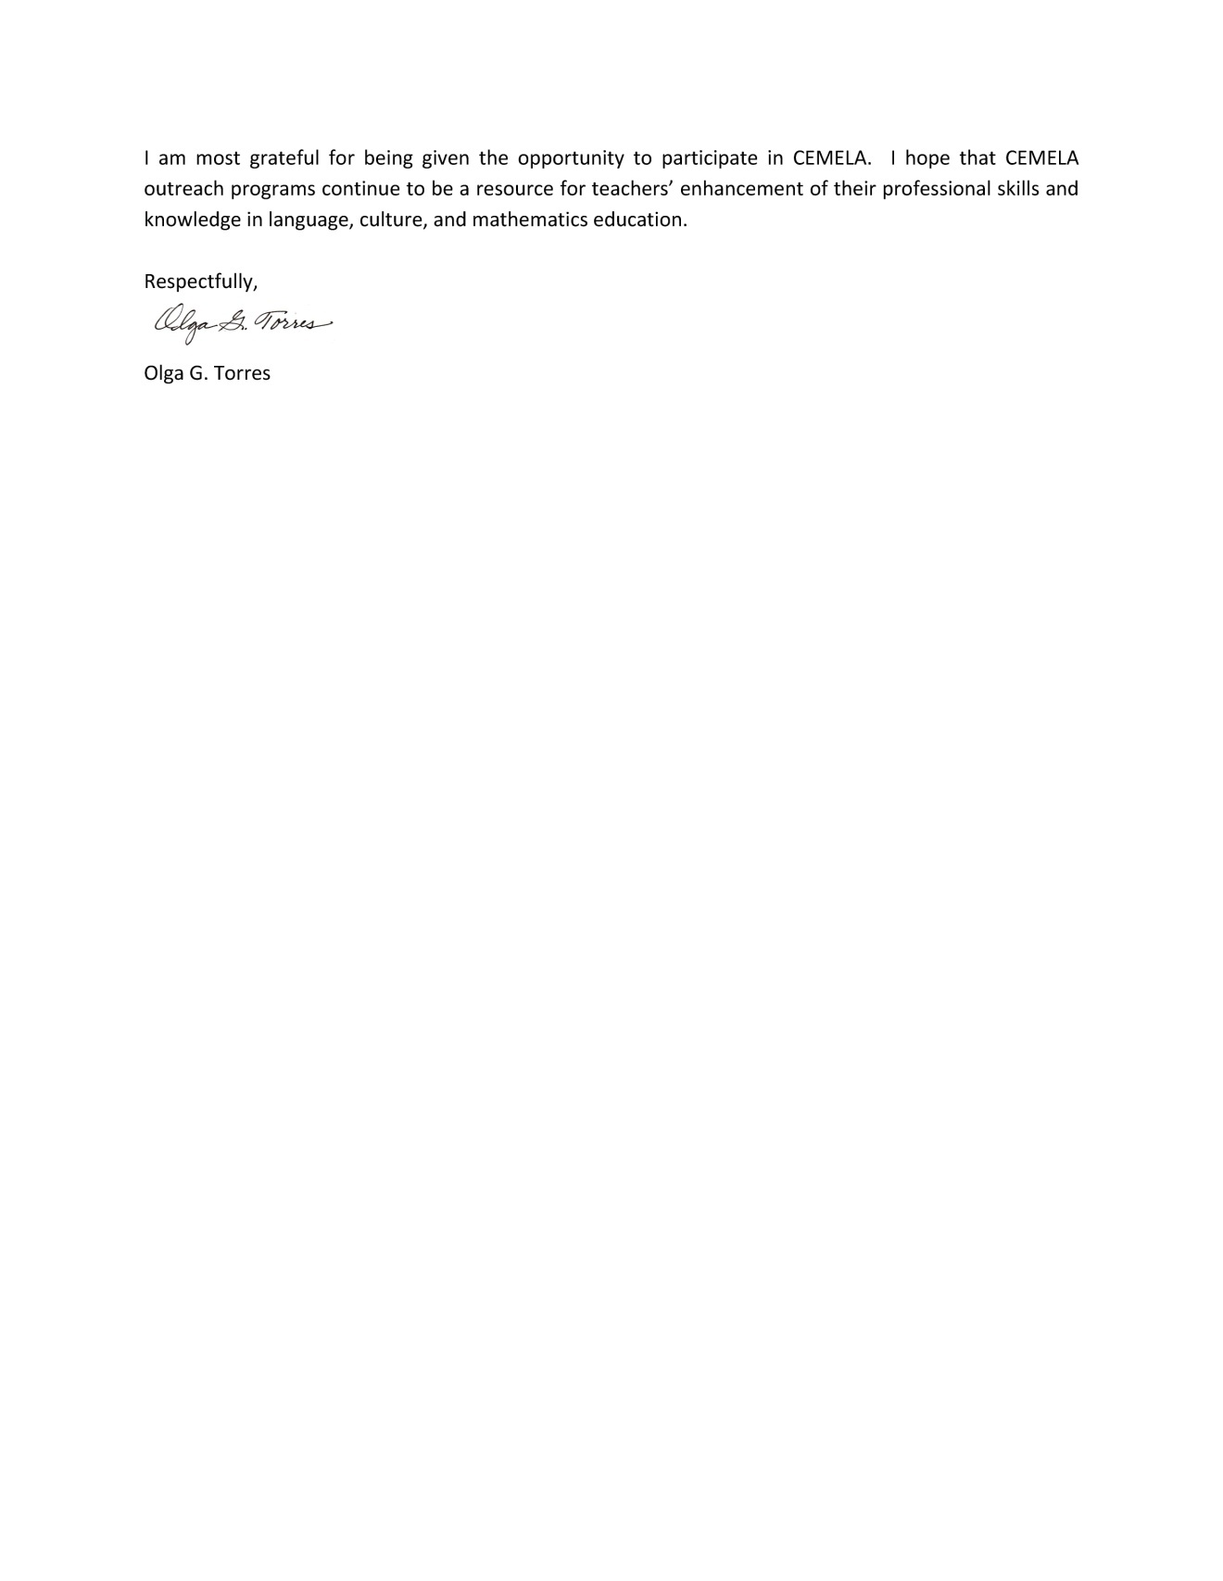

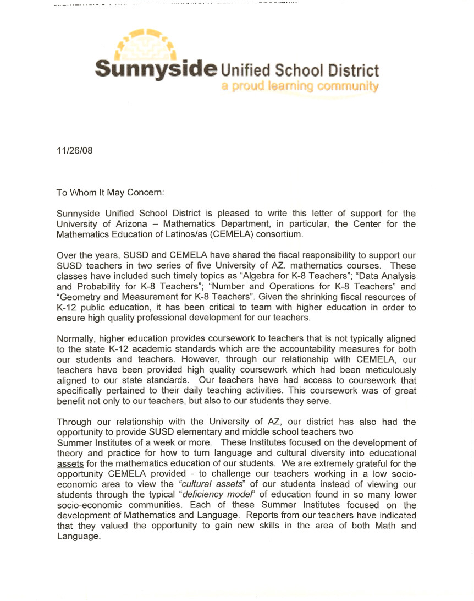
Letters for the Physics Bus

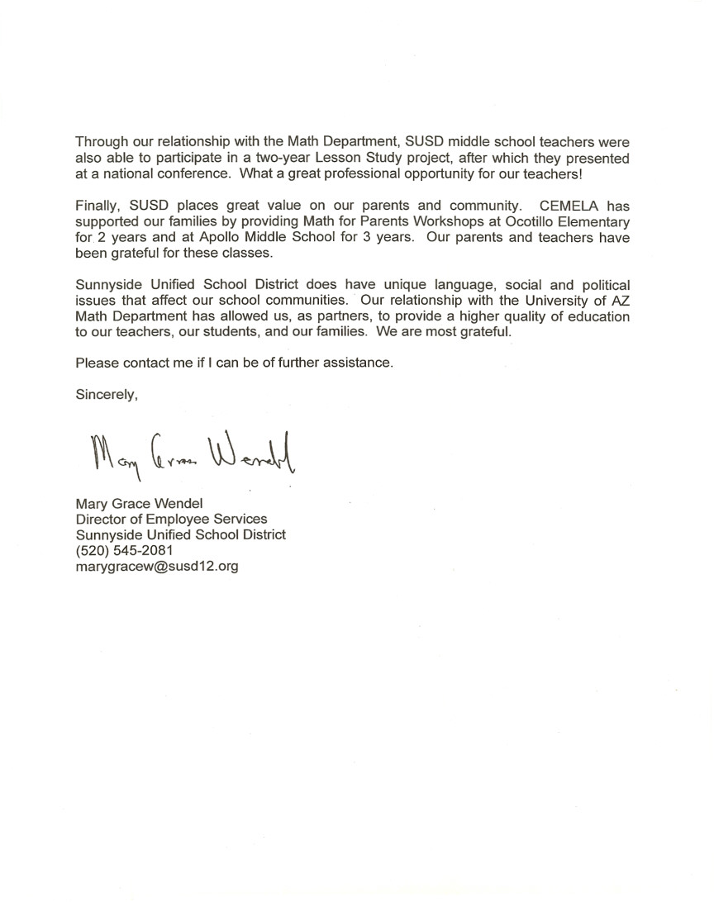

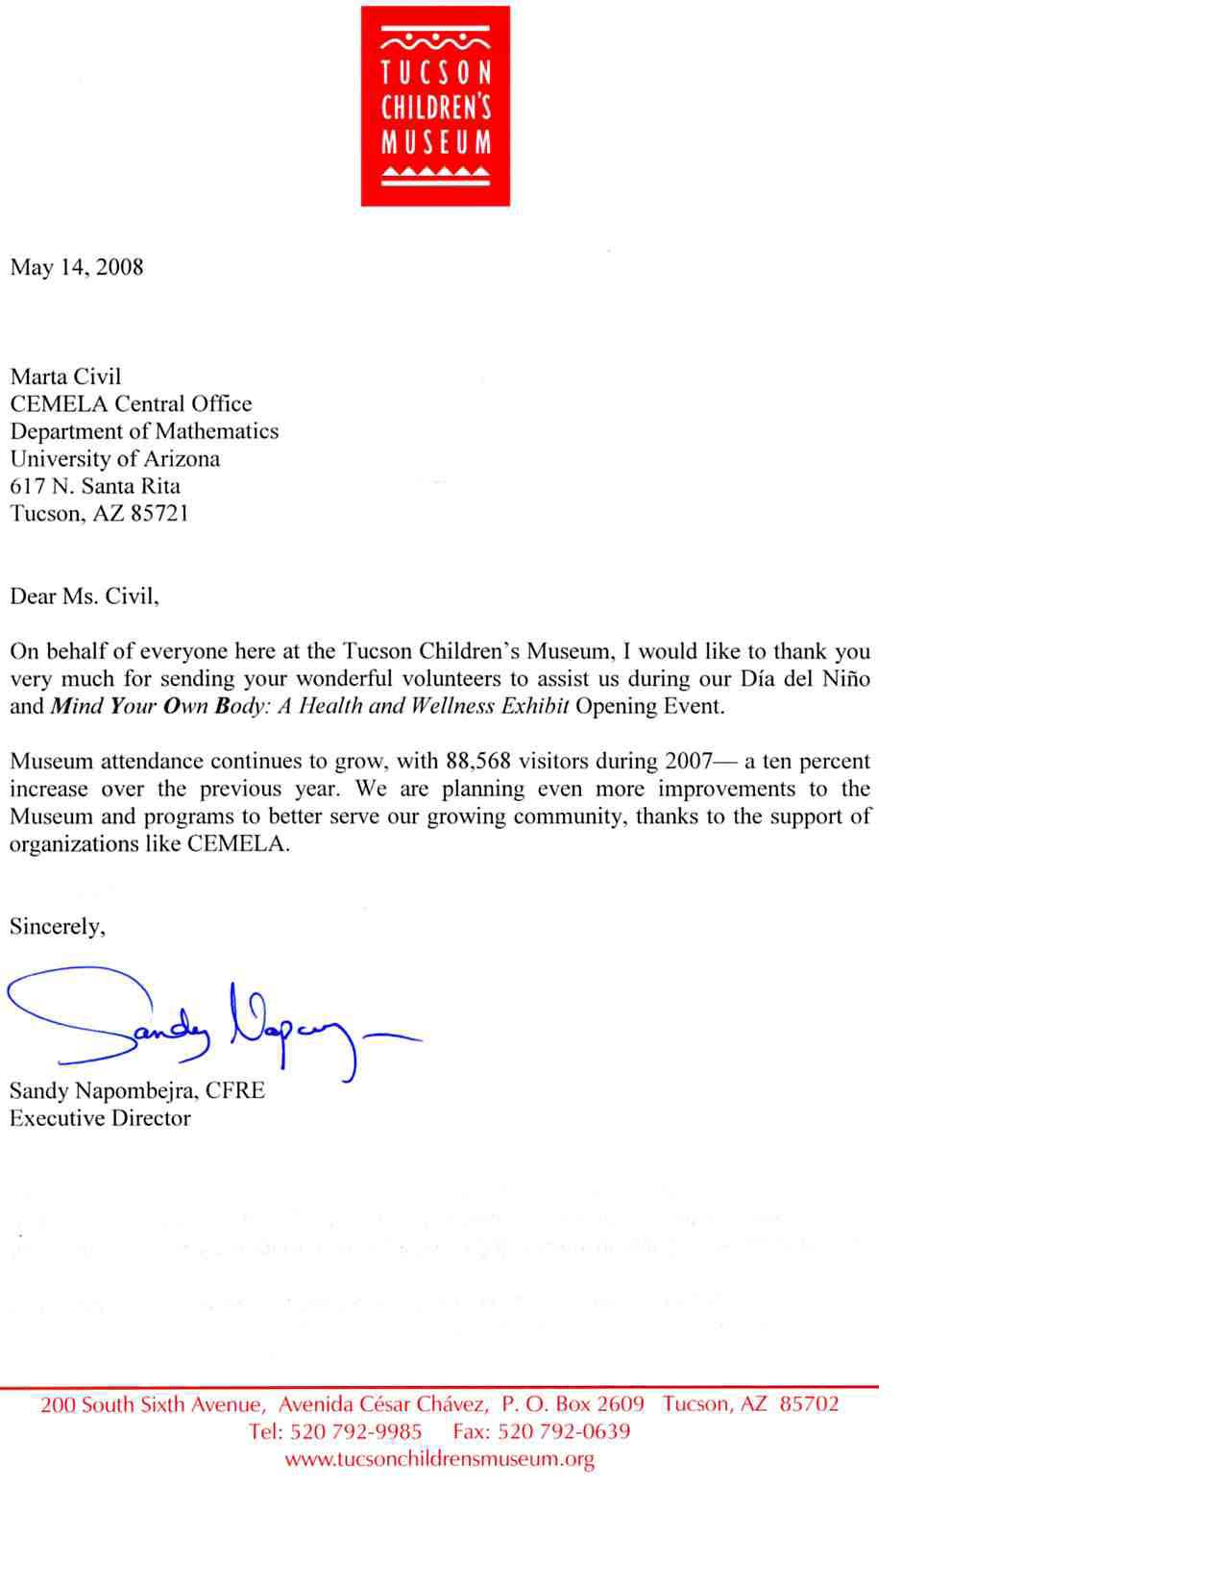

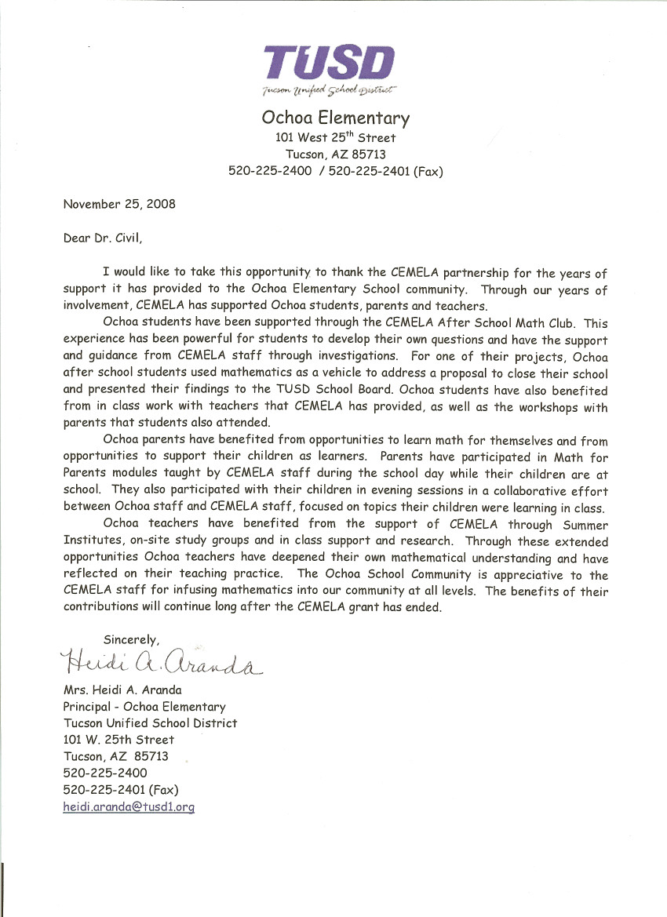

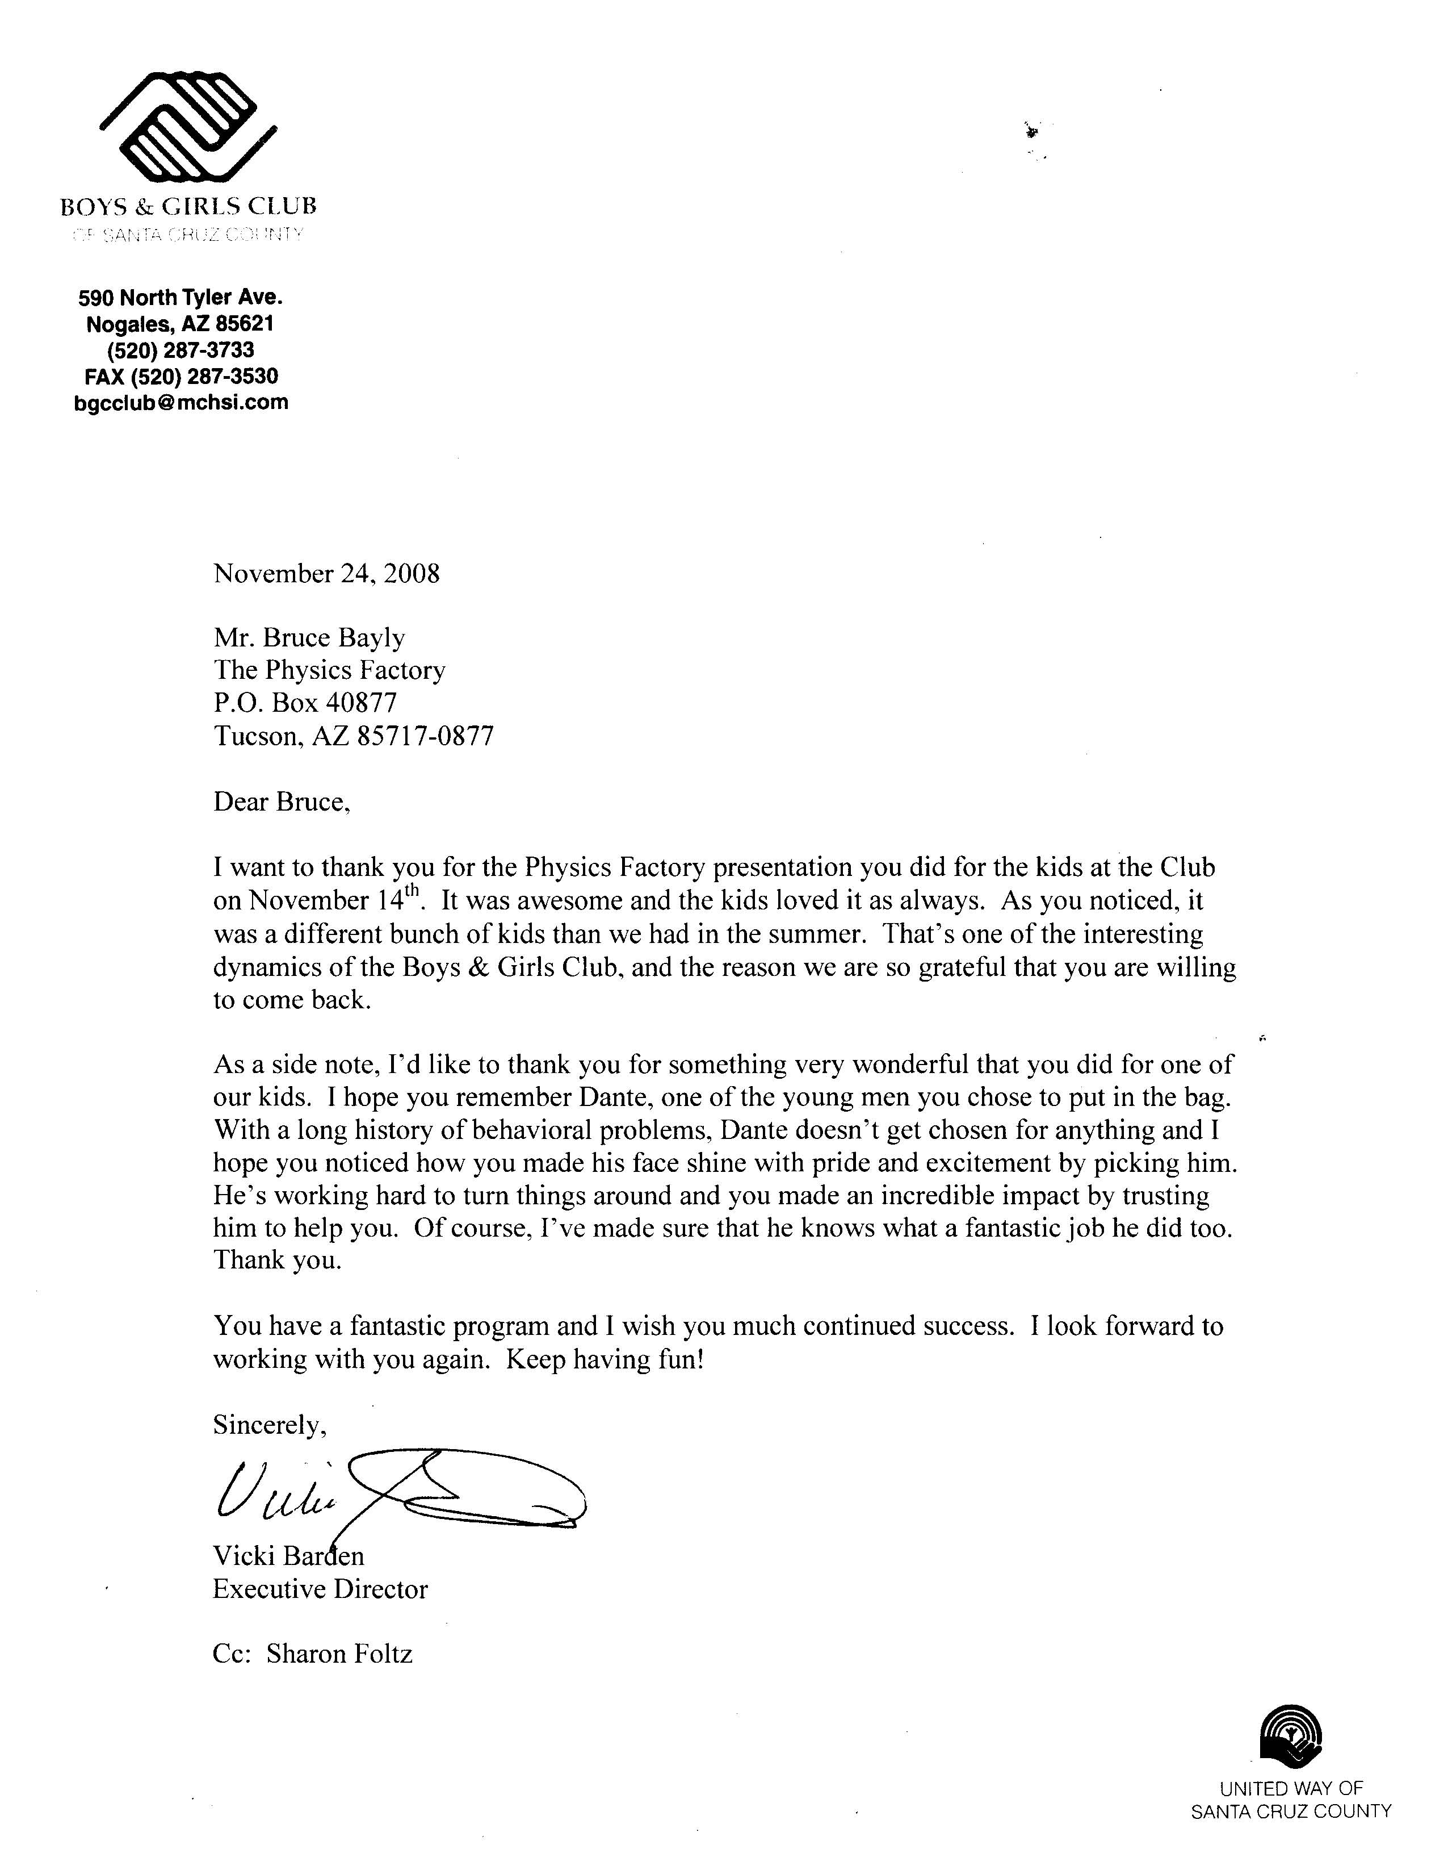

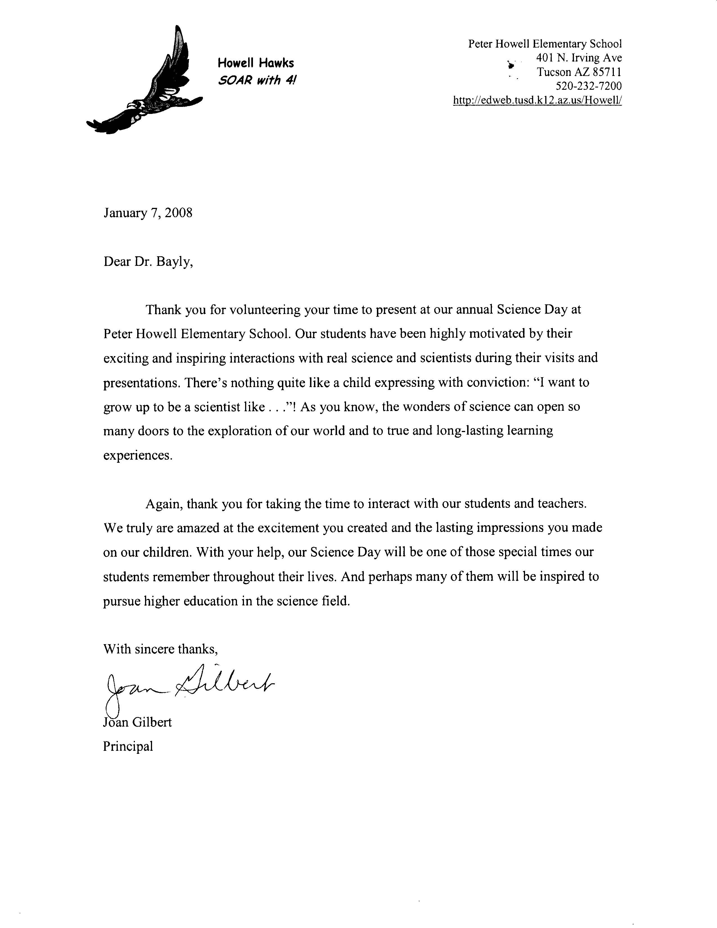


Physics Bus tour excites kids about science
Physics Bus tour excites kids about science
By Shari Lopatin
The Daily Courier
Tuesday, July 03, 2007
PRESCOTT VALLEY - Imagine a room full of
lightning bolts, tornadoes of fire, and smoky liquid nitrogen.
Sounds rather stimulating.
That's exactly how the kids at the Central Yavapai Boys and Girls Club felt Thursday afternoon, when the "Physics Bus" visited their school.
Erik Herman, Bruce Bayly, and Chris Discenza are math and science teachers from Tucson. The three met 10 years ago, and spawned the Physics Bus idea five years ago. This was their first time presenting in Prescott.
"We are pretty much advertising science. We want to get (the kids) hooked when they're young," said Herman, who is the president and co-founder of the tour.
"This past month was like a marathon: two performances a day," he continued.
The three teachers talked about different forms of energy, such as heat, light, and sound.
"What is it the Jedi (in Star Wars) use to get their power?" Bayly asked the kids.
A group called out the answer: "The force."
Bayly smiled and nodded his head. "In our galaxy, it's called the electromagnetic field," he said.
During the presentation, kids watched the teachers freeze graham crackers in liquid nitrogen, then eat the snacks and blow smoke out their noses.
A lightning strobe, producing a half-million volts of electricity, sent miniature lightning strikes into the air.
Herman even brought in a "sound tube" with fire and sang into a microphone, causing the flames to rise and fall. Best of all, the teachers introduced the kids to a hovercraft they created using air pressure, and gave the camp counselors a rise.
"We do cutting-edge science here in front of these kids," Bayly said, adding they are always developing new things to show off.
"It's still very, very new to us. Even when we're presenting things to elementary- and middle-schoolers, the science still has a lot of unanswered questions," he said. "I find it very intellectually stimulating."
Jessica Tammen, a 16-year-old Prescott High School student, helped the three teachers with their presentation.
"I love chemistry and physics, so it's fun to come help out," she said. "I think (the kids) liked it. They might be interested to take physics now."
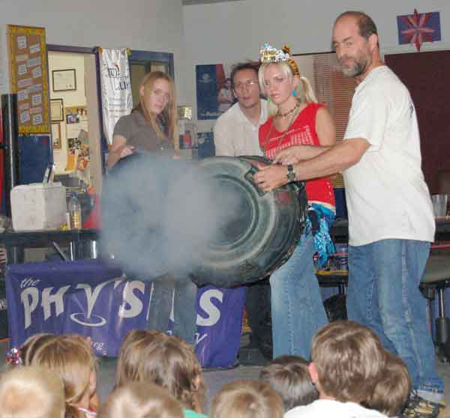
The Daily Courier/Shari Lopatin McCabe Bedell, Chris Discenza, Jessica Tammen, and Bruce Bayly produce a puff of smoke as part of their Physics Bus tour to demonstrate the power of airflow for children at the Central Yavapai Boys and Girls Club Thursday.

Tucson Region
Focus on Tucson: physics in action
Science as a show
Story and photos by James S. Wood
Arizona Daily Star
Tucson, Arizona | Published: 01.08.2007

An explosion here, a propane fire there, kids cheering with excitement — it's not what you typically see at an elementary school.
For the Physics Factory staffers, it's just another day on the job for their traveling science show.
"It all started when a bunch of us got together to try and outdo each other," said Erik Herman, Aztlan Academy physics teacher and senior instructor for the Physics Factory.
The nonprofit group started by putting on two shows a year at the University of Arizona.
"From there we thought: 'Why do it just twice a year? Let's get a bus and bring it to schools,' " Herman said.
Watching a recent performance, about 60 students at C.E. Rose Elementary School, 710 W. Michigan St., oohed and aahed.
"Our goal is to get kids interested in science so that later on in high school they will remember science is fun and redeeming despite being challenging," said UA mathematics professor Bruce Bayly, who is also part of the Physics Factory staff.
The group took its show on the road last summer with a 7,000-mile cross-country trip to more than 10 cities, which included a stop at the American Association of Physics Teachers meeting in Syracuse, N.Y.
Their bus was almost home from that trip, all the way to Benson, when it broke down. Now the team is trying to raise $15,000 to replace it. For more information, go to www.physicsfactory.org
To view some of the Star's award-winning Tucson photography, please log on to dailystarphotos.com

According to recent salary figures published in the Notices of the American Mathematical Society. (February, 2001). “Group I Public” includes the public Universities from among the approximately 45 highest ranked Mathematics Departments in the most recent National Research Council rankings.

