Parameters for Drift Simulations 26 Jul 2013
J.Rutherfoord, University of Arizona
DrifterParameters.V6.doc

[See my EMail to PYS on 17 Jan 2014 for a discussion of the mechanisms which go into 23.6 eV/ionization at 2200 V/mm. Include that discussion here in the next version.]

Program to simulate creation, drift, and recombination of ionization charges in liquid argon. The program reports the charge densities, electric field, and current densities. The program assumes a planar geometry so there is only one special dimension which we choose to be z. The program is designed to find steady-state solutions. If there are instabilities in the problem this program won’t find them.

Liquid Argon Gap: Parameter in mm units. Adjustable. Assumed to be parallel plate electrodes.

Potential across the gap: Parameter 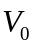 in units of V/mm. Adjustable.

Magnitude of the ionization: Parameter 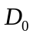 in units of ion pairs/mm³/s. Adjustable. This is the ionization rate at infinite electric field, i.e. before initial recombination. The spatial distribution of ionization is assumed to be uniform in x and y. In z (the coordinate normal to the electrode surfaces) at infinite electric field the ionization rate has a slight linear z-dependence with slope to agree with my EGSnrc simulations. The region of the gap closer to the beta source has a higher ionization rate than the region farther away. So is the ionization rate mid-way across the gap. At finite electric fields, initial recombination (HV Plateau Curve, a function of electric field) decreases the produced ionization. This is z-dependent if the electric field varies with z (and it usually does). So the actual ionization rate is given by 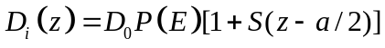 with the liquid argon gap in the region 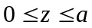. See below for a definition of 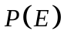.

It is sometimes useful to refer the ionization rate 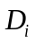 to the critical value. The critical ionization rate per unit volume is
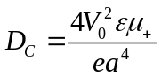
where
is the potential across the gap in volts, is the permittivity of liquid argon in F/mm, 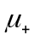is the mobility of singly-charged positive argon ions in liquid argon in mm²/Vs, is the proton charge in Coulombs, and is the gap width in mm. Then 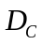 is the critical ionization rate in units of mm⁻³ s⁻¹. That is, it is the critical number of electron-ion pairs produced per unit volume per unit time. If we want the critical charge (of either sign) produced per unit volume per unit time then we remove the factor in the denominator. We will use 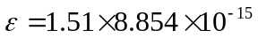 F/mm. We write the number of ionization electrons produced per unit volume per unit time as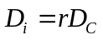 where is the rate relative to the critical value.

Initial Recombination

We interpret the HV Plateau Curve as the probability that an electron-ion pair survives (avoids) initial recombination.

HV Plateau Curve (initial recombination):

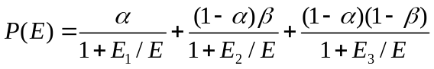
where
, and  is the electric field in units of V/mm. is a function of . Note that 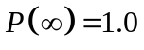 When charge is created, first the amount at infinite E-field is determined and then this is multiplied by to get the produced ionization charges at finite E-field.

Fig. 1. HV Plateau Curves.

Positive Argon Ion mobility

This parameter is not well measured. While there are many measurements reported in the literature, there is no apparent consistency between measurements. And there is certainly no pretense of measuring an Electric Field dependence to this parameter. A value close to 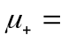0.100 mm²/Vs seems to fit my PIB data.

See M.A.Kirsanov and I.M.Obodovskiy, “Ion Processes in a Liquid-Xenon Ionization Chamber under High-Intensity Pulsed Irradiation”, ISSN 0020-4412 Instruments and Experimental Techniques, 2010, Vol. 53, No. 2, pp. 185-193. At UAz libraries, search on Instruments and Experimental Techniques. In this paper are a nice indications, and some references thereto, of the mechanism of positive ion transport.

Electron velocity vs E-field

The build-up of positive Argon ions in the liquid argon appears to be insensitive to the electron velocity. The many measurements reported in the literature show good consistency. Some determine the temperature dependence. Here I assume T=90 K.

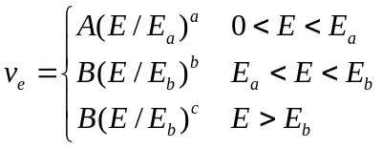
where 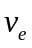 is in units of mm/s and the electric field E is in units of V/mm. The parameters areand 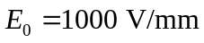. This parameterization can easily be changed to a simpler one.

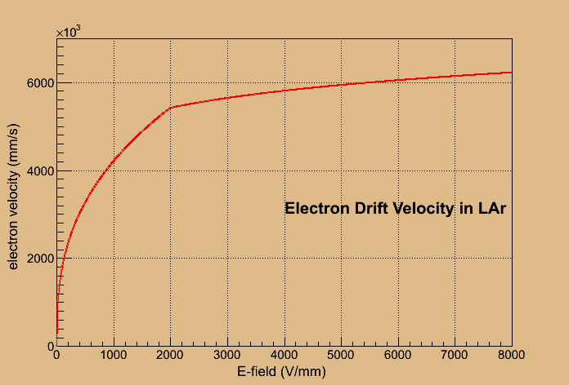
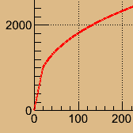
Add data?

Fig. 2. Electron drift velocity in liquid argon versus electric field with expanded view of the small Electric Field region. Note that 1000 V/mm is the operating point of many liquid argon calorimeters.

Molecular Oxygen ion mobility

We assume that oxygen dissolved in liquid argon does not dissociate. When an oxygen molecule, a contaminant in the liquid argon, attaches an electron it becomes negatively charged and drifts in the electric field. As best I know there are no measurements of the drift velocity so we use a simple mobility for negative Oxygen molecular ions of 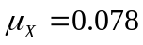 mm²/Vs as suggested in a private communication from Richard Holroyd, Brookhaven National Lab Chemistry Department, emeritus.

Bulk Reactions

Bulk reactions occur several places in this simulation. The recombination of electrons with positive argon ions, the attachment of electrons to neutral oxygen molecules, and the neutralization of positive argon ions with negative oxygen molecular ions are examples. If we call 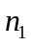 the number density of one species and 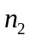 the number density of another species, then when these two species react to make a third species we have

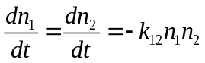

where 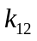 is the rate constant. If and have units of mm⁻³ then has units of mm³/s.
In our various references a variety of units are used so I will provide some conversions here. We start by observing that the number density of argon atoms in liquid argon is

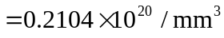

If the number density of oxygen molecules dissolved in the liquid argon is 1.0 ppm then, in our units, this density would be 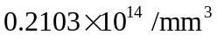.

Molarity, M, is defined as the number of moles of solute dissolved in one liter of solution. So a Molarity of 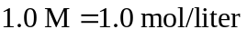, i.e. 1.0 mol of solute per liter of solution. Molarity is related to number density.

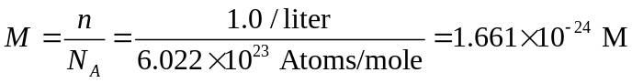
Then the conversion constant from number density in units of mm⁻³ to units of Molarity is

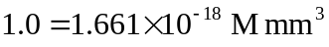

Bulk recombination of electrons with positive argon ions

The bulk recombination rate constant for electrons and positive Argon ions depends on the E-field. At larger E-fields a bulk recombination rate constant of about 3.6×10⁻³ mm³/s seems approximately right for my PIB data. At lower E-fields the rate constant should rise in rough agreement with Shinsaka et al. to of order 0.1 mm³/s. In this reaction the product is a neutral Argon atom which we don’t track in this simulation.

The Debye formula for the recombination rate is
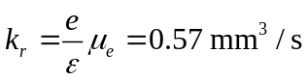
where 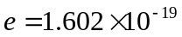 C is the proton charge, F/mm is the permittivity of liquid argon, and 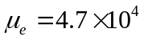 mm²/Vs is the electron mobility in liquid argon at low electric fields (<20 V/mm). This is quite a bit higher than the Shinsaka et al measurements at low fields.

My simulation program has six options for the rate constant, all shown in Fig. 3. I currently favor the lowest one shown in light blue which does not agree with the Shinsaka et al data.

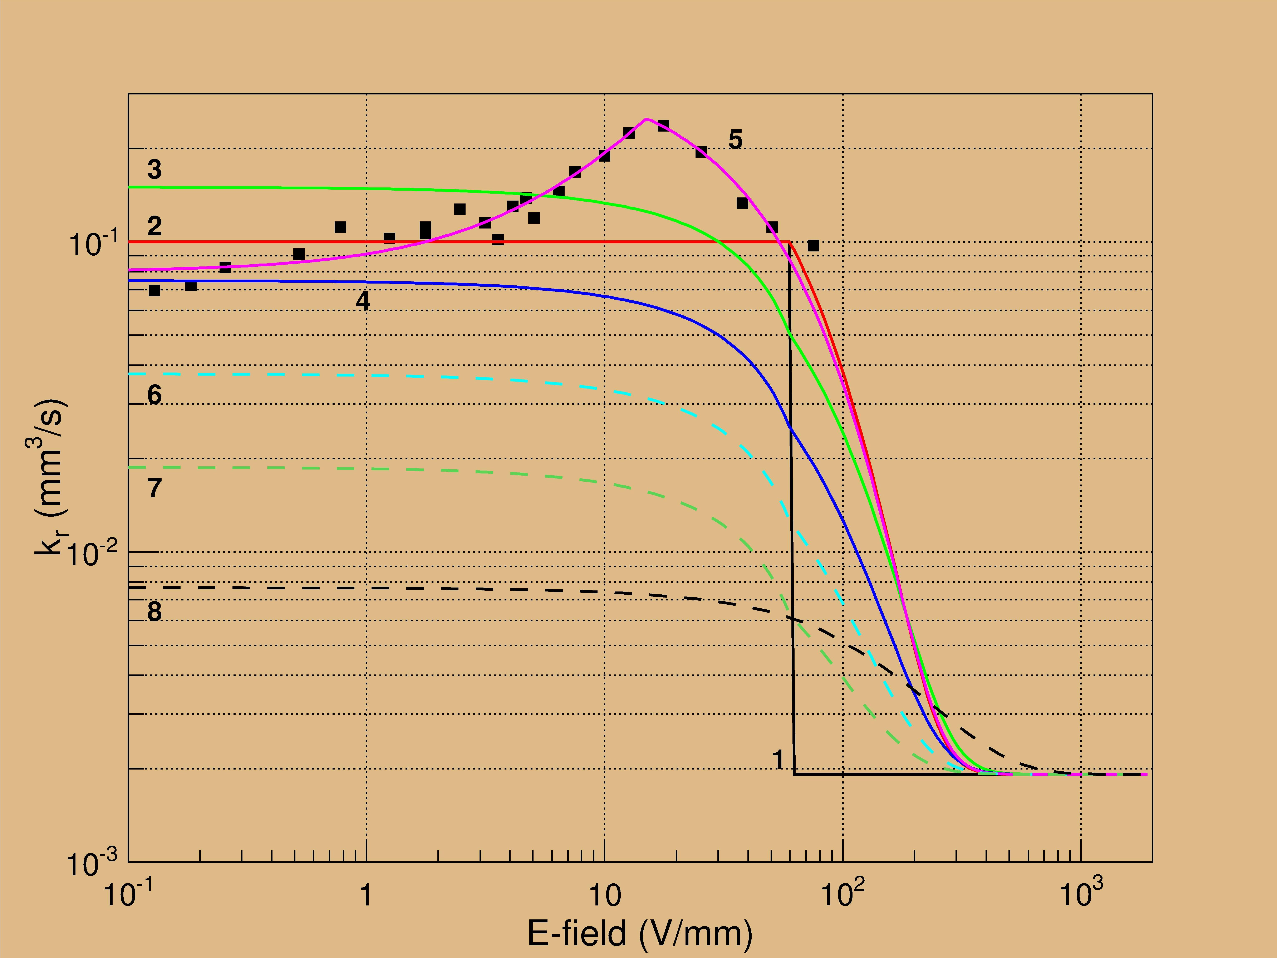
Number these parameterizations as in PARAMS.FOR

Fig. 3. Various parameterizations of the bulk recombination rate constant for electrons and positive argon ions in liquid argon.

Shinsaka et al., J.Chem.Phys. 88 (1988) 7529.

Electron attachment by dissolved oxygen contaminant

The rate constant at which neutral Oxygen molecules attach ionization electrons is given by Zeitnitz et al. as
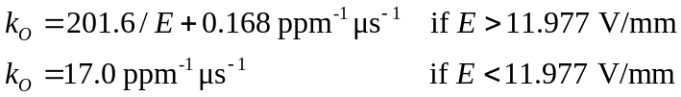

where is the E-field in V/mm. To convert this to mm³/s we multiply by a factor 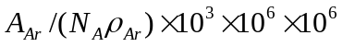 where 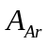 is the atomic weight of Argon in g/Mole, 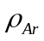 is the density of liquid argon in g/cm³, and 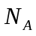 is Avogadro’s number in Atoms/Mole. The factor 10³ converts g/cm³ to g/mm³, the first factor 10⁶ converts ppm, and the second factor 10⁶ converts μs to s. The reaction product is a negatively charged molecular oxygen ion which drifts in the E-field and diffuses.

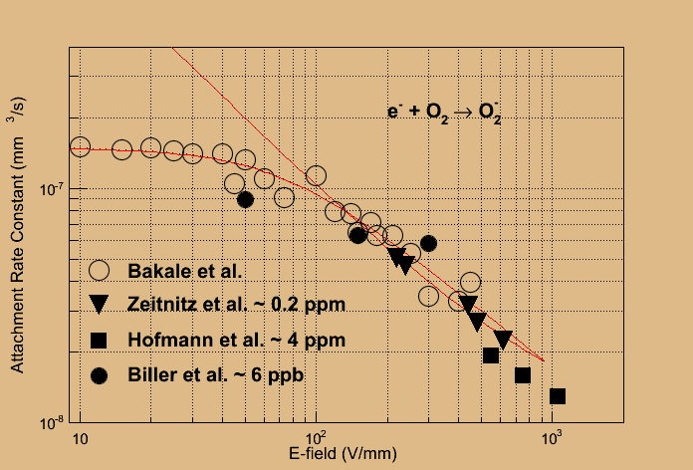

Fig. 4. Attachment rate constant for electrons and oxygen contaminant in liquid argon.

G.Bakale, U.Sowada, and W.Schmidt, J.Phys. Chem. 80 (1976) 2556.
C.Zeitnitz et al., NIM A 545 (2005) 613.
Find reference!
W.Hofmann et al., ????????????????
S.Biller et al., NIM A 276 (1989) 144.

Bulk recombination of Oxygen molecular ions with positive Argon ions

The bulk recombination rate constant for negative Oxygen molecular ions and positive Argon ions is not measured, as far as I know. Holroyd suggests as a logical guess
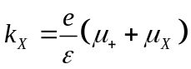
The reaction products are a neutral oxygen molecule and a neutral argon atom. The neutral oxygen molecules are subject to diffusion.

Diffusion

See E. Shibamura et al (Doke), Phys Rev A 20 (1979) 2547.
Leonid Kurchaninov made two interesting points in late March at Protvino. (See my HiLum notebook.)
1) Electron diffusion constant should use a temperature corresponding to the super-heated electrons in higher electric fields. Shibamura et al discusses this point.
2) Scattering of the drifting electrons may be off of phonons as well as off of argon atoms.

How the drift simulation program works

The gap is divided into 64 bins. After a set number of iterations a steady state is reached. At this point the number of bins is doubled and iterations continue. This is repeated until a steady state is reached with 1024 bins.

Each iteration time step is the time it takes an electron to drift a quarter of a bin at the projected maximum E-field in the gap. For 1024 bins this is about 0.12 ns for a 2 mm gap at 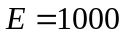 V/mm.

The primary output of the simulation program is the current density as a function of time. The current density is reported every time step (~1.8 ns) over a period of somewhat less than 7 μs. This output is repeated approximately every 10 ms. This timing is designed to closely mimic the primary HiLum data stream where each ~7 μs corresponds to an “event”. With about 100 events per spill we get about one event every 10 ms. The first event comes very close to the beginning of the spill so for this event there is almost no accumulation of positive ions.

The external circuit is simply an ideal HV supply. The current through the gap also flows through this supply. If a more realistic external circuit doesn’t significantly affect the potential across the gap, then the current measured in the simulation can be input to a SPICE simulation of the circuit to get the signal after the shaper.

If the ionization were constant in time then a steady-state current would be reached in a short time and this would equal the sum of the charge current due to electrons and the charge current due to positive argon ions. But in our case the ionization depends on time so that the current density passing any plane within the gap and the current per unit surface area of the electrodes passing through the external circuit is
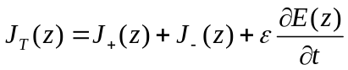
where is the position of the imaginary plane parallel to the electrodes, 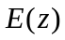 is the electric field at that plane, is the dielectric constant for liquid argon (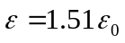), and 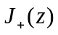 and 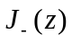 are the charge densities due to the drifting charges. On very general grounds it can be shown that 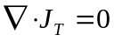, i.e. 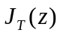 is independent of . The third term is the familiar displacement current, sometimes called the induced current in the context of ionization chambers, and it can be a large contribution to 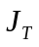, but not in the steady state.

