ATLAS Liquid Argon **FCalPulse Project**

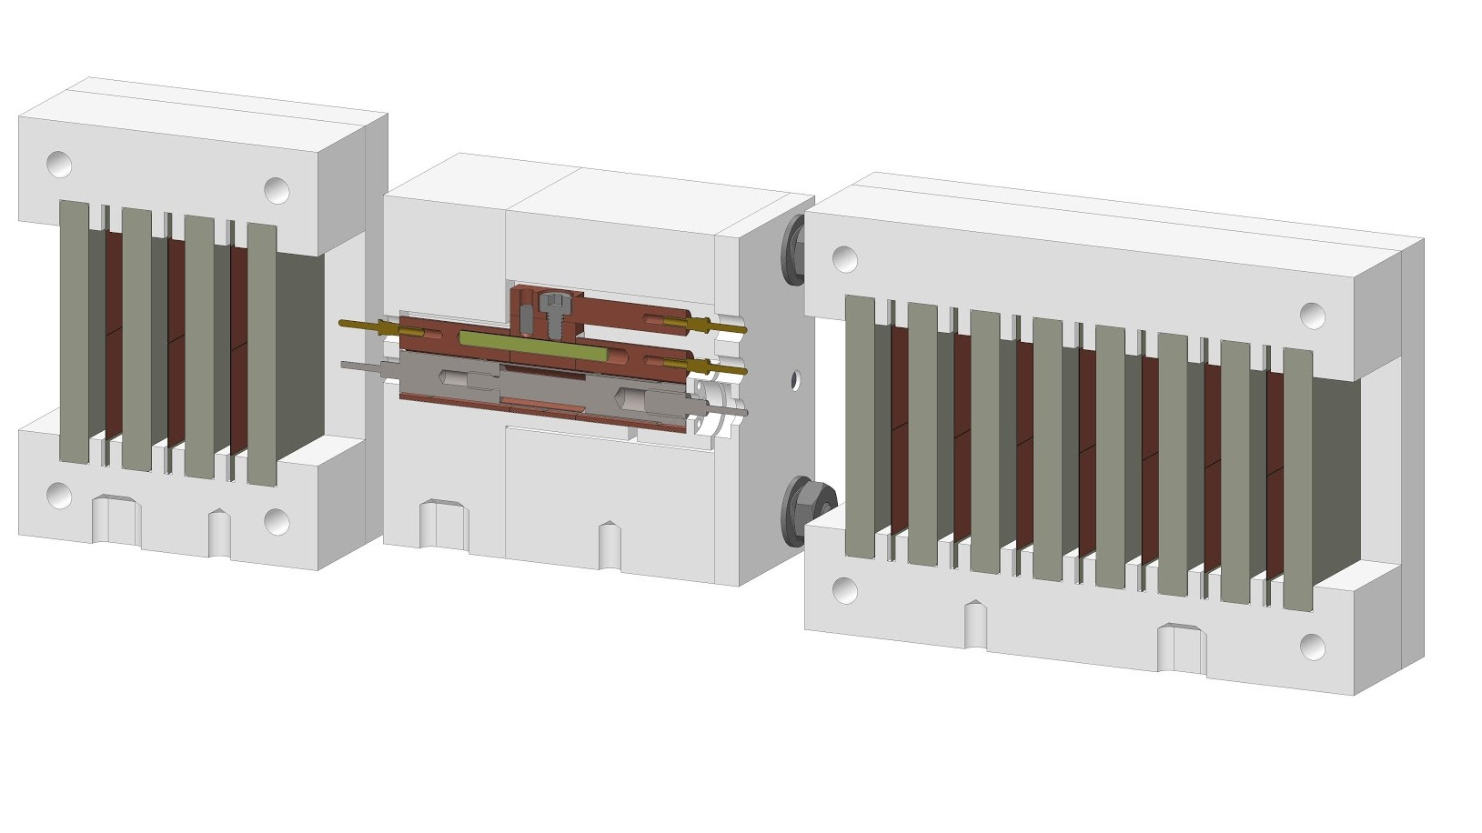

Tungsten plate shower calorimeter

Tail catcher

}

Sr-90 beta source in FCal1-style electrode

Electron shower reaches max here

Electron beam

Electrode rod with hollowed out cavity

Plug

spacer

Assembled electrode rod

Segmented electrode tube

100 mCi Sr-90 beta source coating outer surface of foil

